Institutions and Prosperity
Public Institutions for Enabling the Private Sector
with a focus on public procurement and regulatory institutions

Contents
Foreword i
Acknowledgements ii
Executive Summary iii
Organizational dimensions v
Governance Dimensions vii
Chapter 1. A Framework for Understanding Public Institutions 1
Defining public institutions, institutional capacity, and policy mandates 2
Conceptual framework: The role of public institutions 3
Applying the framework 13
Chapter 2. Public Institutions that Procure from the Private Sector 17
Framework for public procurement institutions 17
Applying the framework: Corruption and “passive waste” in public procurement 31
Chapter 3. Public Institutions that Regulate the Private Sector 33
Framework for regulatory institutions 33
Applying the framework: Case study on telecoms regulatory institutions in Peru 47
Annex 1. Methodology for Assessing Procurement Systems (MAPS) indicators 51
References 54

Foreword
A thriving private sector is the engine of economic growth and development: it drives job creation, generates income, and spurs innovation. Yet behind any flourishing private sector is a well-functioning public sector that fosters a strong business climate and provides public goods and services that support private investment. Nearly all governments have a mandate to enable the private sector, though many struggle to fulfill it in practice. Accordingly, effective public institutions – the ministries, departments, and agencies tasked with the day-to-day work of government – play a significant role in advancing private sector-led growth and development. Conversely, when public institutions are weak, they can inhibit the private sector and constrain broader growth and development.
Institutions for Prosperity: Public Institutions for Enabling the Private Sector, the first report in a new series, examines private sector development through this critical but often overlooked lens: the capacity of public institutions to implement their policy mandates effectively. The report provides evidence that investing in institutional capacity can generate returns far greater than simply increasing spending on “government-as-usual” programs. Drawing on extensive evidence and data, it offers policymakers a practical approach to diagnose the often-complex challenges facing public institutions and identify pathways for addressing them, with a focus on public procurement and regulatory institutions.
A distinguishing feature of the report and series is its focus on individual public institutions rather than the government as a whole, capturing the differences within a government. The report’s conceptual framework highlights that the capacity of each individual public institution depends on both organizational and governance dimensions. Organizational dimensions include the personnel, financial resources, information systems, and management practices that keep public institutions operating efficiently. Governance dimensions refer to the rules and incentives that keep them working in the public interest, particularly the extent to which they are independent from undue influence, accountable to citizens, and transparent in their processes.
The report shows how organizational and governance constraints can weaken procurement and regulatory institutions’ effectiveness and, in turn, stifle private sector development and job creation. It applies the framework to each, including a discussion of corruption and “passive waste” in procurement and a case study on telecom regulatory institutions in Peru. The analysis underscores the need to understand how organizational and governance dimensions interact to determine public institutions’ capacity to implement policies effectively.
The report serves as both a resource for policymakers and a call to action. Institutions for Prosperity is part of an emerging agenda to better understand and strengthen public institutions as critical organizations – the government bodies and public officials tasked with delivering policy goals in a world facing growing challenges. The series combines granular data, innovative research from across the social sciences, and practical examples to equip policymakers and practitioners with the adaptive tools needed to improve institutional performance. It also contributes to broader efforts to address weak institutions by developing a comprehensive data collection process to analyze institutions worldwide.
Strong public institutions can enable a thriving private sector. Similarly, the ultimate goal of this series is to enable governments to better fulfill their mandates – to serve their populations more effectively and meet the world’s growing list of challenges head on.

Acknowledgements
The Institutions and Prosperity: Enabling the Private Sector report was prepared by a World Bank team led by Rita Ramalho, under the guidance of Arturo Herrera, Global Director for Institutions, and Chiara Bronchi, Practice Manager, Public Institutions Unit. Overall guidance was provided by Pablo Saavedra, Vice President for Prosperity, and Aart Kraay, Prosperity Chief Economist. The core team comprised Rogelio Granguillhome Ochoa, Galileu Kim, Tanu Kumar, Greg Larson, Paul Phumpiu Chang, and Stuart Russell. Awais Ahmed Khuhro and Ines Dezcallar Miranda were research analysts. We would like to pay tribute to the memory of our colleague, Paul Phumpiu Chang. His commitment and expertise played a crucial role in shaping the case study on Peru’s telecom regulatory environment and his contributions continue to be central to our team’s work. His kindness and wonderful sense of humor will be truly missed.
Woudassie Bezabeh Alamrew provided administrative support to the team. Abebe Adugna, James Anderson, Ivan Anton Nimac, Alexandre Borges de Oliveira, Eric Braian Arias, Doerte Doemeland, Verena Fritz, Mario Guadamillas, Alex Habershon, Adrienne Hathaway-Nuton, Zahid Hasnain, Alberto Leyton, Denis Medvedev, Ryan Rafaty, Manuel Ramos Maqueda, Natasha Rovo, Adenike Sherifat Oyeyiola, Roby Senderowitsch, Asli Senkal, Richard Sutherland, Serdar Yilmaz, and Laura Zoratto provided inputs to the report at various stages.
The team would like to thank the peer reviewers: Asya Akhlaque, Edouard Al-Dahdah, Phil Keefer (InterAmerican Development Bank), Martha Martinez Licetti, Snezana B. Mitrovic, and Michael Woolcock.
The communications and engagement strategy was led by Lara Saade with support from Nick Nam. Special thanks are extended to Jewel McFadden, who coordinated and oversaw the report’s formal production, and to the World Bank’s Formal Publishing Program, including XX. The report was edited by Greg Larson and proofread by XX. XX verified the report’s citations and assisted with copyediting. XX designed the cover and interior layout.
The team gratefully received suggestions and guidance from an Advisory Panel composed of both external and internal participants. External participants included Shanta Devarajan (Georgetown University), Dan Foarta (former Stanford University), and Phil Krause (Collaborative Africa Budget Reform Initiative). Internal participants included James A. Brumby, Oscar Calvo, Jeff Chelsky, Helene Grandvoinnet, Deborah Hannah Isser, Marco Larizza, and Francesca Recanatini. Thanks are also due to participants in a workshop to discuss the report’s preliminary findings: Serena Sara Daniela Cocciolo, Thiago De Gouvea Scot de Arruda, Nona Karalashvili, Norman Loayza, and Sylvia Solf.
The team apologizes to any individuals or organizations who are inadvertently omitted from this list. The team is grateful for the help received from all who contributed to the report, including those whose names may not appear here.

Executive Summary
The private sector is the main driver of economic growth and development, but it needs a functioning public sector to thrive. Governments around the world invest heavily in public goods that are essential for private sector growth, from roads, bridges, and ports to regulatory frameworks. Yet institutional challenges like waste, corruption, insufficient expertise, and uneven enforcement often weaken the link between spending and results. Consequently, policies and projects can frequently prove less effective than hoped for by citizens, firms, and policymakers themselves. Such implementation failures are a central challenge and one of the primary reasons governments fail to enable economic development (World Bank 1997 and 2017; Andrews, Pritchett, and Woolcock 2017).
Institutions and Prosperity: Public Institutions for Enabling the Private Sector is the first report in a series that focuses on why policy implementation fails and how it can be improved. This edition focuses on two areas that sit at the heart of market competition: public procurement and regulation. Globally, public procurement represents a large share of government expenditure, with spending largely concentrated in the construction of critical infrastructure. Likewise, regulations are policy instruments used by governments to ensure that the private sector develops in a manner compatible with the public interest, particularly where markets fail to do this on their own. When public procurement or regulatory institutions function poorly, the costs fall broadly on firms, consumers, and taxpayers.
This report advances current knowledge on governance and institutions by focusing on specific public institutions, rather than on entire countries or governments. As governments may implement policies effectively in some areas but not others, the report concentrates on the individual ministries, departments, and agencies responsible for implementation. The report refers to these entities as public institutions, defined as “public sector organizations mandated with policy implementation, along with the rules and processes that guide these organizations.” Evidence from the World Bank Business Ready Dataset shows that the performance of public institutions serving the private sector varies substantially even within the same country, underscoring the importance of focusing on specific institutions (figure E.1).
Figure E.1 Wide variation in institutional capacity within countries across ten policy areas
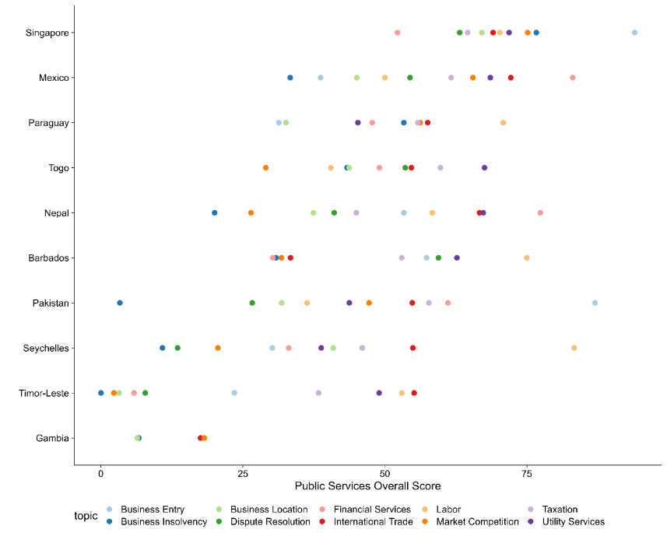
Source: World Bank Business Ready Database. Note: Ten countries out of the 50 covered were randomly selected for illustrative purposes. According to the World Bank Business Ready Database: “Public Services spans the facilities that governments provide to support compliance with regulations and the institutions and infrastructure that enable business activities. Indicators under this pillar are limited to the scope of the business environment in areas related to the life cycle of the firm. They emphasize such aspects as digitalization, interoperability of government services, and transparency.”
The report also develops a conceptual framework for the Institutions and Prosperity series that can be used to identify institutional constraints to effective policy implementation. The framework unpacks institutional capacity along four organizational dimensions and three cross-cutting governance dimensions (see figure E.2, Kim and others 2026). The organizational dimensions (personnel, financial resources, information systems, and management practices) capture the internal structures that determine whether an institution can deliver on its mandate. The governance dimensions (accountability to citizens and their representatives, independence from undue influence, and transparency in decision-making) determine whether that delivery serves the public interest rather than narrow private or political interests. While political economy and power dynamics within the policy arena affect what policy mandates are created (World Bank 2017), a public institution’s organizational and governance dimensions—the focus of this report-- shape its ability to successfully implement those mandates and contribute to development outcomes.
Figure E.2 Conceptual framework for assessing the implementation capacity of public institutions
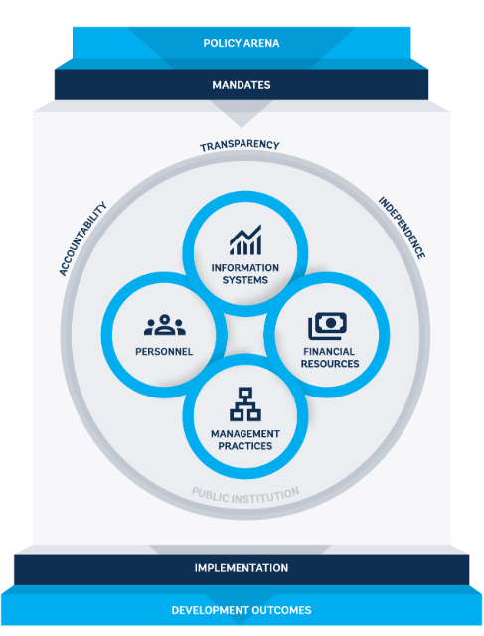

A key feature of the framework is its emphasis on how institutions actually function, rather than on their formal attributes. Many governance assessments emphasize the de jure form of institutions rather than their de facto capacity to function and implement their mandates. The framework in this report takes several such forms and policy mandates as a starting point, while focusing on how they are executed in practice.
This emphasis highlights the importance of a holistic and multi-dimensional approach to institutional capacity. Typically, efforts to strengthen institutional capacity focus on one formal aspect at a time. Government technology reform projects often emphasize information systems, for instance, while public administration reform projects frequently focus on personnel. This report’s focus on common implementation problems underscores that institutional challenges often stem from interconnected weaknesses across multiple dimensions. Coordination failures across departments, for example, may result from ineffective information sharing as well as management practices that entrench silos. Similarly, low budget execution can stem from weak public financial management, insufficient staff training on budget processes, or high transaction costs due to poorly connected information systems.
Accordingly, the framework’s organizational and governance dimensions are mutually reinforcing. Organizational dimensions collectively shape an institution’s effectiveness at implementing its mandate, while governance dimensions determine whether its efforts serve the public interest. Notably, the governance dimensions can apply to institutions as a whole or to individual organizational components. An institution’s personnel, for example, may be highly motivated and face strong career incentives to implement its mandate, but weak mechanisms for independence from the private sector may result in some employees exercising undue favoritism.
This report applies the framework to public institutions mandated to foster private sector development, focusing on procurement and regulatory institutions. It highlights the challenges and tradeoffs these institutions must navigate to enable the private sector effectively while minimizing favoritism and corruption. More broadly, the report demonstrates how the framework can help diagnose the specific and interconnected constraints that frequently prevent public institutions from implementing their mandates effectively.

Organizational dimensions
Personnel, financial resources, information systems, and cross collectively help public institutions translate policy into implementation. These organizational dimensions are interconnected: an institution’s management practices, for example, typically shape the recruitment, promotion, skills, and compensation of its personnel. Similarly, strong information systems may enable effective management of financial resources. As noted above, each organizational dimension also interacts with the framework’s governance dimensions. The discussion below examines each organizational dimension in the context of procurement and regulatory institutions.
Personnel are a key factor when assessing the capacity of procurement and regulatory institutions. Personnel comprise an institution’s recruitment, promotion, and dismissal of staff as well as compensation and skills – including both staff competencies and work experience. These factors are critical for effective regulation and procurement (figure E.3). In telecoms regulation, for instance, regulators need expertise in highly technical fields, including broadband technology and spectrum allocation (Stern 2000). Likewise, procurement agencies without capable personnel can pay higher prices, face cost overruns, and experience contract delays, incurring costs for both taxpayers and the private sector. In the Russian Federation, for example, roughly 20 percent of the variation in quality-adjusted prices paid by the government for goods and services is attributable to the skills of individual procurement officers (Best, Hjort, and Szakonyi 2023).
Figure E.3 Quality of procurement personnel is positively correlated with procurement outcomes
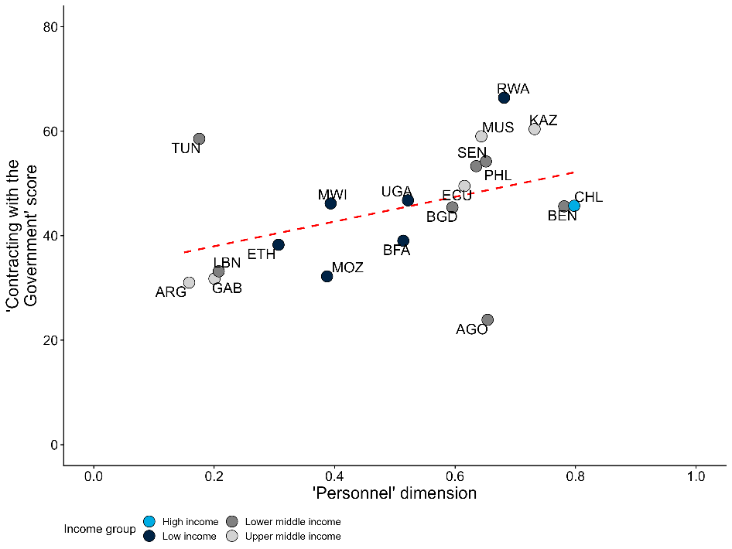
Source: Methodology for Assessing Procurement Systems (MAPS) and Nogues Comas and Mendes dos Santos (2021).
Note: The x-axis is a country-level measure of the quality of procurement personnel derived from the MAPS assessments. See annex 1 for more details and a list of the MAPS indicators used to calculate the measure. The y-axis is a country-level measure of the ease of contract with the government from Nogues Comas and Mendes dos Santos (2021). The indicator combines three dimensions: the steps required to complete the procurement process, the time associated with each step, and the sophistication of e-procurement platforms. The correlation remains significant at the 90% confidence level after controlling for GDP per capita.
Financial resources are a critical factor for institutional effectiveness, particularly in procurement. While limited resources are a common challenge for public institutions, weak budget management is also common. In procurement, poor financial management often involves cost overruns, contract renegotiations, payment delays, and capacity bottlenecks linked to fiscal cycles. Payment delays can be particularly harmful for the private sector, though they often result from broader weaknesses in public financial management – such as limited budget space or liquidity – requiring a more holistic response. In southern Europe, for example, public entities took an average of five to six months to pay for goods and services purchased between 2000 and 2010 (Conti and others 2021). Such delays, which are typically more common in large construction contracts, can decrease firms’ cash reserves and reduce corporate investment (Abad and others 2023). Payment delays can also push firms, especially smaller and less experienced ones, to exit the market (Conti and others 2021). Such challenges can undermine procurement institutions’ common policy goal of increasing SME participation in public contracts.
Information systems help public institutions reduce transaction costs and make better-informed decisions, which are critical for both regulation and procurement. To effectively supervise dynamic and often rapidly evolving markets, regulatory institutions need timely data on market trends, technological developments, and compliance with existing regulations. Automated data gathering on air pollution, for instance, can enhance the quality and accuracy of information for environmental regulators (Greenstone and others 2022). For procurement institutions, information systems like e-procurement, which enables tender documents to be published online, can help reduce transaction costs at each step of the procurement process. In Indonesia and India, for example, the implementation of e-procurement platforms enabled firms outside the public buyers’ home regions to win contracts (Lewis-Faupel and others 2016). However, the capability of information systems can vary widely. While about 160 countries in the world had some type of e-procurement system by 2024, only about 40 were connected to information management systems beyond procurement (figure E.4). Moreover, information systems will not deliver their full potential if bureaucrats lack the ability or incentives to use them effectively.
Figure E.4 Many countries have e-government procurement (GP) systems, but those systems have varying capabilities
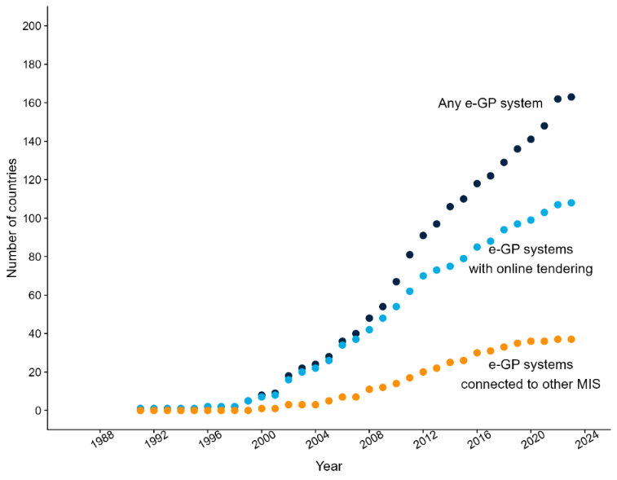
Source: GovTech Maturity Index.
Note: “Any e-GP” system refers to the countries that have any type of e-government procurement system. The countries with “e-GP systems with online tendering” are a subset of the first group where tendering can be done online. The countries with “e-GP systems connected to other MIS” are a subset of the first group where the procurement system is connected to other management information systems (MIS) with the government.
Management practices play a central role in how regulatory and procurement institutions function, particularly for strategy setting and coordination. In procurement, management practices that contribute to excessive workloads can harm procurement outcomes and inhibit innovation. When the workload of U.S. government procurement officers declines, for example, the probability that a procurement contract generates a patent increases (Giuffrida and Raiteri 2023). Procurement outcomes are also strongly correlated with the degree of employee cooperation (Best, Hjort, and Szakonyi 2023), likely reflecting the complexity of procurement processes, which involve multiple steps and actors with different skills. In regulatory institutions, setting and committing to a medium- to long-term strategy is equally critical. Such forward-looking vision helps reduce regulatory uncertainty for firms and consumers.

Governance Dimensions
Accountability, independence, and transparency influence whether public institutions implement their mandates in ways that align with the public interest. These governance dimensions reflect the importance of considering the broader political economy within which public institutions function. As with the framework’s organizational dimensions, the governance dimensions are interconnected and interact across each organizational component. The discussion below examines accountability, independence, and transparency in the context of procurement and regulatory institutions.
Accountability, or the influence of external stakeholders (including the private sector) on public institutions, has important impacts on procurement and regulation. Establishing structured and diverse accountability mechanisms is critical for procurement and regulatory institutions, given the wide range of stakeholders they face. In regulatory institutions, accountability can be understood along two dimensions: “horizontal relationships” with political institutions and other regulatory institutions, and “vertical relationships” with regulated entities. Mechanisms like annual reviews and oversight committees can strengthen horizontal accountability (OECD 2014), while dispute resolution and grievance mechanisms can support vertical accountability by enabling firms to voice their concerns. Evidence suggests that such mechanisms increase foreign direct investment and improve regulatory compliance (Hebous, Kher, and Tran 2020; Malesky and Taussig 2019). In procurement, accountability relationships also operate along two dimensions: ex ante oversight before contracts are awarded, and ex post investigation after the award. Complaints processes are a common form of ex post accountability, allowing firms to challenge the validity or legality of procurement decisions. Published audits, another form of ex post accountability, can create incentives that decrease the risk of corruption (Avis, Ferraz, and Finan 2018).
Independence protects procurement and regulatory institutions from undue influence not aligned with the wider public interest. In regulatory agencies, rules and processes can prevent regulatory capture by insulating regulators from undue influence from the private sector, politicians, and other interest groups (Carpenter and Moss 2013). For example, rules against revolving door appointments – where regulators move to the industries they oversee and vice versa – can reduce the risk of capture (Dal Bó 2006). Stability in leadership is also critical for regulatory independence: frequent changes in management can create leadership vacuums and shifting priorities, delaying decision-making and disrupting implementation. In this report’s case study on Peru’s telecommunications regulatory ecosystem, for example, frequent turnover of the relevant minister delayed key regulatory milestones (figure E.5). With the telecoms sector undergoing rapid technological change, such delays can have significant consequences for the quality, accessibility, and price of services. Procurement institutions likewise require independence from firms bidding on public contracts and from politicians seeking to use contracts for patronage. Given the significant financial stakes, suppliers may have strong incentives to offer procurement officials bribes or kickbacks in exchange for favorable treatment (Campos and others 2021). Without sufficient independence, such pressures can lead to contract awards based on factors other than quality, price, or policy objectives.
Figure E.5 Frequent leadership changes delay key regulatory milestones (Peru)
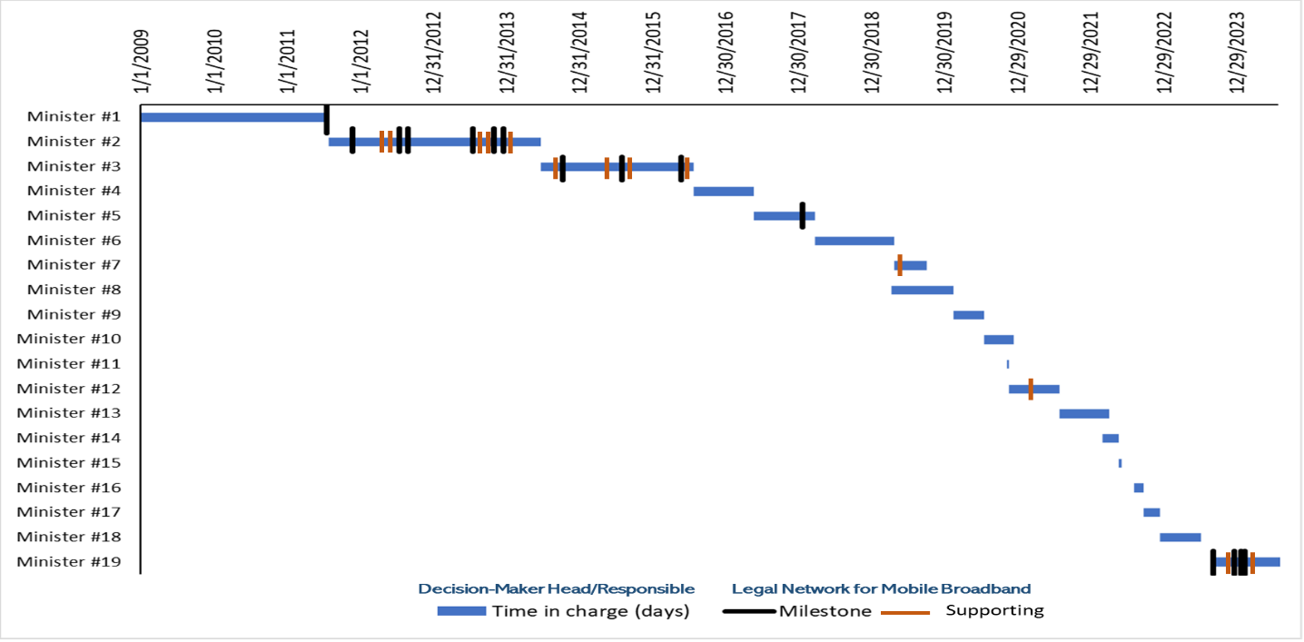
Source: Authors’ elaboration.
Note: Each black line represents key legislative or regulatory acts (milestones) that significantly impacted Peru’s mobile internet service sector. Each orange line represents other legislative or regulatory acts (supporting) that complemented milestones. The blue bars represent the number of days each decision-maker was in charge. Frequent leadership changes often led to delayed decisions, shifting priorities, inconsistent implementation, and lack of follow-through on existing plans. For example, key regulatory milestones – such as the 4G spectrum auction and Mobile Virtual Network Operator (MVNO) regulations – were delayed across multiple leadership changes.
Transparency supports both accountability and independence in regulatory and procurement institutions. When external stakeholders have access to detailed information on institutional behavior, they can more effectively hold public institutions to account. In regulatory institutions, greater transparency can reduce the risk of capture by enabling public scrutiny of decision-making processes and interactions between the public and private sectors. For example, in the Peru case, adopting a more transparent and accountable approach to telecoms regulation and market oversight reduced regulatory uncertainty. In procurement, the value of transparency depends on when and how data is published. Ex ante transparency in tender criteria enables horizontal monitoring by bidders (Bauhr and others 2019), while ex post transparency on contract awards is most useful for citizens, civil society (such as non-profit organizations and journalists), and non-selected bidders seeking to challenge procurement decisions (Duguay, Rauter, and Samuels 2023).
The Institutions and Prosperity series is designed to help policymakers and practitioners understand, analyze, and address challenges in the public institutions they engage with. Drawing on examples and case studies, this first edition shows how the framework developed for the series can be applied to diagnose and address capacity issues that hinder effective implementation in procurement and regulatory institutions. Figures E.6.a and E.6.b illustrate the framework’s practical value, showing how it can pinpoint underlying organizational and governance challenges, inform targeted solutions, and help public institutions better fulfill their mandates in line with the public interest.
Figure E.6.a How addressing issues in organizational and governance dimensions can affect outcomes in procurement
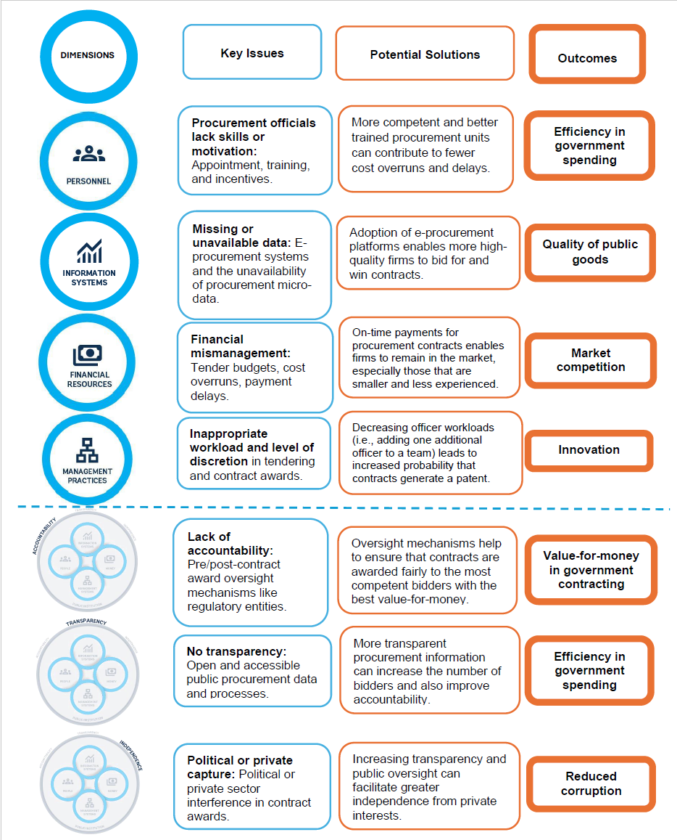

Figure E.6.b How addressing issues in organizational and governance dimensions can affect outcomes in regulation
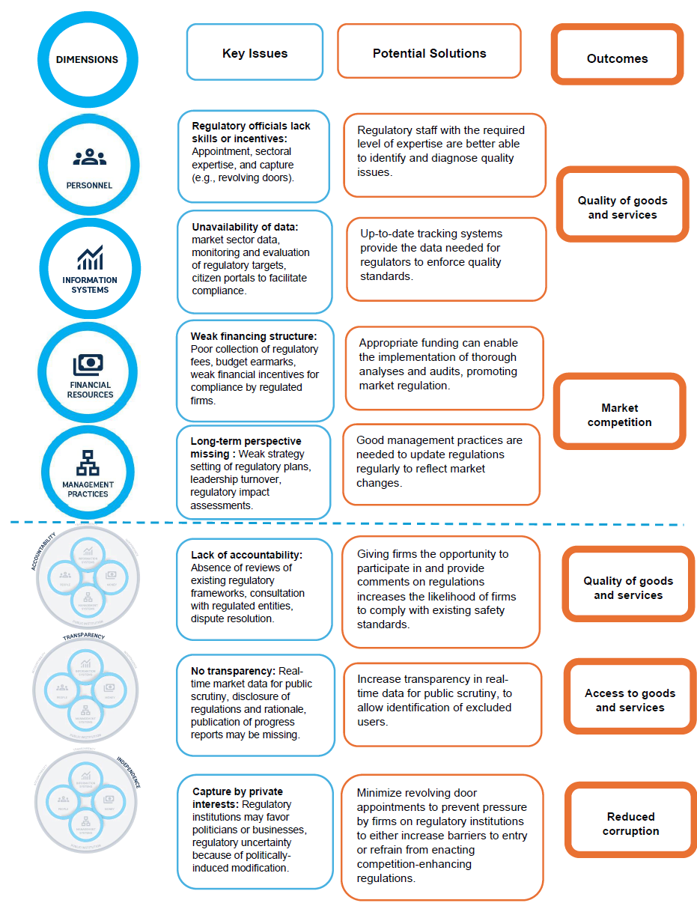

Chapter 1. A Framework for Understanding Public Institutions
Even when governments formulate effective policies on paper, their efforts often falter during implementation. Implementation failures are a central challenge in development and are often cited as one of the primary reasons why governments fail to enable economic development (World Bank 1997 and 2017; Andrews, Pritchett, and Woolcock 2017).
Existing work on policy effectiveness frequently focuses on policy design rather than implementation. Governance assessments, for example, often examine public financial management, public procurement, or tax administration systems by focusing on de jure aspects of governance, such as laws, policies, and structures. However, policies may be ineffective not because their de jure form is suboptimal, but because their de facto implementation is poorly executed.
This report focuses on failures that occur during implementation, which can take several forms. Implementation failures can result from coordination failures across departments, a lack of sufficiently specialized staff, or insufficient information for highly technical or context-specific aspects of policy implementation. Even when employees have sufficient skills, resources, and coordination, they may shirk their duties or misuse resources, performing in a manner that privileges their own private benefits over the public interest. These implementation problems can lead to poor development outcomes: teacher absenteeism can lead to poor educational outcomes; ineffective private sector regulation can lead to environmental externalities or poor service provision; rent-seeking and corruption can misdirect public funds from public service delivery to private interests.
To better understand implementation failures in public procurement and regulation, this report presents a novel conceptual framework to map their institutional-level roots. Prior assessments frequently use imprecise concepts like “weak capacity” or “insufficient political will” which, while often accurate, do not pinpoint specific constraints or actors for targeted interventions or reforms. The report’s framework can help policymakers and practitioners describe, with greater precision, the weaknesses that often lead to failures in policy implementation.
While most governance assessments are country- or government-wide, the framework takes individual public institutions as its unit of analysis. Policy-oriented analyses of government performance and institutional capacity at the country or government level can be imprecise, as they obscure substantial variation within governments. To be actionable, assessments should focus on the individual institutions, ministries, departments, agencies, and other government entities responsible for implementing a given mandate, policy, or project.
For additional precision, the framework differentiates between the organizational and governance dimensions of institutional capacity. Organizational dimensions relate to the internal structures and processes that shape a public institution’s ability to deliver on its mandate, while governance dimensions influence whether that delivery aligns with the public interest, especially given the broader political economy in which institutions function.
The framework’s more granular approach to assessing institutional capacity draws on insights from several World Development Reports. The 1997 World Development Report, highlighting the importance of effective states and institutions for development, emphasizes that institutional capacity limits the set of policies that states can implement effectively. The 2004 World Development Report emphasizes the principal-agent problem of service delivery and how accountability and transparency can help make public services work for the poor. The 2017 World Development Report established a high-level framework for understanding how power asymmetries within the policy arena shape how public institutions function. The Institutions and Prosperity series builds on the accumulated knowledge of these and other reports to provide a finer-grained and more specific analytical framework to assess the capacity of public institutions. This edition’s focus on private sector development likewise builds on previous work developed in the 2002 World Development Report, which highlighted how public institutions can be designed for market-led economic growth.
To demonstrate how the framework can diagnose and measure policy implementation problems, the report uses newly available micro-data on the public sector. These data shed light on how specific dimensions at specific public institutions function – including personnel, using payroll and micro-level employment data, and financial resources, using procurement bids and tax records (Rogger and Schuster 2023). In addition to administrative data, the report also leverages surveys of public officials, some of which were analyzed using web-scraping and machine learning techniques. The World Bank’s Bureaucracy Lab has pioneered such surveys across multiple countries through its Global Survey of Public Servants (GSPS). The report uses these data initiatives to move beyond aggregate, country-level measures and better understand the diversity of public institutions within and across governments.

Defining public institutions, institutional capacity, and policy mandates
Building on existing literature, this report defines public institutions as public sector organizations mandated with policy implementation, as well as the rules and processes that govern these organizations. This is narrower than Douglass North’s canonical definition of institutions as the “rules of the game in a society, or more formally, the humanly devised constraints that shape human interaction” (North 1990). However, the report’s definition aligns with and builds on existing World Bank literature. The aforementioned 2017 World Development Report, for example, defines institutions as “a set of formal state institutions (a term used in the literature to denote organizations and rules) that enforce and implement policies.”
The report defines institutional capacity as the ability of public institutions to successfully complete projects and/or implement the policies defined in their mandates. Colloquially, it is the ability to “get things done.” Increasing institutional capacity can thus be understood as decreasing the gap between de jure policy mandates and the de facto reality of policy implementation. Notably, this definition focuses on the level of individual public institutions. While many definitions focus on the level of entire governments (i.e., state capacity), this perspective obscures variation in capacity across institutions with similar mandates within the same government.
Policy mandates provide the starting point for the report’s approach to analyzing institutional capacity. Such analysis begins by identifying the aspect of policy implementation to be improved and the institution responsible for that policy area. For example, efforts to reduce cost overruns in budget execution would focus on the ministry of finance, specifically the department responsible for budgeting. In some cases, mandates require coordination across multiple institutions. Addressing climate change, for instance, involves an ecosystem of institutions implementing complementary policies, from green public procurement to water management. In such cases, institutions should be analyzed jointly to assess their collective capacity to implement shared mandates (La Cascia and others 2023). Building on this starting point, the framework then examines whether the relevant institutions have sufficient capacity across key organizational and governance dimensions to effectively implement their mandates.

Conceptual framework: The role of public institutions
Effective public policy requires both good policies and successful policy implementation. One of the main messages of the 2017 World Development Report is that the process through which policies are made – referred to as the “policy arena” – fundamentally shapes policy effectiveness. This is true, but the process through which policies are implemented fundamentally shapes their effectiveness. While acknowledging the importance of the policy arena and the design of policy mandates, this report focuses on whether such mandates can and will be implemented in a manner that serves the public interest.
Figure 1.1 presents a conceptual framework developed for the Institutions and Prosperity series, highlighting the organizational and governance dimensions of policy implementation. The framework starts with a public institution’s policy mandate. It then identifies four organizational dimensions relevant for all policy implementation: personnel, financial resources, information systems, and management practices. These are the core factors internal to public sector organizations. The framework also identifies three governance dimensions: transparency, accountability, and independence. These factors are externally facing, in that they capture how public institutions relate to other institutions, politicians, firms, or civil society more broadly.
The framework’s organizational and governance dimensions are mutually reinforcing. The governance dimensions, in particular, are cross-cutting in that they manifest across the four organizational dimensions. In other words, one should consider not just independence in the abstract but the independence of personnel or the independence of financial resources. For instance, an institution’s personnel may be highly motivated and face strong career incentives to implement its mandate, but weak mechanisms for independence from the private sector may result in some employees exercising undue favoritism. Taken together, a public institution’s organizational and governance dimensions shape its ability to function effectively in the public interest, fulfill its policy mandates, and contribute to development outcomes.
The purpose of the framework is not to advocate for a set of “best practices.” This is particularly true given the pitfalls of what the literature refers to as “isomorphic mimicry” – the tendency of states to superficially mimic the processes, rules, and systems of governments they see as successful, with insufficient attention to whether they are suitable or effective in the relevant context. Instead, the framework seeks to provide a common language for policymakers and practitioners that is more precise and granular than vague diagnoses of “weak capacity” and “insufficient political will.” For any public institution, the combination of organizational and governance dimensions that shape implementation capacity depends on its specific political economy and historical context. Management practices may be particularly important in some environments, for example, while financial resources may be critical in others. Furthermore, a reform to improve financial resources in one context may differ from a reform to improve it in another.
In many cases, the framework can help diagnose aspects of political economy that contribute to weak institutional capacity or poor policy implementation. As noted, the 2017 World Development Report emphasized how political economy and power dynamics within the policy arena affect what policies are created (World Bank 2017). Yet political bargaining in the policy arena often influences policy implementation, as well. After all, the framework’s organizational and governance dimensions highlight institutional features that result from historical processes, political bargaining, and an iterative process of institution building (Vogler 2020; Iyer and Mani 2012). For example, a lack of independence in personnel practices (i.e., lack of meritocratic hiring) might suggest that politicians seek to influence staffing decisions through bribes, patronage, and personal connections, leading to suboptimal outcomes (Dahlstrom and Lapuente 2022). Likewise, efforts to improve an institution’s organizational and governance dimensions are often constrained by broader political economy dynamics.
In this context, the framework’s mutually reinforcing organizational and governance dimensions can help identify opportunities for reform. In the example above, while it may not be feasible to strengthen independence by directly mitigating political influence over staffing, it may be possible to strengthen accountability by establishing new management practices, such as institutional target-setting and evaluations of whether targets have been met. (See the examples of target-setting from Guatemala and Ghana below and in figure 1.5.)
Figure 1.1 From policies to outcomes – public institutions framework


Organizational dimensions
Organizational dimensions are internal to public institutions and represent the core “nuts and bolts” they need to function. This aspect of the framework is based on evidence that public institutions’ organizational structures affect their capacity to implement policies (Pepinsky, Pierskalla, and Sacks 2017; Bertelli and others 2020). Four organizational dimensions are emphasized: personnel, financial resources, information systems, and management practices. While discussed separately below, these dimensions are connected. Management practices, for example, are likely to shape the career and skills of an institution’s personnel, while financial resources typically shape their compensation. Likewise, strong information systems may support effective management practices and enable responsible oversight of financial resources.
The framework therefore emphasizes the importance of considering multiple organizational dimensions in a holistic manner rather than a more piecemeal approach. Public financial management reforms, for example, should consider not only aspects related to financial resources, but also the personnel who construct the budget and the practices through which they are managed. In most cases, implementation failures occur because of problems related to multiple dimensions rather than a problem with one single factor. Practically speaking, this means interventions and reforms aimed at increasing institutional capacity should simultaneously target multiple dimensions rather than one at a time.

Personnel
Personnel are crucial for public institutions to deliver on their mandates and support effective implementation. Civil servants are effective when they can work together and respond to challenges that arise, rather than simply complying with a set of bureaucratic rules. As such, the framework highlights three connected elements that are particularly important for incentivizing personnel: “career” concerns, skills, and compensation.
Career concerns involve issues such as recruitment, promotion, dismissal, and the balance between specialists and generalists. For instance, the method through which civil servants are recruited is widely considered to select bureaucrats of different abilities (Finan, Olken, and Pande 2017; Pepinsky, Pierskalla, and Sacks 2017; Hasnain and others 2019). In particular, meritocratic exams are associated with better development outcomes than other recruitment methods (Evans and Rauch 1999, 2000), although it is important to align exam content with the knowledge and skills required for the job (Muralidharan 2024). Once staff are recruited, opportunities for career advancement and promotion can offer strong incentives to improve performance (Bertrand and others 2020; Deserranno, Kastrau, and León-Ciliotta 2022).
Skills such as the educational and professional backgrounds of an institution’s staff, as well as training and other professional development activities, are also important. At the time of recruitment, educational attainment and relevant prior work experience are important (Decarolis and others 2020; Best, Hjort, and Szakonyi 2023). Once officials are on the job, Azulai and others (2020) suggest that capacity training programs can help improve performance.
Compensation, including both monetary and in-kind benefits, also shapes incentives. Promotions are usually associated with both career advancement and salary increases, offering further incentives to improve performance (Bertrand and others 2020; Coviello and others 2024, World Bank 2026).
Using data from the GSPS, figure 1.2 illustrates variation in recruitment patterns across countries and public institutions. In multiple countries – notably Kosovo, Croatia, Estonia, and Slovakia – institutions predominantly hire public servants through an interview process. In Brazil, institutions tend to rely on written exams. Ethiopian institutions, by contrast, are notable for their wide variation in recruitment practices.
Figure 1.2 The share of public servants recruited through interviews varies within and across countries
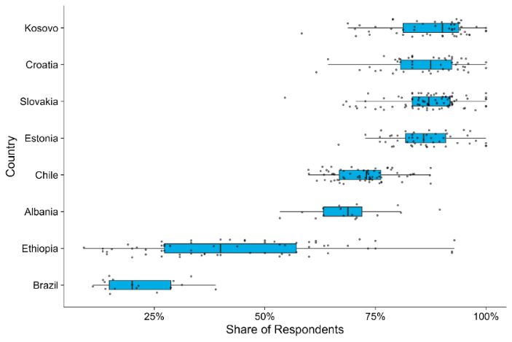
Source: GSPS. Each black dot represents an institution-level share. With minor variation across countries, the survey question is: For your first job in the civil service, do you remember whether you had to pass an interview as an assessment? Note that earlier and more recent cohorts’ recruitment processes may differ.

Financial resources
In the framework, financial resources refers to public institutions’ overall funding levels as well as the public financial management (PFM) processes through which they spend funds. While many international PFM assessments exist – including the Public Expenditure and Financial Accountability Framework (PEFA) and Open Budget Index (OBI) – they often emphasize whether the “form” of PFM processes reflects international best practice (Andrews and others 2014). In reality, many governments do not execute their budgets as planned (Addison 2013). This is often partly due to corruption and rent extraction, but budget execution is also frequently hampered by “passive waste” due to excessive procedures, ineffective training, lack of incentives to minimize costs, or coordination problems (Bandiera, Prat, and Valletti 2009; Rasul and Rogger 2018; Williams 2017). This report’s framework primarily focuses on public institutions’ de facto PFM practices, such as the extent to which institutions draft credible budgets, make prudent fiscal decisions, and access reliable resource flows.
Figure 1.3 Budget execution varies within and across governments, which can be an impediment for public institutions to deliver
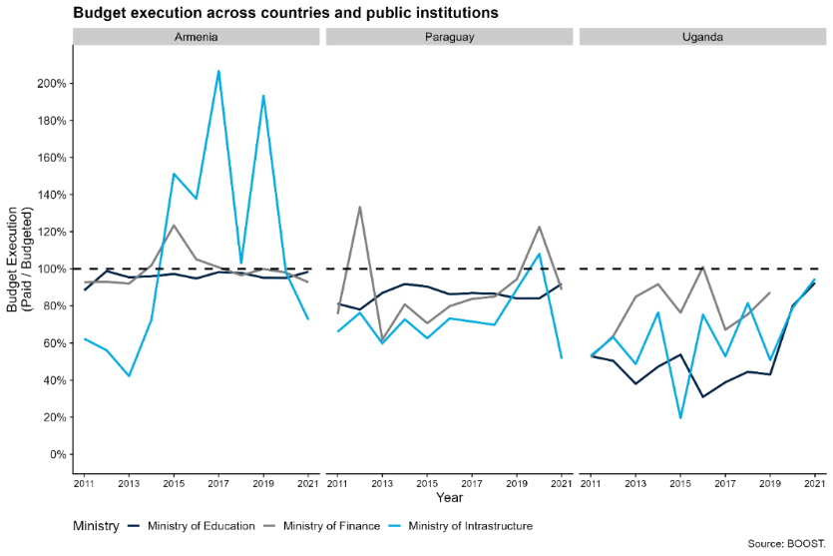
Source: World Bank BOOST data on budget execution across key public institutions in Armenia, Paraguay, and Uganda. These three countries were chosen based on data availability as well as preference for countries from different income levels and regions.
Budget execution varies considerably across public institutions within a single country. Figure 1.3 uses the World Bank’s BOOST public expenditure database to illustrate institution-level variation on budget execution for the ministries of finance, education, and infrastructure in Armenia, Paraguay, and Uganda. While overall budget execution is consistently lower in Uganda than Armenia and Paraguay, there are considerable differences across institutions within each country. Budget execution by Armenia’s infrastructure ministry, for example, is highly variable, while its finance and education ministries’ expenditures are much more closely aligned with their budgets. These large differences are not visible in Paraguay and Uganda. Interestingly, in both Armenia and Paraguay, the education ministries’ budget execution is remarkably consistent over time. Within-country variation in budget execution may reflect differences in institutional capacity across line ministries (i.e., education and infrastructure) and the mix of recurrent or capital expenditures they are responsible for executing. Alternatively, it may reflect cross-country differences in each ministry of finance’s institutional capacity, given finance ministries’ responsibility for allocating funding to line ministries.

Information systems
Information systems refers to how public institutions use government technologies in their core processes and routine operations (e.g., budgeting, human resource management, procurement). These systems are increasingly digital, as digitalizing core government functions reduces costs, minimizes delays, prevents corruption, and facilitates access to information.
The mere presence of information systems is insufficient for effective implementation, so the framework refers to whether information systems are actively used by public officials. Public officials may not use information systems for a variety of reasons, but two primary factors stand out. First, officials may prefer to stick with analog processes if they do not have the knowledge, skills, or resources to fully use digital technologies. For instance, officials may not have a reliable internet connection or sufficient understanding of the relevant software. Second, officials may be hesitant to render their actions in a traceable and transparent format. Digitized processes and systems are more easily captured and analyzed than paper-based processes, which are often obscure and harder to trace. Officials’ failure to use information systems or provide correct information can highlight important political drivers of weak institutional capacity, such as officials’ personal or political interests or their ability to coordinate with other institutions (Eutsler and others 2023; Liu 2023; Sandefur and Glassman 2015; Trinh 2019). As noted below, these incentives are closely related to the transparency of information systems.
Figure 1.4 analyzes the uptake and interoperability of information systems across countries using the World Bank’s GovTech Maturity Index (GTMI). GTMI is a survey of governments’ use of digital technology and various management information systems (MIS). The left panel shows the availability of different systems within governments. While many countries have financial management information systems (FMIS) or customs systems, relatively few – including upper- or middle-income countries – have public investment management systems (PIMS). The right panel underscores that system interoperability in existing systems varies: only about half of low- and lower-middle-income countries with e-procurement systems, for example, can easily exchange information with other government technologies. Similarly, while almost all countries have a human resource management information system (HRMIS), the absence of HRMIS bars in the right panel indicates that these systems cannot exchange information with other government systems. This lack of information exchange may originate in rules about the confidentiality of personnel data, yet it also represents a tradeoff: not being able to connect data across different parts of the government prevents information flow, creates silos, and undermines government coordination and effectiveness.
Figure 1.4 While many countries have information systems, information exchange is limited – undermining these systems’ potential to help public institutions deliver
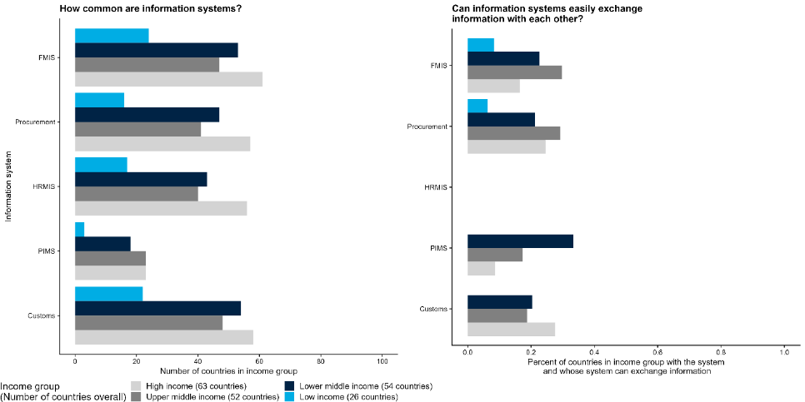
Source: GovTech Maturity Index (2022).

Management practices
To function effectively, public institutions need strong management practices to coordinate and steer their operations and strategic direction. Management practices are distinct from personnel in that they concern not individuals themselves, but how groups or teams of individuals interact within institutions. Three elements are particularly important: strategy and decision-making, or how an institution sets its strategies and distributes decision-making authority to implement them; monitoring and evaluation, or how an institution oversees, evaluates, and incentivizes staff; and organizational culture, or mutually agreed-upon behaviors and beliefs that are not codified or written down. While the first two elements refer to practices often formalized through written rules and processes, organizational culture captures more informal aspects, including esprit de corps, norms, and trust between public officials.
The formal aspects of management practices have been shown to affect institutional capacity in both the public and private sectors. Cross- and single-country studies emphasize how effective management can enhance productivity (Scur and others 2021; Bloom and others 2015; Rasul and Rogger 2018). Effective management practices offer balance between giving public officials sufficient autonomy to perform and innovate while providing enough monitoring to ensure objectives are met. In the public sector, however, management practices are often overly focused on monitoring, while providing limited autonomy or discretion (Rasul, Rogger, and Williams 2021) or overburdening officials with compliance tasks (Dasgupta and Kapur 2020). Honig (2024) argues that “mission-driven” management practices – motivating officials to fulfill their organization’s overall mission – can be more effective than simply monitoring compliance. Using GSPS data, figure 1.5 illustrates a high degree of within-country variation with respect to whether public institutions in Guatemala and Ghana set mission-driven targets. Setting targets is a first step: ensuring implementation requires more than just the intention to implement.
The informal aspects of management practices, or organizational culture, are also crucial for implementation. While the report’s framework takes “culture” at the societal level as given, organizational culture may differ across institutions in the same country and evolve over time. For instance, public sector managers can inspire greater motivation in their personnel through non-financial appeals, such as appeals to the public interest (Honig 2021). This type of prosocial motivation has been shown to improve job performance in a wide range of settings (Callen and others 2015).
Figure 1.5 Institutions within Guatemala and Ghana vary in the extent to which they set targets
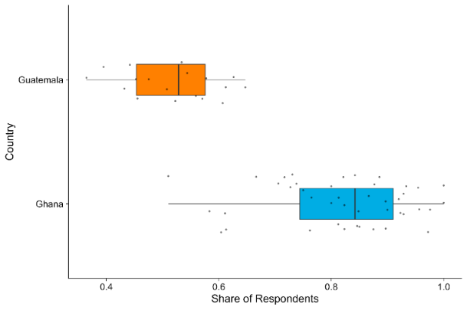

Sources: GSPS. Each black dot represents an institutional-level share. The survey question is: Does your organization have a clear set of targets derived from the organization’s goals and objectives?

Governance dimensions
In addition to strong organizational capacity, effective public institutions also need strong governance. Even with sufficient and capable personnel, generous budgets, sophisticated information systems, and sound management practices, public institutions can still fail to fulfill their mandates in a way that aligns with the public interest. Often, this occurs when institutions work inefficiently, drift from their policy mandates, misallocate public resources, or implement policy in the private interest of some set of internal or external stakeholders. To address these possibilities, the framework emphasizes the importance of three cross-cutting governance dimensions: accountability, independence, and transparency.
The governance dimensions are concerned with institutions’ relationships with external actors, such as politicians, the private sector, and civil society. The framework’s organizational dimensions, by contrast, are internal to each institution. The governance dimensions are motivated by an understanding of policy implementation as a principal-agent problem in which public institutions implement policy on behalf of external stakeholders, such as citizens and political representatives (World Bank 2004). Accountability, independence, and transparency help align institutional incentives with these stakeholders’ interests.

Accountability
Accountability is the appropriate influence of external stakeholders over a public institution’s decision-making. Often, the stakeholder is another public institution within the same government, such as public sector auditors who investigate allegations of abuse of public spending. In other cases, the stakeholders can be private firms, civil society organizations, or the general public. This includes the extent to which firms can meaningfully challenge regulatory decisions that they believe to be biased or unfair. Across these stakeholders, their influence can take multiple forms, including the ability to review the institution’s decisions, enact consequences (negative or positive) for policy outcomes, and provide feedback on performance. When the stakeholder is the general public, accountability can include oversight by citizens and bottom-up mobilization through what is often called the “short route of accountability” (World Bank 2004; Kosack and Fung 2014).
Effective accountability aligns an institution’s interests with those of external stakeholders. This includes preventing it from acting in its own interest or drifting from its mandate (Schillemans and Busuioc 2015). Several examples from the literature illustrate the effect of accountability mechanisms on developmental outcomes. In China, for example, citizen monitoring – in the form of public appeals to regulators when firms violated pollution standards – decreased pollution emissions (Buntaine, Zhang, and Hunnicutt 2021). In Brazil, bureaucrats’ personal connections to politicians increases public accountability and performance (Toral 2023).

Independence
Independence reflects the rules and processes that protect a public institution from undue influence and ensure that private interests do not capture it. While accountability ensures that external stakeholders have influence over policy implementation, independence helps ensure that institutions act without bias and evade institutional capture. The framework specifically considers independence from two sets of actors: politicians and the private sector. Independence from politicians can be enhanced when civil service systems protect some public servants from dismissal or appointment by executive leadership (Grindle 2012). Another example of independence is the appointment process common among high-ranking central bank officials, which requires legislative approval or term appointments spanning consecutive administrations. Independence from the private sector can be strengthened through rules preventing “revolving door” career trajectories where officials alternate between in public institutions and private firms. Similarly, policies prohibiting the exchange of gifts and bribery can reduce the likelihood of private capture and increase independence (Bajpai and Myers 2020).
Independence is particularly important when political institutions are not fully democratic or when private interests have captured the policy arena. When the political process is captured, politicians and other external stakeholders may seek to influence public institutions in ways that do not align with the public interest (Rijkers, Freund, and Nucifora 2017; Canen and others 2023). Moreover, independence measures prevent elected officials from using institutions for their own political gain; evidence suggests that competitive elections may incentivize politicians to extract resources from public institutions to finance political campaigns (Brierley 2020).
Figure 1.6 uses GSPS data to highlight indicators that measure the independence of public institutions’ personnel and management practices. It shows the extent to which personnel recruitment is not perceived to be influenced by political connection, showing wide variation across institutions within the same countries.
Figure 1.6 Large institution-level variation in perceptions of the influence of political connections on recruitment
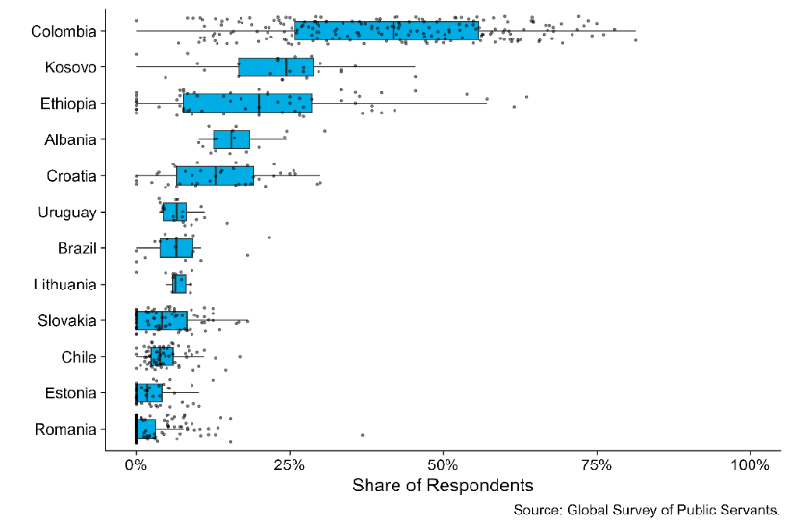
Source: GSPS. Each black dot shows the share of respondents at an individual public institution that agrees that knowing a politician or having political connections is important to get a public sector job. The survey question, with minor variations, is: How important have the following criteria been for you to get your first job in the civil service? Knowing a politician or someone with political links.

Transparency
Transparency is the visibility of a public institution’s decisions and actions to external stakeholders. Transparency is essential for accountability: enforcement mechanisms are only effective if the relevant stakeholders have enough visibility into a public institution’s operations to become aware of infractions or deviations from its policy mandate (Khemani and others 2016). Cross-country analysis finds that countries with more transparent central banks face lower costs of disinflation during economic emergencies (Stasavage 2003). Increased media freedom, a proxy for transparency, is also associated with decreased corruption (Camaj 2013). Transparency is particularly effective at improving outcomes when paired with accountability mechanisms. As a famous example from Uganda demonstrates, public access to information through newspapers deterred local officials from capturing education grants and thus helped improved school enrollment and learning outcomes (Reinikka and Svensson 2011).
The framework’s transparency dimension emphasizes that government information and data should be public, easily accessible, and reasonably easy for citizens to understand. Information systems vary in their degree of transparency, both across and within countries. For six information systems, figure 1.7 shows whether selected income countries have the system and publish system governance information (e.g., audit or compliance reports), have it but do not publish such information, or do not have the system. About 30 percent of low-income countries with customs information systems publish this type of information, while a much smaller percentage with an HRMIS publish it. The same country is often in each of the three categories across different systems. Malawi, for instance, has an FMIS that publishes governance information, but it has no e-procurement system. Such variation in transparency across information systems suggests that some types of government information are more publicly accessible than others, even within the same country.
Figure 1.7 Governments frequently have systems for collecting information but may not publish it, undermining transparency
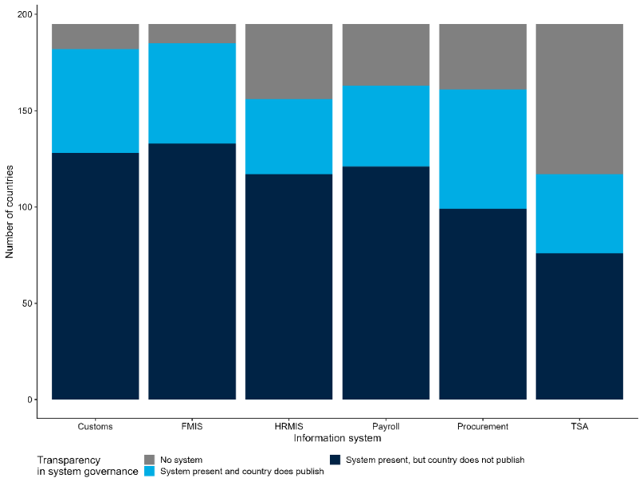
Source: 2022 GovTech Maturity Index (GTMI).
Note: Financial Management Information System (FMIS), Human Resource Management Information System (HRMIS), Treasury Single Account (TSA).

Governance’s cross-cutting role
The framework’s governance dimensions are cross-cutting, in that they apply to each of the framework’s organizational dimensions. For example, reforms designed to strengthen independence cannot target independence in and of itself; instead, the independence of one or multiple organizational dimensions must be addressed. Independence reforms focused on personnel, for instance, may increase the number of public officials recruited through meritocratic processes rather than political appointments. Likewise, independence reforms focused on information systems may seek to render the information collected by digital technologies more neutral, comprehensive, and free from bias (table 1.1).
Table 1.1 Examples of measures for governance dimensions across organizational dimensions
 |  | Organizational dimensions
 |  | Personnel | Financial resources | Information systems | Management practices
Governance dimensions | Accountability | Rewards or sanctions based on performance evaluations or other observable measures of behavior | Release of funds conditional on periodic budget review or audit | Repercussions for data manipulation | Pay-for-performance schemes
 | Independence | Percentage of civil service recruited through meritocratic processes | Whether cash flows are forecasted, monitored, and predictable | Whether those collecting, processing, and securing data are different from those enacting policy | Autonomy in determining staffing and use of budget
 | Transparency | Publicly available organizational structure | Publicly available budget and expenditures | Public documentation on how data is collected and secured | Existence of reporting on monitoring and evaluations

Applying the framework
The framework offers policymakers and practitioners an approach for diagnosing the causes of failure in policy implementation. Table 1.2 presents examples of common problems in policy implementation and illustrates how a public institution’s organizational and governance dimensions might contribute to those problems. While several problems may also originate in the policymaking or institutional design phase, the focus of the report and framework is on identifying institution-level problems at the time of policy implementation. The exact ways in which organizational and governance dimensions contribute to problems will depend on context; table 1.2 simply presents examples to illustrate different possibilities.
Implementation problems can stem from multiple organizational or governance dimensions, highlighting the framework’s interconnectedness. For example, recruitment practices – an aspect of the personnel dimension – may prevent the hiring of sufficiently skilled public officials. But this challenge can also stem from weaknesses in the management practices dimension, such as a lack of sufficiently specialized departments to hire technical staff. As such, a weakness in one organizational dimension can lead to a weakness in another. Weaknesses in an organizational dimension may also be related to governance weaknesses, as table 1.1 highlights. Poor hiring practices, for instance, can stem from the capture or insufficient independence of an institution’s personnel practices.
Once practitioners have identified the most relevant dimensions for a given implementation problem, context-appropriate solutions can be targeted. While the range of potential solutions is wide, the last column of table 1.2 presents selected examples from the literature.

Applying the framework to procurement and regulatory institutions
To demonstrate the framework’s diagnostic potential, the next chapters will apply it to analyze how procurement and regulatory institutions’ capacity may affect outcomes in the private sector. Rather than focusing on the “right” regulatory or procurement policies for a particular sector, this report focuses on the organizational and governance dimensions that may prevent institutions from delivering on their given policy mandates. This approach aligns with existing World Bank Group private sector diagnostics. Box 1.1, for example, examines common procurement and regulatory challenges faced by firms, as identified by Country Growth and Jobs Reports (CGJRs) and Country Private Sector Diagnostics (CPSDs). The diagnostics highlight clear scope for improving institutional capacity in these areas to address domestic constraints to private sector growth, such as conducting basic functions like procuring infrastructure and maintaining strong regulatory environments.
Box 1.1 Public Institutions for Procurement and Regulation – Insights from World Bank Group Diagnostics
Procuring infrastructure contracts
The World Bank Group’s Country Growth and Jobs Reports (CGJRs) and Country Private Sector Diagnostics (CPSDs) often highlight how the effective management of financial resources shapes ability of public institutions’ ability to procure the construction of infrastructure like electricity, roads, and supply chain nodes. The CGJR for Moldova, for example, notes this challenge when emphasizing the need to improve the country’s low quality of infrastructure. The country’s CPSD finds that roads, in particular, have received insufficient investment. The State Road Fund is both insufficiently capitalized and lacks predictability as a source of funding for road maintenance. One recommendation is to establish multiyear payment mechanisms that would enable output- and performance-based contracts to improve road maintenance and operation. As one of Europe’s poorest countries, Moldova may face challenges in allocating additional resources to road maintenance; however, strengthening how existing funds are managed could still improve contracting outcomes.
Regulatory environments
CGJRs and CPSDs also highlight how weak transparency, accountability, and independence in regulatory institutions can create constraints for firms. In Pakistan, both domestic and foreign investors cite corruption in the country’s fragmented regulatory environment as a major impediment to doing business, with the CGJR identifying this as a key barrier to foreign direct investment. Pakistan has at least 12 different categories of regulations and enforcement is irregular, creating opportunities for rent-seeking and corruption. The country’s CPSD therefore recommends strengthening accountability, particularly through the establishment of redress and dispute mechanisms for investors.

Public Procurement
Chapter 2 focuses on public procurement, represents a large share of government expenditure globally, and this spending is primarily concentrated in the construction of important public goods like roads, bridges, and ports. Procuring a quality road network helps decrease transport costs, make supply chains more resilient, and integrate labor markets (Banerjee and others 2020; Shamdasani 2021; Chaurey and Trung Le 2022). Government’s ability to develop high-quality public goods is therefore critical. The adoption of e-procurement systems in India, for example, helped change the composition of winning roads contractors, which helped strengthen the quality of the country’s road network (Lewis-Faupel and others 2016).
Strong institutional capacity is essential to ensure that procurement institutions deliver these benefits. Inefficiencies including passive waste, administrative delays, and “home bias” – a preference for domestic or sub-regional firms over foreign or more distant competitors – can severely increase timelines and costs while simultaneously disincentivizing firms from bidding in the first place (Bandiera, Prat, and Valletti 2009; Garcia-Santana and Santamaria 2024; Conti and others 2021). As procurement contracts directly benefit the firms that win them, it is also important for institutions to rely on efficient allocation practices that are free from corruption, collusion, or undue favoritism. (Mironov and Zhuravskaya 2016; Avis, Ferraz, and Finan 2018; Chassang and Ortner 2019).

Regulation
Chapter 3 focuses on regulations, the laws and formal rules that determine requirements and standards for firms, citizens, and the public sector. They aim to ensure that private sector development aligns with the public interest when markets fail to do so. Developing and developed countries alike are exposed to market failures in the form of weak competition and information asymmetries (Jacobs and Ladegaard 2010). Among other responsibilities, regulations set business registration requirements and fees as well as credit market and labor regulations (World Bank 2016a). Existing evidence suggests that weaknesses in institutional capacity lead to regulatory failures, increasing costs and risks to firms (Estache and Wren-Lewis 2010; Jacobs and Ladegaard 2010).
Regulatory institutions are responsible for several processes that support and enhance the design and implementation of regulations (OECD 2014). For example, financial sector regulatory institutions gather market data on innovative products, such as cryptocurrencies or blockchains, to design regulations that address underlying risks (Government Accountability Office 2023). Regulatory institutions may also engage with firms, including in manufacturing, to gather feedback on regulations, strengthening accountability and improving compliance (Malesky and Taussig 2019).
However, in many developing countries, the design and enforcement of regulations are often constrained by the weak capacity of regulatory institutions (Laffont 2005). A lack of independence due to political interference, for example, can shift priorities toward electoral considerations rather than broader welfare objectives (Müller 2023). Low institutional capacity can also exacerbate regulatory risk and uncertainty, negatively affecting firms’ investment and business decisions (World Bank 2016a). Improving regulatory institutional capacity can therefore enable private sector development in developing countries (Brown and others 2006).

Table 1.2 Using the framework to diagnose potential sources of common policy implementation problems
Implementation problem | Potential sources of problems |  |  |  | Possible solutions
 | Personnel | Financial Resources | Information Systems | Management Practices
Public officials lack the skills for the job  (i.e., regulators do not have the skills to understand a specific market, leading to failures in consumer protection) | Recruitment does not identify the most relevant skills  Independence: Recruitment favors private interests  Accountability: Few repercussions for poor hiring | The institution lacks financial resources to recruit, employ, and retain skilled officials |  | The institution lacks sufficiently specialized departments to tackle technical issues | Limited term lengths as well as public election or joint administrative and legislative appointment of administrative officials (independence of personnel practices) reduces the likelihood of their capture by private interests (Besley and Coate 2003; Martimort 1999; Smart 1994)
The institution lacks information about the nature of the problem it is addressing (i.e., procurement agencies do not track schools’ needs, leading to lack of supplies) |  |  | Information about the problem is not stored in a systematic and interoperable way  Independence: Private actors prevent the collection of data that might expose malfeasance | The institution lacks departments specialized in the nature of the problem it is addressing  Accountability: There are no repercussions for technical failures in program implementation | Officials’ focus on personal or political interests or poor coordination with other institutions can inhibit use of information systems (Eutsler and others 2023; Liu 2023; Sandefur and Glassman 2015; Trinh 2019)  Technology for monitoring expenditures (transparency of financial resources) can reduce corruption and graft (Khemani and others 2016); audits decrease unaccounted-for expenditures (Olken 2007)
Public officials shirk duties (i.e., teacher absenteeism leads to poor learning outcomes) | Career advancement and salary are not appropriately tied to individual performance; multiple individuals responsible for an outcome, leading to free-riding  Independence: personnel are motivated by private interests  Accountability: There are few mechanisms to sanction absenteeism | Passive waste limits resources available to tie salary to individual performance or salaries not paid in a timely manner | Systems to monitor progress on a project do not exist or are not used  Transparency: Public and higher-level officials do not have access to data measuring officials’ effort |  | The potential to contact the top of a public organization is a powerful determinant of bureaucrat performance (Bertrand and others 2020); meritocratic promotions lead to higher worker productivity (Deserranno, Kastrau, and León-Ciliotta 2022); capacity training programs can help improve performance even further (Azulai and others 2020). Target setting can increase productivity and motivation (Locke and Latham 2002), yet it can also crowd out other objectives, inhibit learning, and reduce intrinsic motivation (Ordonez and others 2009); increased autonomy is associated with higher rates of task completion (Rasul, Rogger, and Williams 2021)

Chapter 2. Public Institutions that Procure from the Private Sector
Public procurement enables the private sector by creating important public goods like roads, bridges, and ports that benefit firms across the economy. Quality public goods are also important for a range of other efforts that benefit the private sector, such as improving supply chains, connecting workers to jobs, and reducing transaction costs. Facilitated by public procurement, these public goods are the engines that fuel economic growth. Weak procurement institutions can therefore harm private sector development through poor provision of public goods, inefficient use of public resources, and undue favoritism in awarding contracts.
This chapter applies the report’s conceptual framework to procurement institutions, demonstrating how the framework can be used to diagnose weak institutional capacity. It complements the Independent Evaluation Group’s (IEG) recent report on the World Bank’s 2016 procurement reform, which focused on the procurement rules and processes used in World Bank-financed projects. The second policy recommendation in that report’s conclusion specifically recommends efforts to “strategically strengthen country-level procurement capacity” (World Bank 2024b). Expanding upon that recommendation, this chapter identifies procurement institutions’ policy mandates and then, using concrete examples, clarifies how the framework’s organizational and governance dimensions can be applied and measured. It concludes with a case study illustrating how the framework can be used to diagnose the causes of corruption and waste in public procurement.

Framework for public procurement institutions
To diagnose these issues, figure 2.1 applies the framework to public procurement institutions. As noted in chapter 1, the report defines institutional capacity as the ability to “get things done”: to successfully complete the projects and/or implement the policies described in a given institution’s mandates. This section applies that definition to procurement institutions. It unpacks the framework in figure 2.1, highlights the relevant literature, and presents novel analysis of the available data. While measuring the organizational and governance dimensions of procurement systems is difficult, the available data can be used to explore and diagnose weaknesses across countries, as well as across institutions within the same government. Many of these data are indicators constructed from the Methodology for Assessing Procurement Systems (MAPS) assessments, which are detailed evaluations of country procurement systems.
Figure 2.1 Framework applied to procurement institutions
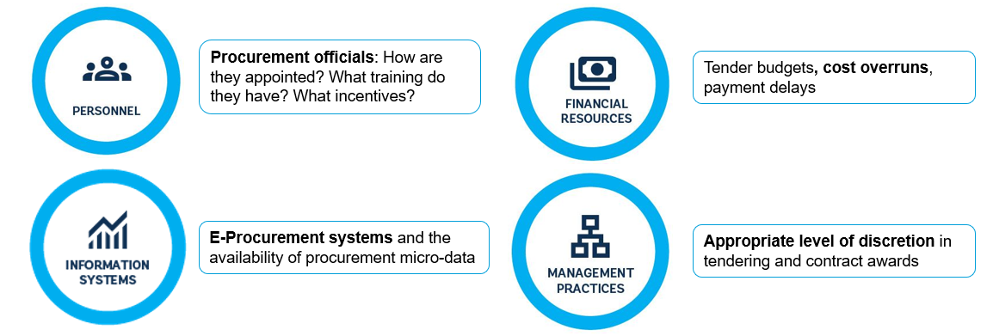
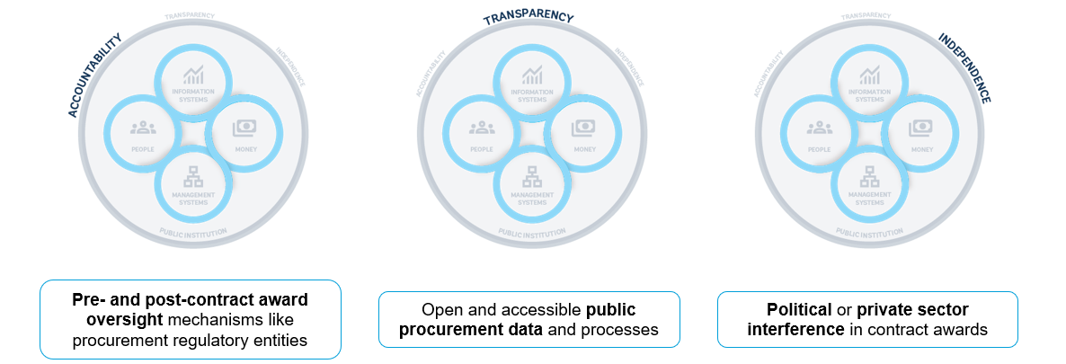
Source: Adapted from Kim, Kumar, Ramalho, and Russell (2026).

Policy mandates
Procurement institutions are spread across different levels and layers of government. Some countries have a central government procurement agency that procures standardized items like medicine or office materials for use across the administration. The procurement of non-standardized goods and services, however, is usually handled by individual units lodged within other ministries, agencies, state-owned enterprises, and other institutions. These units – which may comprise only two or three individuals – are responsible for coordinating with the ministry or agency’s staff about their procurement needs and conducting the necessary purchases. This report takes a broad definition of “procurement institutions” as both the centralized buyers and the more disaggregated units lodged within other ministries and agencies. These two types of procurement institutions are conceptually distinct and have different personnel and responsibilities. That said, the framework outlined in figure 2.1 can be applied to either type.
Most procurement institutions have two key policy mandates, the first of which is to maximize efficiency and economy. Procurement institutions are responsible for purchasing goods and services in a manner that maximizes both quantity and quality while simultaneously minimizing costs. In other words, public buyers make purchases that try to maximize efficiency and economy. “Efficiency” is usually related to transactional efficiency or the timeliness of the procurement process, while “economy” is generally concerned with avoiding unnecessary or unproductive costs (World Bank 2022b).
Procurement institutions’ second key policy mandate is to advance the governments’ broader policy objectives. Increasingly, procurement institutions are asked to focus on strategic objectives like “value for money,” a concept encompassing both fiscal savings and broader socio-economic concerns (World Bank 2022b). The purpose of value for money is typically to pursue ancillary policy goals, such as minimizing greenhouse gas emissions, promoting the growth of small and medium enterprises (SMEs), supporting firms owned by women or disadvantaged groups, and favoring the development of domestic firms. In part due to the significant size of the procurement sector, governments hope to achieve these goals by incentivizing firms through the goods and services they purchase.
It is important to note that these two policy mandates are sometimes at odds with one another. Broader policy objectives like prioritizing sustainable or minority-owned suppliers are often worthy and important goals. However, such suppliers may have higher costs, so awarding them contracts can often contradict efforts to maximize efficiency and economy. Likewise, evaluating the implications of various bids for carbon emissions and environmental harm is time-consuming, so conducting these types of analyses during the contract award stage may jeopardize efficiency. Such tensions emphasize the complexity that public procurement institutions often face.
Procurement outcomes such as unit prices or the quality of goods can vary widely for similar contracts across institutions within a single country. For example, within several different Latin American countries, different institutions pay vastly different prices for the same pharmaceutical products (Mihály, Oliveira, and Regös 2021). There are similar differences in unit prices across institutions in the Russian Federation, even after controlling for potential differences in the quality of the goods purchased (Best, Hjort, and Szakonyi 2023). In these and other contexts, much of the differences in unit prices can be explained by differences in how procurement laws and policies are implemented. In other words, even when faced with the same national procurement frameworks, some institutions are more capable at implementing their policy mandates than others.
Procurement institutions may fail to deliver on these two policy mandates due to a wide range of organizational and governance problems. The procurement process involves many stakeholders, each with their own objectives and priorities. The problems most relevant for each actor will depend on those objectives and their broader operational context. That said, several problems commonly prevent procurement institutions from delivering on their mandates:
- Procurement officials may lack sufficient knowledge of procurement methods or markets to minimize costs while maximizing quality. In these cases, officials may not have sufficient incentives to collaborate with the private sector, which is often crucial for important upstream procurement tasks like researching the market, designing appropriate specifications, and drafting terms of reference.
- Firms, politicians, or other public officials may pressure procurement officials to award contracts to favored firms that may not be the most qualified, increasing costs or decreasing quality.
- Procurement officials themselves may be captured by firms and receive bribes from specific suppliers in return for awarding them contracts.
- Procurement activities may be overly arduous and complex, such as relying on paper-based, manual processes that require approval from many stakeholders. The number and manual nature of these steps can create delays.
- Politicians or other decision-makers may impose unnecessary or unrealistic time constraints that rush steps in the procurement process and hinder effective implementation.

Organizational dimensions

Personnel
Procurement officials manage many complex tasks throughout the procurement process (Decarolis and others 2020). They must first work with their technical colleagues to define the ministry or agency’s needs and translate those needs into tender documents. For instance: What are the specifications of the vehicles the agency wants to purchase, or the requirements of the bridge it wants to construct? Second, procurement officials manage the design of procurement auctions and the solicitation of firm bids. They must then carefully evaluate each bid, which requires an understanding of the market for the good or service in question. Finally, after the winning firm is chosen, procurement officials must design a contract that minimizes the risk of delays and cost overruns.
Each of these steps requires different types of knowledge, implying that the “competence” of procurement officials has a significant effect on outcomes. Procurement agencies with fewer competent officials can pay higher prices, face cost overruns, and experience contract delays. In the Russian Federation, for example, roughly 20 percent of the variation in quality-adjusted prices paid is attributable to the individual officers managing the procurement process (Best, Hjort, and Szakonyi 2023). Likewise, in Italy, prices for similar products vary significantly across different office clerks in the procurement system; the worst-performing procurement units pay approximately 55 percent more than the best-performing units (Bandiera, Prat, and Valletti 2009). This research demonstrates that there is considerable variation in procurement performance across officers, even within the same institutional environment. This variation in effectiveness often stems from weaknesses in the personnel dimension.
Procurement officials’ education and the extent of their procurement-specific training, for example, are important determinants of performance. Unfortunately, many governments do not have specific career paths or roles for procurement bureaucrats. Instead, the procurement function is typically fulfilled by officials who specialize in other policy areas but spend some of their time on contracting. For instance, only 22 out of 95 countries surveyed in a recent World Bank report recognized public procurement as a standalone function in the civil service (World Bank 2023b). Similarly, in France, procurement contracts have long been managed by officials with an exclusively legal background (Saussier and Tirole 2015). While knowledge of legal requirements is important, it is often not enough to optimize efficiency and value for money.
Beyond personnel qualifications, procurement units are often understaffed and overburdened. Even in the United States, public agencies often rely on short-term consultants to manage procurement rather than full-time staff (Liscow, Nober, and Slattery 2023). In addition to frequently lacking the necessary expertise, such consultants do not have the same career incentives for performance as full-time employees. Overreliance on consultants without adequate expertise has been shown to lead to tenders without sufficient detail in key “upstream” procurement tasks like conducting market research, designing appropriate specifications, and drafting realistic terms of reference (Liscow, Nober, and Slattery 2023). Lack of specificity in such early-stage procurement tasks can increase prospective contractors’ perceived risks, leading them to increase their bids and ultimately increasing the cost of the contract.
The capacity of procurement institutions’ personnel varies across countries as well as across institutions within the same country. As noted in chapter 1, the framework’s personnel dimension comprises three components: career, skills, and compensation. Figure 2.2 plots the quality of a country’s procurement personnel, as derived from the MAPS assessments, against a measure of how easy it is to contract with the country’s government, based on a survey of procurement professionals. The latter measure captures procurement outcomes related to a range of relevant factors, such as the number of procurement steps or the timeliness of the procurement process. The figure shows a positive correlation between the quality of a country’s procurement officials and procurement outcomes. In other words, the presence of more capable or higher-quality procurement personnel makes it easier for the private sector to contract with government.
Figure 2.2 Quality of procurement personnel is positively correlated with procurement outcomes
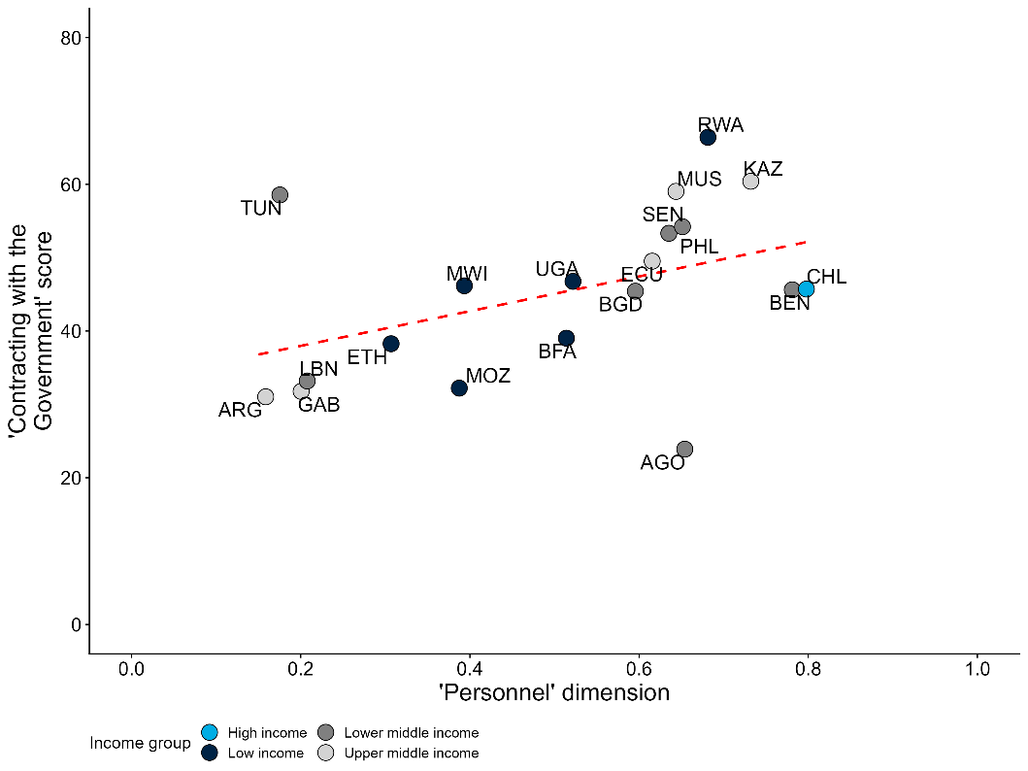
Source: MAPS and Nogues Comas and Mendes dos Santos (2021).
Note: The x-axis is a country-level measure of the quality of procurement personnel derived from the MAPS assessments. The MAPS assessments capture twenty indicators relative to the personnel dimension, reflecting many of the elements cited above as important for competent procurement officials. The criteria are rated as present, partially present, or not present, which are then coded as 2, 1, and 0, respectively. See annex 1 for more details on the MAPS criteria used. The y-axis is a country-level measure of the ease of contract with the government from Nogues Comas and Mendes dos Santos (2021). The indicator combines three dimensions: the steps required to complete the procurement process, the time associated with each step, and the sophistication of e-procurement platforms. The correlation remains significant at the 90% confidence level after controlling for GDP per capita.

Financial resources
The framework’s financial resources dimension focuses on the resources available to procurement units for managing the procurement process, as well as their practices and processes for managing contract expenditures. Given the scale of government procurement, how these resources are managed has an important effect on procurement outcomes and the ability of procurement institutions to realize their mandates. While a large literature examines how auction design affects firm bidding and contract values (Lewis and Bajari 2011; 2014; Decarolis 2018), auctions are generally determined by law rather than individual procurement units. The financial dimension therefore covers two aspects when applied to procurement institutions: the budget and staffing resources for managing the procurement process (rather than the expenditures spent on procurement contracts themselves), and the practices and processes for managing contract expenditures, such as contract design, renegotiations, and payments.
Budget and staffing resources vary widely across procurement units, even within the same government. For example, figure 2.3 uses the World Bank’s BOOST public expenditure database to illustrate this variation across ministries, departments, and agencies in Burkina Faso. It plots the ratio of procurement volume (measured by total investment spending) to the resources spent on the offices managing procurement – including staff and recurrent costs, but excluding contract expenditures. The figure shows significant differences across institutions, with the scale of resources devoted to procurement management often misaligned with the scale of the procurement task. For instance, investment spending in the agriculture ministry far exceeds the resources allocated to its procurement unit, whereas the ratio is much smaller in other entities, such as the infrastructure ministry. Consistent with this report’s emphasis on institution-level analysis, these patterns highlight the importance of examining variation across procurement institutions within a country.
Figure 2.3 Financial resources available to procurement units within Burkina Faso varies significantly
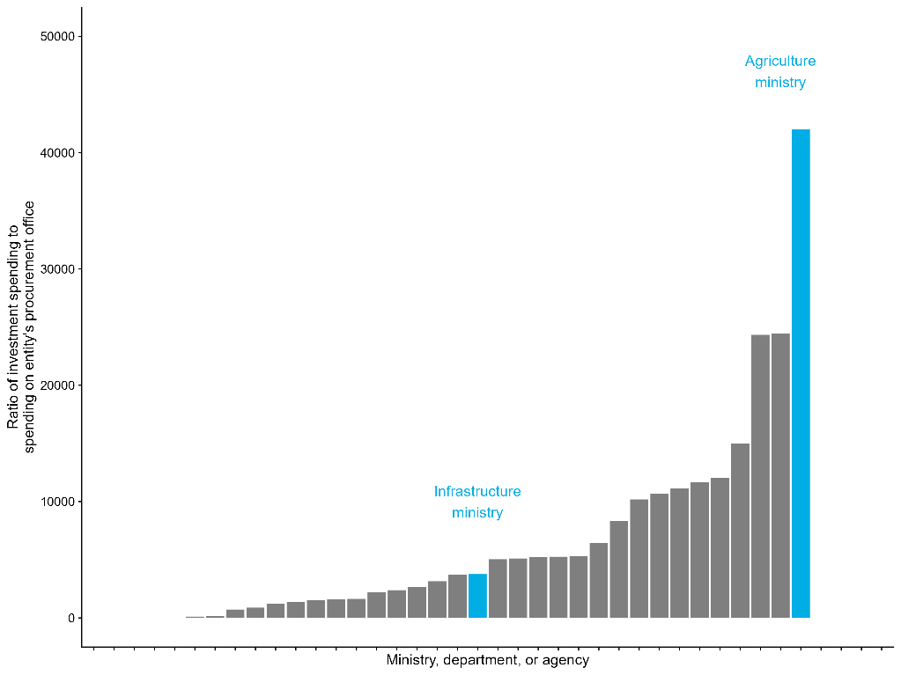
Source: BOOST data.
Note: Each dot represents a different procurement unit within the government of Burkina Faso.
The practices and processes for managing procurement contract expenditures involve four key challenges: cost overruns, contract renegotiations, payment delays, and capacity bottlenecks due to fiscal cycles. First, cost overruns are a persistent problem in public procurement, especially for large-scale public works projects (Decarolis and others 2020). Overruns can occur for a variety of reasons, on both the buyer and supplier sides. With respect to suppliers, firms might provide intentionally low prices to win the contract, or they may mismanage a contract during implementation. From an institutional capacity perspective, cost overruns can also occur when procurement officials underestimate the contract budget. As discussed above, this can be due to officials’ lack of substantive domain expertise in the goods or services being purchased. Particularly in construction projects, design flaws or unforeseen site conditions – such as removing unanticipated rock formations – may require greater costs than foreseen in initial contracts.
Cost overruns typically lead to contract renegotiations, which can greatly increase the cost of the overall contract. Renegotiations impose significant adaptation costs on suppliers, who can respond strategically by marking up the price of their initial bids (Bajari, Houghton, and Tadelis 2014). As such, the practices and processes that contribute to cost overruns and renegotiations can fuel unnecessarily expensive contracts. Well-connected firms may even factor the prospect of renegotiation into their bidding strategies. Energy firms connected to the Indian government, for example, have been found to submit power bids below cost because they know they can renegotiate the contract later when global coal prices increase (Ryan 2020). In this case, the possibility of renegotiations decreases initial contract costs but greatly increases overall costs.
Payment delays are also common in public procurement. While not always the fault of procurement units themselves, such delays often reflect weak integration with the broader public financial management system. Across the 50 countries covered in the 2024 Business Ready report, firms waited an average of 55 days for payment after submitting an invoice, with delays exceeding 100 days in 10 percent of countries. In southern Europe, public entities took five to six months on average to pay for goods and services purchased between 2000 and 2010 (Conti and others 2021). In Brazil, while public finance laws mandate that public buyers pay their suppliers within 30 days after procurement verification, many payments exceed this window (Dahis, Rica, and Scot 2024). The 90th percentile in payment length reaches 42 days. Delays are usually more common in construction projects than in smaller contracts for off-the-shelf goods, but in all cases they can decrease firm cash reserves and corporate investment (Abad and others 2023). Payment delays may also lead firms to exit the market, especially smaller and less experienced firms (Conti and others 2021). Notably, this runs counter to the common policy goal of increasing SME participation in procurement contracts. Favoring SMEs in contract assignment may be counterproductive when payment delays are significant, as these firms tend to be more liquidity constrained. More broadly, this illustrates how potentially beneficial policies can have adverse outcomes when institutional capacity is weak.
Government fiscal cycles can also create capacity bottlenecks for procurement units, especially when public budgets have “use-it-or-lose-it” policies. When a public buyer ends the fiscal year with a surplus, such policies require the buyer to lose that surplus, either by not carrying it forward to the next fiscal year or by reducing the buyer’s subsequent budget. This dynamic can contribute to contract award values spiking toward the end of the fiscal year. In European countries, for example, award values rise sharply in the final quarter and month (Lofaro and others 2023). Similarly, the United States federal government spends 4.9 times more in the last week of the fiscal year than the average weekly level for the rest of the year (Liebman and Mahoney 2017). Such rushed spending risks awarding contracts to lower-quality suppliers and undermining implementation.

Information systems
Public procurement is a complex policy domain with many distinct processes and procedures (Nogues Comas and Mendes dos Santos 2021). Until recently, each step in the procurement process – from distribution of public tenders to the announcement of contract awards – required communication between buyers and suppliers through paper documents. Over the last three decades, however, the diffusion of information systems specific to public procurement, such as e-procurement systems, has streamlined procedures. Figure 2.4 demonstrates the growth of these systems over this period. By 2024, more than 160 countries had e-procurement systems and more than 100 of these systems included online tendering capabilities. While these systems can help procurement institutions implement their mandates more efficiently, reduce costs, and decrease corruption, they are also not necessarily a straightforward or automatic remedy for weak institutional capacity.
The most obvious potential promise of e-procurement systems is their ability to reduce transaction costs at each step of the procurement process. E-procurement systems enable tender documents to be published online, where they are more accessible for potential bidders. This is especially important in many low- or middle-income countries, where public buyers in rural or remote areas may not be near relevant bidders. The implementation of e-procurement platforms in Indonesia and India, for instance, enabled firms outside the buyer’s home region to win contracts (Lewis-Faupel and others 2016). On average, these firms were of a higher quality than firms from the buyer’s home region, which in turn led to improvements in procurement outcomes. Similarly, the introduction of an e-procurement system in Bangladesh increased the number of average bids per contract and increased savings (Blum and others 2023).
Figure 2.4 Many countries have e-government procurement (GP) systems, but system capabilities vary widely
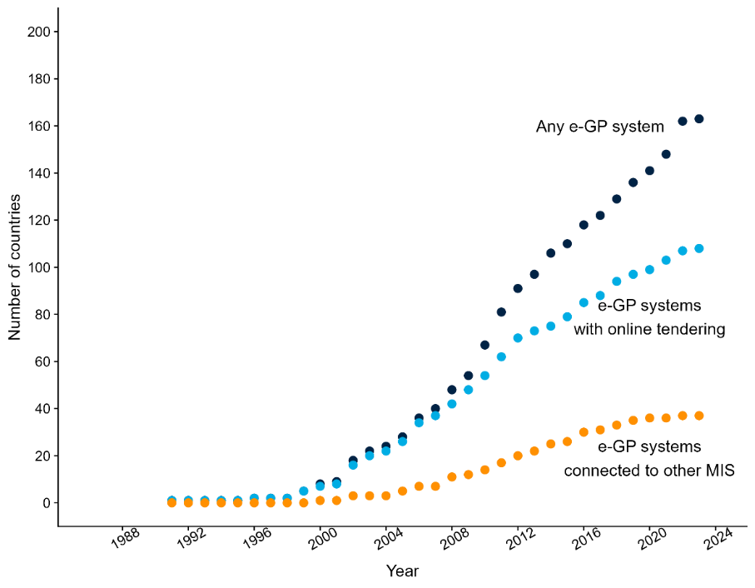
Source: GovTech Maturity Index.
Note: Any e-GP system refers to countries that have any type of e-GP system. Countries with e-GP systems that include online tendering are a subset of this first group. Countries with e-GP systems connected to other management information systems (MIS) are also a subset of the first group.
The electronic management of tender documents and firm bids enables procurement officials to study these documents and award contracts more efficiently. Paper-based analog systems require officials to manually enter information, while many e-procurement systems automatically fill in forms based on information that suppliers submit with their bid. This mechanism decreases processing times and minimizes data entry errors. In Bangladesh, the total time for processing a government tender – from the publication of the tender advertisement to the contract award – decreased by an average of about 16 days following the adoption of an e-procurement system (Blum and others 2023).
In addition to reducing transaction costs, e-procurement systems can decrease corruption that occurs through the procurement process. E-procurement systems increase transparency because they make it easier for firms and civil society organizations to access information about public tenders and contract awards. Increased transparency should enable firms and citizens to monitor and oversee the procurement process more easily. However, empirically isolating the effects of such systems on procurement-related corruption is difficult. While e-procurement systems may save public buyers financial resources, these savings are not easily attributable to reductions in corruption, as they may also reflect efficiency improvements, such as easier access to tenders or faster processing of paperwork (Blum and others 2023; Lewis-Faupel and others 2016).
Despite their many promises, e-procurement systems are not a “silver bullet” for improving procurement institutions’ capacity. As Figure 2.4 highlights, not all e-procurement systems are the same and some systems are more capable than others. While about 160 countries had some type of system by 2024, only about 40 of those systems were directly connected to other management information systems (MIS) outside procurement. Moreover, information systems will not fulfill their promise if bureaucrats have neither the ability nor the incentive to fully use them. There are concrete reasons why public officials often resist using such platforms: if they lack the technical skills to understand and use new technologies, for instance, they may avoid information systems and continue with status quo processes (Adam and Fazekas 2021). Such gaps can be addressed. More maliciously, public officials who serve corrupt political principals or who are corrupt themselves may have strong incentives to sidestep information systems that make their work more transparent. As a result, while many countries have e-procurement systems, there is often significant heterogeneity in how public buyers use them and for what purposes (Schuster and others 2023).
While transparency can help decrease procurement-related corruption or collusion, not all types of transparency are equally effective. In particular, policymakers should carefully consider which procurement information is made transparent as well as when during the procurement process. The timing of transparency is especially important in procurement. Ex ante transparency, or the availability of information before a contract is awarded, is likely more effective at curbing corruption or collusion, since it enables fair competition and empowers firms to monitor tender requirements or bid selection. Ex post transparency, by contrast, or the availability of information after the award, has a much more diffuse audience (i.e., citizens, civil society), and thus has less of a direct stake in monitoring than bidding firms (Bauhr and others 2019).

Management practices
The quality of management in the public sector is an important determinant of government productivity and effectiveness (Rasul and Rogger 2018; Rasul, Rogger, and Williams 2021). Procurement institutions are no different. Management practices that contribute to excessive workloads, for instance, have been found to harm procurement outcomes (Giuffrida and Raiteri 2023). Similarly, in the United States, procurement outcomes are most strongly correlated with the degree of employee cooperation – a finding that is potentially due to public procurement’s complexity (Decarolis and others 2020). As noted, procurement requires many different steps and activities spread across different individuals with different skills, so it is understandable that appropriately coordinating these processes requires effective management.
However, experts debate the extent to which effective management in public procurement requires strict rules or whether procurement officials should have more autonomy and discretion. Autonomy and discretion refer to practices that empower procurement officials with broad decision-making latitude when managing and awarding contracts. These may include the usage of non-price factors in competitive procurement processes or, at the furthest extreme, the ability to award contracts without a competitive auction. Though important for achieving value-for-money, non-price evaluation criteria introduce subjectivity and require more skilled evaluators. From the bidder perspective, greater discretion and more non-price criteria can also create confusion with respect to how bids will be evaluated. In procurement institutions, the extent of discretion is often a function of legal rules that set thresholds, below which officials have more flexibility in contract awards. Beyond such precise legal rules, discretion can also be limited through oversight mechanisms where other officials have opportunities to monitor or review evaluator decisions.
Limiting discretion through rules and oversight is often thought to increase competition for public contracts, thereby decreasing prices and improving procurement outcomes. There is substantial evidence that procurement methods involving higher levels of discretion – such as restricted competition or direct awards – often leads to favoritism, corruption, and worse outcomes. For example, these relatively flexible, high-discretion procurement methods can incentivize public buyers to manipulate their contract values just below the mandated thresholds, thereby avoiding competitive auctions (Baltrunaite and others 2021; Szucs 2024). Contracts awarded through such high-discretion methods are in turn more likely to go to politically connected firms and show signs of worse contract performance (Baltrunaite and others 2021; Caires, Peralta, and Mendes 2023; Szucs 2024).
On the other hand, overly rigid rules and oversight that limit discretion and autonomy may actually constrain procurement officials, who are best placed to increase efficiency (Kelman 1990). Procurement practitioners often view strict price-only rules as limiting flexibility for decisions that may ultimately improve value for money. In particular, discretion may have positive effects if it enables buyers to direct contracts towards trusted suppliers with whom they have long-term relationships. This is especially important when buyers have incomplete information about the quality of bids or the capacity of potential suppliers to successfully execute a contract. As such, increasing discretion can increase the probability that the same firms repeatedly win contracts, even if this does not negatively affect procurement outcomes (Coviello, Guglielmo, and Spagnolo 2018). Experimental evidence from Pakistan, for instance, demonstrates that granting procurement officers more autonomy from monitors actually reduces prices without reducing quality (Bandiera and others 2021).

Governance dimensions

Accountability
Accountability in the context of procurement institutions can broadly be divided into oversight prior to and after contract award. As noted in Chapter 1, this report focuses on accountability mechanisms within government or between government and society, rather than higher-level definitions of accountability, such as elections to hold politicians accountable to citizens. Pre- and post-contract award accountability relationships connect procurement institutions to various oversight actors. More broadly, transparency mechanisms also enable civil society organizations to hold procurement institutions accountable.
Pre-contract award oversight primarily focuses on whether the procurement process is respected, typically through audit and monitoring mechanisms. In Burkina Faso, for example, agents from a specialized agency – the Directorate for the Regulation of Public Procurement and Financial Engagement – are posted within each contracting authority to monitor whether the legal framework is respected (World Bank 2022c). However, the mere presence of internal auditors does not guarantee effective oversight, as auditors may be inefficient or corrupt themselves. In Pakistan, the profile of internal monitors has a significant effect on procurement outcomes, particularly delays; intentionally withholding approval is a key mechanism whereby auditors can manipulate the process (Bandiera and others 2021).
Post-contract award oversight examines whether the winning bidder was selected fairly and in accordance with the tender specifications. In some countries, this oversight is conducted by procurement-specific regulatory entities, such as Uganda’s Public Procurement and Disposal of Public Assets Authority. In Brazil, the Administrative Council for Economic Defense (CADE) has built a dedicated infrastructure for collusion screening in procurement markets. One example is the Brain Project (Projeto Cérebro), launched in 2013, which uses data mining and algorithmic tools to detect suspicious bidding patterns in procurement processes. In other countries, general audit offices serve this function. While the publication of audits can provide incentives that decrease corruption risk (Avis, Ferraz, and Finan 2018), the threat of ex post oversight may also skew the incentives of procurement actors. The introduction of audits in Chile, for example, decreased the use of procurement auctions with more regulated and transparent steps, as these features made the auctions more auditable (Gerardino, Litschig, and Pomeranz 2022).
Another type of post-award oversight enables bidding firms to file an appeal or complaint about a procurement contract they believe was awarded unfairly. This is often managed by a procurement regulatory entity. Firms in Burkina Faso, for instance, can appeal a contract award to the Authority for the Regulation of Public Procurement, an independent regulatory body comprising representatives from the government, private sector, and civil society (box 2.1). In Hungary, a similar procurement regulatory body averaged almost 2,000 complaints per year between 2019 and 2021, covering about 5 percent of the country’s procurement contracts (OECD 2023a). Despite the importance of procurement regulatory entities, however, few – if any – researchers have rigorously studied their effectiveness.
Box 2.1 Accountability in public procurement: Example of Burkina Faso
Most countries have a procurement regulatory agency that plays an important accountability role in public procurement. These entities provide post-award oversight for the procurement system by adjudicating complaints from bidding firms about the procurement process or contract awards. Given the importance and sensitivity of public procurement, these agencies typically enjoy some form of independence, at least nominally, from politicians and other parts of public administration. As public institutions that provide accountability within government, they both exemplify the framework’s accountability dimension and are subject to its application.
In Burkina Faso, the most relevant procurement regulatory entity – the Authority for the Regulation of Public Procurement (ARCOP in French) – has received positive reviews in recent international assessments. Burkina Faso’s 2017 PEFA, for example, provides an “A” rating to the country’s procurement complaint management (PEFA indicator 24.4). Across other Sub-Saharan African countries’ recent PEFA scores, only 25% have received the same rating on that indicator. As such, while ARCOP falls short of international best practice (see below), it is still a useful example of oversight in a context of limited institutional capacity.
As an independent administrative authority, ARCOP has formal financial autonomy from the rest of the government. It is responsible for adjudicating procurement-related disputes as well as training procurement officials, and conducting audits or evaluations of Burkina Faso’s procurement system (World Bank 2022c). When a bidding firm wants to dispute a particular tender or contract award, the firm files an administrative complaint with the System for Dispute Settlement (ORD in French), a committee within ARCOP that reviews procurement complaints and rules on their validity.
As part of ARCOP, the ORD has considerable institutional independence from the rest of the government. The committee consists of twenty-four representatives reflecting different stakeholder groups in the procurement process. To represent the public sector, eight members are civil servants appointed by either the prime minister, the finance minister, the infrastructure minister, or the health minister. Eight other members represent the private sector and are appointed by professional associations or the Chamber of Commerce. The final eight members represent civil society organizations working on governance and corruption. Every complaint before the ORD is reviewed by a three-person subcommittee with one representative from each of these groups.
The presence of representatives from the private sector and civil society in the ORD strengthens ARCOP’s accountability function. Between 2014 and 2021, ARCOP received complaints from more than 1,500 different firms, filed against contracting authorities ranging from ministries to small local governments. While the ORD judged many of these complaints to be valid and ordered the contracting authority to revisit the award, the system is not perfect. It is relatively cumbersome and difficult for bidders to file disputes, resulting in many smaller or less experienced firms being either unaware of or unable to take advantage of the dispute mechanism. That said, the system does enable bidders who believe they have been treated unfairly to have some means of recourse.
In addition to exercising its accountability role, ARCOP is itself a public institution to which this report’s framework can be applied. ARCOP’s own capacity is limited due to shortcomings in its organizational and governance dimensions, limiting its ability to fully deliver on its mandate. The 2022 Methodology for Assessing Procurement Systems (MAPS) assessment of Burkina Faso’s public procurement system, for example, noted that ARCOP does not provide sufficient training for procurement officials or conduct sufficient audits of the procurement system (World Bank 2022c). When it does conduct them, ARCOP’s procurement audits are not exhaustive, focusing only on a small sample of contracts and contracting authorities. While every entity and contract need not be audited, the MAPS assessment makes clear that the current status quo is not sufficient to address potential accountability concerns.
ARCOP’s own institutional capacity suffers in part due to issues related to its financial resources. The entity’s most significant and consistent funding source is a user fee paid by bidding firms when they file disputes with the ORD. While these fees should provide ARCOP some independence from political budget decisions, the 2022 MAPS report notes that they are insufficient, limiting ARCOP’s auditing capacity (World Bank 2022c). These dynamics highlight the interdependence of institutional capacity across entities within the same government. Enhancing the accountability of procurement institutions in Burkina Faso may thus require attention to the institutional capacity of related institutions like ARCOP.

Independence
The ability of procurement institutions to balance quality, price, and strategic policy objectives in their contract award decisions depends on their independence from external pressures. To realize their mandates, procurement institutions require sufficient independence from two types of pressure: private sector firms that hope to win public contracts and politicians seeking to interfere in procurement decisions. Firms face strong incentives to offer bribes to officials in exchange for favoritism in the procurement process, given the significant financial stakes involved (Decarolis and others 2020: Campos and others 2021). Without sufficient independence from private sector interests, the promise of kickbacks can also incentivize procurement officials to award contracts based on the size of bribes rather than quality, price, or policy objectives.
In addition to pressure from potential suppliers, procurement officials often face pressure from their own political principals. Politicians can directly interfere in contract awards to favor firms for personal enrichment, political finance, or both (Boas, Hidalgo, and Richardson 2014; Brierley 2020; Titl, Witte, and Geys 2021). For example, procurement methods with significant discretion have been found to be more likely to result in contracts awarded to suppliers that are connected to the ruling party (Szucs 2024). Politicians can also exert pressure by selecting who serves as procurement officials (Sigman 2023). Even if selection into procurement institutions is meritocratic, politicians may still exert pressure by threatening to rotate officials to undesirable or isolated workplaces (Brierley 2020).
Pressures from firms or politicians can have many negative implications for procurement outcomes. Contracts awarded to politically connected firms often lead to higher prices and the selection of less-productive suppliers (Mironov and Zhuravskaya 2016; Szucs 2024). Political interference in the procurement process can also lead to more contracts with cost overruns (Bellodi, Morelli, and Vannoni 2024) or renegotiations. Across contexts, distributing contracts based on political favoritism rather than criteria related to price, quality, and strategic objectives is associated with poorer procurement outcomes (Brogaard and others 2021). In Bulgaria, for instance, reducing non-competitive procurement practices that suggest corruption could generate savings of about 700 million euros (World Bank 2023c)
Beyond procurement outcomes, insufficient independence also weakens procurement institutions’ ability to support broader private sector development. Corruption stemming from insufficient independence, in particular, impedes private sector growth by discouraging market entry and propping up unproductive firms. In Brazil, for example, municipalities receiving anti-corruption audits experience an increase in the number of firms receiving public procurement contracts (Colonnelli and Prem 2022) and politically connected firms perform worse after the audits. Firms can also be discouraged from bidding for public contracts if they doubt the integrity of the public buyers (Colonnelli and others 2024). In such cases, particularly where buyers are not seen as independent, only well-connected firms willing to pay bribes may choose to submit bids.

Transparency
Transparency in procurement institutions is connected to several organizational and governance components. Strong information systems, for example, can promote transparent procurement processes. While tender advertisements and procurement data are often published in official government gazettes or newspapers, in practice such information can be difficult to access if it is only available in physical publications. Transparency in public procurement is thus most effective when procurement information is made publicly accessible through e-procurement information systems, as described above. While such systems require firms to have internet access, the publication of tender information on digital platforms diversifies the types of firms that bid on public contracts (Blum and others 2023; Lewis-Faupel and others 2016).
Transparency in procurement institutions also supports both accountability and independence. Accountability actors can more effectively hold procurement institutions in check when they have detailed information about their behavior, though which actors benefit depends on the data available. As noted, ex ante transparency – the availability of tender criteria before a contract is awarded – is most effective, because it allows for horizontal monitoring by bidders, who have a strong incentive to monitor contract information and ensure that contracts are awarded fairly (Bauhr and others 2019). In contrast, ex post transparency – the availability of information after the award – is more helpful to citizens and civil society (e.g., non-profit organizations, journalists) as well as national procurement regulators (Duguay, Rauter, and Samuels 2023).
Increasing the transparency of procurement institutions and tender information has many positive effects on procurement outcomes. Publicizing tender information leads to more competition (Coviello and Mariniello 2014) and attracts different kinds of bidders, particularly those who are not based near the public buyer (Lewis-Faupel and others 2016; Kenny and Crisman 2016). There is debate, however, on how these effects ultimately impact contract execution. Some evidence shows that publicizing tender information can reduce the cost of procurement without affecting renegotiations or delays (Coviello and Mariniello 2014). Conversely, transparency may actually restrict the discretion of procurement officials and prevent them from using private information to direct contracts towards suppliers they know will perform well (Duguay, Rauter, and Samuels 2023). The ultimate effect of transparency may therefore depend on the capacity and incentives of procurement officers to identify high-performing firms.
There is considerable cross-country variation in the transparency of procurement institutions. The MAPS assessments capture fourteen indicators related to transparency, including legal rules around the publication of tender opportunities, the publication of information in a structured and machine-readable format, and the availability of procurement statistics. Using data from MAPS, figure 2.5 plots the scores received by a selection of countries on transparency-related criteria as a share of the total potential points. (See footnote 32 and annex 1 for more details on how this measure is constructed.) As with the personnel measure in figure 2.2, Chile’s procurement institutions rank highest on transparency. Several countries, such as Lebanon, Gabon, and Tunisia, need to improve their procurement transparency. Notably, GTMI data indicate that all countries in figure 2.5 except Malawi have an e-GP system. However, the wide variation in MAPS scores suggests that the mere presence of a system does not ensure transparency. Rather, their implementation and effective use – captured in the MAPS indicator – appear to be more important.
Figure 2.5 While many countries’ procurement institutions have e-GP systems, there is wide variation in transparency
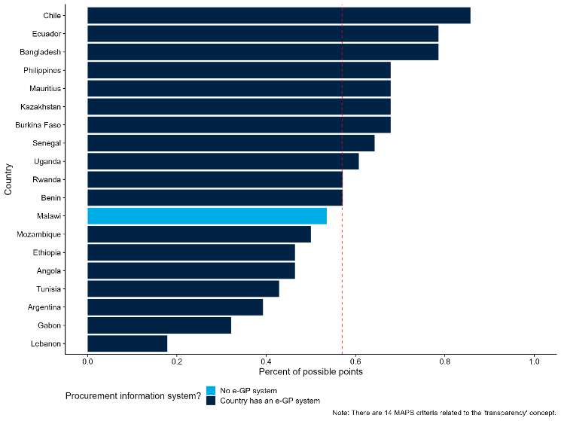
Source: MAPS and GTMI.
Note: The x-axis is a country-level measure of transparency in procurement personnel derived from the MAPS assessments. Please see annex 1 for more details and a list of the MAPS indicators used to calculate the measure.

Institutional challenges in procurement span multiple dimensions
As highlighted above, most capacity challenges in procurement institutions involve multiple organizational and governance dimensions of the framework. Table 2.1 outlines a set of procurement problems with key examples from the literature and practical experience. Given that many issues cut across multiple dimensions, the framework can be useful for identifying relevant interventions or reforms to support institutional capacity in procurement. A critical first step is clearly defining an agency’s mandate, as this guides assessment of which issues and dimensions are most relevant.
For each procurement challenge, table 2.1 notes how it can hinder procurement outcomes like efficiency of government spending, quality of public works, and speed of government contracting. All of the outcomes listed support private sector development; quality public works, for instance, help keep transportation costs low and supply chains resilient. Many outcomes stem from multiple dimensions: the efficiency of government spending, for example, is related to the competence of procurement personnel, their independence from political pressures, and the transparency of procurement processes. Assessing procurement problems in this way helps diagnose where interventions can improve procurement-specific outcomes while also supporting broader private sector development.
Table 2.1 Procurement outcomes are linked to both organization and governance dimensions
Procurement problem | Organizational and governance dimensions | Procurement outcome
Procurement officials do not have sufficient knowledge of procurement methods or markets to minimize costs while maximizing quality. | - Personnel: 20% of the variation in quality-adjusted prices paid in the Russian Federation was attributable to the individual officers who managed the procurement process (Best, Hjort, and Szakonyi 2023).  - Personnel: More competent procurement units are associated with fewer cost overruns (Decarolis and others 2020). | Efficiency of government spending
Procurement officials lack sufficient market knowledge to write tender or contract documents relevant to the market in question. This may attract an insufficient number of high-quality firms. | - Information systems: Implementation of e-procurement platforms in Indonesia and India enabled more high-quality firms to win contracts, thus improving the quality of the ultimate infrastructure that was built (Lewis-Faupel and others 2016). | Quality of public goods
Procurement activities are arduous and complex because they rely on paper-based, manual processes that require approval from many different stakeholders. The number and manual nature of these steps creates delays. | - Information systems: Total time for processing a government tender in Bangladesh decreased by an average of about 16 days after adoption of an e-procurement system (Blum and others 2023).  - Accountability: More competent procurement units are associated with fewer time delays and renegotiations (Decarolis and others 2020).  - Personnel: Identity of individual procurement monitors in Pakistan greatly influenced procurement delays (Bandiera and others 2021). | Speed of government contracting
Politicians or other decision-makers impose unnecessary or unrealistic time constraints that rush steps in the procurement process and hinder effective implementation. | - Management practices: Decreasing officer workloads (i.e., adding one additional officer to a team) leads to a 28% increase in probability that contracts will generate a patent (Giuffrida and Raiteri 2023). | Innovation (i.e., patent filings)
Firms, politicians, or other public officials pressure procurement officials to award contracts to specific, favored firms. These firms may not be the most qualified, thereby increasing costs or decreasing quality. | - Independence: Contracts awarded to politically connected firms result in higher prices and the selection of less-productive suppliers (Mironov and Zhuravskaya 2016; Szucs 2024).  - Transparency: Publicizing tender information reduces procurement costs by increasing the number of bidders (Coviello and Mariniello 2014).  - Independence: Procurement methods that allow for greater officer discretion are more likely to be awarded to suppliers connected to ruling politicians (Szucs 2024).  - Independence: Firms that donate to political campaigns are more likely to subsequently receive a significant increase in the size of contracts they win (Boas, Hidalgo, and Richardson 2014). | Reduced corruption

Applying the framework: Corruption and “passive waste” in public procurement
The inefficient use of public resources, through corruption or other types of waste, is a common problem in public procurement. It is difficult to quantify the extent of financial resources lost through corruption in procurement, but the risks are large and present throughout the procurement process (OECD 2016). In addition to outright corruption, procurement may create “passive waste” – administrative inefficiencies that do not accrue any direct benefits to officials but that, if removed, would make all procurement officials better off (Bandiera, Prat, and Valletti 2009). Examples include excessive red tape or poor coordination. The report’s framework offers a useful tool for understanding these and similar challenges faced by procurement institutions. Importantly, the framework emphasizes that potential solutions must approach these problems from multiple angles and will inevitably involve trade-offs.
While procurement-related corruption is often treated as a personnel issue, the framework highlights why the problem is more complicated. A commonly proposed solution is to change who is appointed as a procurement official, based on the assumption that more professional personnel with higher ethical standards will be less likely to misappropriate financial resources (World Bank 2023b). Another common approach is to professionalize the procurement cadre through training programs. In addition to helping address corruption, more qualified officials may also reduce passive waste, as they may be better equipped to scrutinize complex bids and minimize costs (Best, Hjort, and Szakonyi 2023). While these approaches can help address corruption and passive waste, the framework’s other dimensions show that personnel is only one part of the solution.
For instance, addressing procurement-related corruption almost always requires considering procurement officials’ independence from political pressures. As noted, procurement institutions face multiple pressures that exacerbate corruption risks. Extracting financial resources through procurement, for example, can serve as a channel for politicians to finance campaigns, leading them to pressure even highly skilled officials to award contracts to firms that will provide kickbacks or campaign contributions (Sigman 2023). Even professional bureaucrats hired through meritocratic systems can yield to pressure from their political principals, particularly if those politicians can transfer them to undesirable posts in rural, isolated areas (Brierley 2020). Addressing corruption therefore requires attention not only to personnel aspects – career, skills, and compensation – but also to the extent of political control over these features of the procurement system.
Likewise, strengthening management practices within procurement institutions is another important tool for addressing corruption and passive waste. Policymakers concerned about the misuse of public resources may impose strict controls on procurement officials, limiting their discretion through formal rules and subjecting them to close oversight. Such reforms could be justified, given evidence that discretion in procurement can lead to corruption (Baltrunaite and others 2021; Szucs 2024). However, even if such efforts decrease corruption, they may also increase passive waste. Greater oversight and more rules can overemphasize compliance at the expense of outcomes – for example, by preventing officials from contracting quickly with capable, high-performing firms. Some degree of discretion, therefore, may improve procurement outcomes (Coviello, Guglielmo, and Spagnolo 2018).
The optimal level of discretion likely depends on specific personnel characteristics, as well as governance quality and contextual factors. Constraints on discretion are typically more effective in low-capacity settings, while greater discretion may be optimal in high-capacity environments. Importantly, there can be substantial heterogeneity across institutions, even within the same government. In Italy, for example, increased procurement discretion led to favoritism primarily among public buyers with less qualified staff and less transparent processes (Baltrunaite and others 2021). Evidence from a randomized control trial in Pakistan similarly shows that greater autonomy reduced prices and delays when procurement officers were overseen by inefficient monitors (Bandiera and others 2021). This suggests that expanding discretion can improve efficiency and reduce passive waste when delays stem from supervisors rather than officers. These strong links between the framework’s personnel, independence, and management practices elements highlight that addressing corruption and passive waste in public procurement requires a multi-faceted approach. Focusing on a single dimension may provide only a partial remedy – or even unintended negative outcomes.

Chapter 3. Public Institutions that Regulate the Private Sector
Regulations are laws and formal rules that influence how markets operate. Regulations establish requirements and standards for goods and services, affecting the behavior of firms, consumers, and public institutions. Regulations influence (and often constrain) the behavior of firms and consumers across multiple areas of economic activity. Whether in business registration or bankruptcy laws, regulations have profound consequences for private sector development and economic growth (Klein and Hadjimichael 2003). For example, regulations affect business entry decisions by defining the requirements to open a business. While these business regulations may intend to protect consumers from firm malpractices, they may also inadvertently protect incumbents firms (World Development Report 2024). Thus, designing and enforcing regulations that enable private sector development, while protecting the public interest, is a complex task.
Regulations can enable private sector development, but this requires regulatory institutions capable of designing and enforcing them well. A vibrant private sector is characterized by healthy competition between firms, as well as by high quality goods and services for consumers (Jacobs and Ladegaard 2010). Well-designed and enforced regulations can protect and even strengthen these market characteristics by reducing barriers to entry, deterring cartel formation, and making information available for consumers (World Bank 2016a, Licetti and others, 2021). However, the benefits of regulations depend on the capacity of the regulatory institutions that design and implement them (Laffont 2005, Estache and Wren-Lewis 2010, Jacobs and Ladegaard 2010). Regulatory institutional capacity manifests itself in various dimensions. For instance, regulators’ expertise enables regulatory institutions to monitor and interpret market developments accurately, designing regulations that adequately address changing technological conditions. Additionally, institutional independence prevents capture by incumbent firms, which may otherwise pressure regulatory institutions to enact regulations that restrict market entry (Müller 2023, Slimane and Abir 2021).
This chapter applies the report’s conceptual framework to regulatory institutions. Drawing on empirical evidence and global data, the chapter demonstrates how it is possible to implement a data-driven assessment of the capacity of regulatory institutions. The chapter begins by identifying regulatory institutions’ policy mandates and then shows how the framework’s organizational and governance dimensions can be applied and measured using data and country examples. The chapter concludes by applying the framework to the utilities sector, with a case study on telecoms regulatory agencies in Peru.

Framework for regulatory institutions
Regulatory institutions’ organizational and governance dimensions shape their capacity to achieve key policy mandates. For example, the governance dimension of accountability – in the form of consultations with regulated firms – improves firm compliance with manufacturing regulations (Malesky and Taussig 2019). Likewise, organizational issues such as leadership vacancies in regulatory institutions, as well as limited staffing – key aspects in the personnel and management practices of this report’s framework – cause delays in the implementation of regulations (Carpenter 2002; Bolton, Potter, and Thrower 2016). This report focuses on the organizational and governance dimensions that shape the capacity of regulatory institutions to achieve their policy mandates (Figure 3.1).
Figures 3.1. Overview of organizational dimensions and governance dimensions in regulatory institutions
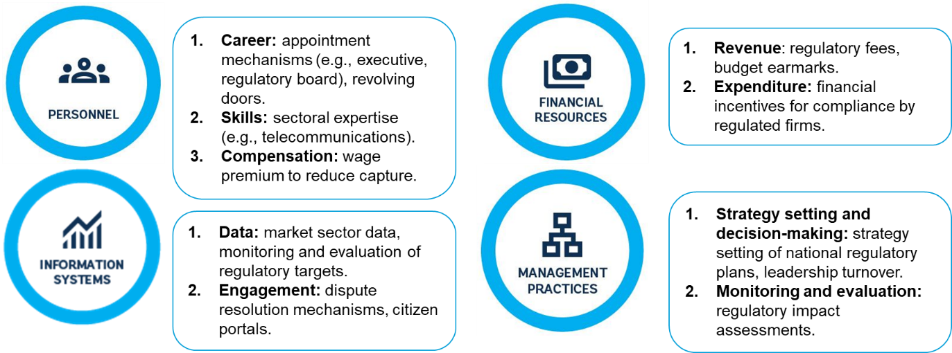
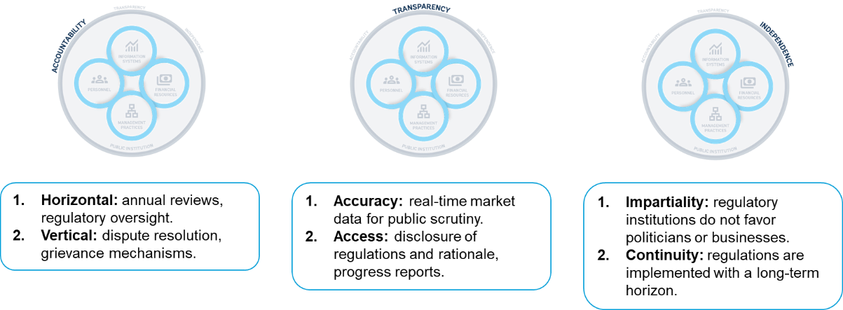
Source: Adapted from Kim, Kumar, Ramalho, and Russell (2026).
The capacity of regulatory institutions varies across countries in the same sector and across sectors in the same country. One way to assess this variation is to examine how regulatory frameworks are implemented in practice, assessing the quality of public services that support firms with regulatory compliance (World Bank 2024a). Data from the World Bank Business Ready Dataset include four topic areas that are especially associated with regulations: business entry, market competition, financial services, and utility services. Figure 3.2 shows that the quality of these public services vary substantially across countries in the same sector and across sectors in the same country. For example, New Zealand and Singapore are top performers in the implementation of their regulatory frameworks on average, yet they display substantial variation across sectors in the same country. Across the sample, implementation gaps are generally higher in financial services and business entry than in utilities and market competition.
Figure 3.2. Implementation gap in regulatory frameworks varies across countries and their sectors
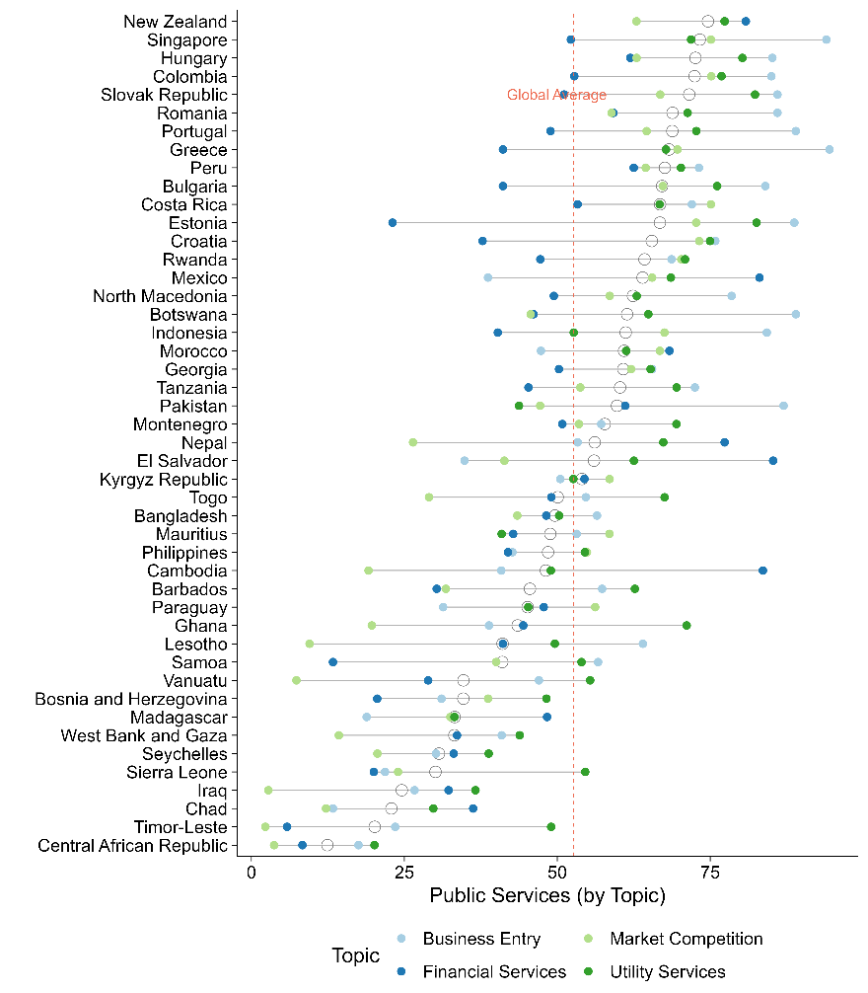
Source: Authors’ elaboration based on data from Business Ready 2024. Public services are defined as the set of “government-provided services that support regulatory compliance, including institutions and infrastructure that enable business activity.” Higher scores denote better public services.

Policy mandates
Regulatory institutions have three main policy mandates: promoting competition, improving the quality of goods and services, and ensuring accessibility. These regulatory mandates at times complement one another. For example, promoting competition is often a means to an end, improving the quality of goods and services due to innovation from new entrants, or enhancing accessibility through lower prices (World Development Report 2024). Given these synergies, competition is typically a core policy mandate for a subset of regulatory agencies known as competition authorities. Policy mandates vary according to the country, sector, and policy priorities and are determined in the policy arena (Jacobs and Ladegaard 2010). Regulatory institutions design and enforce regulations to achieve these mandates, and regulatory institutional capacity is defined as the ability to do so. Sometimes, these mandates lead to trade-offs. For example, setting and enforcing quality standards can lead to higher prices and reduced access. Ultimately, managing these complementarities and trade-offs requires context-specific and fine-tuned adjustments by capable regulatory institutions (Jacobs and Ladegaard 2010).
Regulatory institutions play an important role in promoting competition in markets. Some sectors, such as utilities, are vulnerable to natural monopolies. Regulatory institutions like competition authorities can address this by implementing regulations to prevent the abuse of natural monopoly power and by attempting to emulate the competitive market setting (Joskow 2007). Typically, promoting competition requires the design of regulatory policies that reduce anti-competitive practices, complemented by price-setting (e.g., a price cap regulation, as described in Laffont and Tirole 1993). The World Bank regularly applies the Markets and Competition Policy Assessment Toolkit to identify regulations that limit competition and induce distortions in the market, providing an evidence-based approach for regulatory reforms. In some cases, reducing regulations may promote competition. For example, business sectors in the Philippines with fewer regulatory barriers to competition are more likely to adopt ICT technologies (World Bank 2016b). On the other hand, regulations such as exclusivity rights limit firm entry (World Bank 2018).
Regulatory institutions also play an important role in improving the quality of goods and services. Information asymmetries between firms and consumers can occur when there is uncertainty regarding the underlying quality of goods (Akerloff 1978). In these cases, regulations can improve access to information for consumers and empower them to choose higher-quality goods and services. For example, regulatory institutions can require food producers to provide accurate and reliable information on nutritional facts (e.g., caloric value, macronutrient contents) that enable consumers to make informed decisions on their dietary intake (Christoph and others 2018). Regulatory institutions can also implement regulations that ensure food safety and quality standards for goods and services (Kotsanopoulos and Arvanitoyannis 2017, World Development Report 2025). In financial sector regulation, banking regulators may establish rules that protect consumers from fraud or deception (Levitin 2012). However, onerous standards can be prohibitively costly for firms, reducing incentives for firms to enter the market and thus reducing competition. These dynamics underscore the importance for regulatory institutions to assess trade-offs across mandates when seeking to improve the quality of goods and services in the private sector.
Regulatory institutions further influence who can access private sector goods and services. Digital technologies such as the internet and mobile phones are often concentrated among consumers with higher income, creating a digital divide (World Bank 2016b). In these contexts, telecoms regulatory institutions can ensure access to populations that would otherwise be excluded. For example, a telecoms regulator can set regulations that require mobile providers to provide coverage to communities in remote areas. Similarly, an energy regulatory institution may require electricity providers to connect underserved communities (e.g., rural areas) even if that is unprofitable to firms (Kelly and Rossotto 2012). These potential trade-offs between accessibility and firm profits need to be carefully assessed, so that firms still choose to join the market despite access-enhancing regulations. At the same time, policy mandates such as promoting competition and ensuring access can complement each other. Prices of goods and services are one determinant of accessibility: generally, lower prices increase access, so regulatory institutions should ensure that competition between firms drives prices down (figure 3.3).
Figure 3.3. Countries with regulations that reduce competition have higher prices in mobile services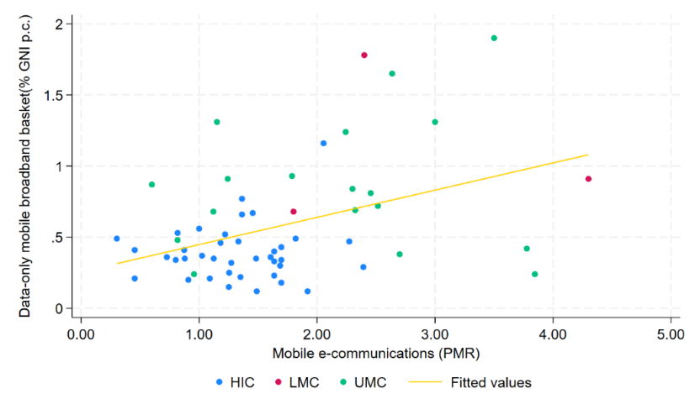
Source: Authors’ elaboration using OECD Product Market Regulation 2023-2024; World Bank Group-OECD Product Market Regulation and International Telecommunication Union 2024.
Note: PMR scale 0-6 (6 more restrictive). The indicator evaluates regulatory restrictions on market entry and conduct, as well as the extent and quality of public ownership, across eight network sectors: electricity, natural gas, air, rail, road, water transport, and fixed and mobile telecommunications. PMR data for Ecuador, Kazakhstan, Kosovo, Malaysia, Moldova, Montenegro, Russian Federation, Serbia, the Philippines, and Viet Nam are based on the WBG–OECD 2018 PMR scores. These were collected between 2018 and 2022 using the previous methodology and should therefore be interpreted with caution. HIC = High-income countries; UMC = Upper-middle-income countries; LMC = Lower-middle-income countries. The data-only mobile broadband basket (2GB, 3G, and above) refers to the cheapest non-promotional option providing at least 2 GB of high-speed data over a 30-day period from the operator with the largest market share. The data-only mobile broadband basket is expressed as a share of GNI per capita.
Regulatory institutions can fail to deliver their policy mandates due to a wide range of organizational and governance challenges. Several problems commonly prevent regulatory institutions from delivering on their mandates:
- Politicians appoint regulators who tilt the rules in favor of certain firms and private interests to the detriment of consumer interests.
- Regulators lack sufficient knowledge of markets to address market failures without undermining private sector development and market competition.
- Regulatory institutions do not have sufficient incentives to collaborate with the private sector, which is often crucial for understanding regulations’ secondary and potentially unintended impacts on firms.
- Monitoring compliance with regulations can be arduous and complex due to insufficient data and inadequate information systems to manage that data.
- Politicians or other decision-makers can cause disruptive changes in leadership at regulatory agencies, making it difficult to approve new regulations to address technological or market changes.

Organizational dimensions

Personnel
Personnel is a key dimension to consider when assessing the capacity of regulatory institutions. Regulators need to understand complex markets, such as those in the financial and electricity sectors. These are often very large and profitable markets where small changes in regulations can have a significant monetary impact for the firms involved. It is therefore crucial that recruitment, promotion, and dismissal practices are structured in ways that prevent conflicts of interest between regulators and regulated firms, providing them with sufficient independence to carry out their intended functions. Additionally, regulators should be adequately paid and have the qualifications needed to understand the markets they regulate.
Recruitment and dismissal processes for the heads of regulatory institutions can set the incentives for the whole agency. In general, heads of regulatory agencies tend to be appointed by heads of government, particularly among telecoms regulators (figure 3.4). While this arrangement can improve policy alignment with government priorities, it also constrains regulatory institutions’ ability to pursue their mandates independently of short-term political interests. For example, a head of government might appoint regulatory heads based on loyalty rather than their ability to implement agency mandates impartially. To ensure a degree of independence between regulatory institutions and political priorities, some countries require that heads of agencies be appointed by a board or reviewed by the legislature. The latter arrangement is rare: according to 2023 data on OECD member countries from the Governance of Sector Regulators, legislatures are involved in only 27 percent of regulatory leadership appointments (Van Langen and others, 2025). Flexibility in dismissing regulators can help address cases of undue influence or partiality in regulatory decisions that favor specific firms. However, it also risks enabling politically motivated dismissals that prioritize short-term priorities rather than long-term stability and market competitiveness (OECD 2017).
Figure 3.4 Telecoms regulatory institutions’ heads are appointed by the head of state in nearly half of all countries | Figure 3.5. Countries with higher income tend to have more specialized staff personnel in banking regulators, but there is substantial overlap across income groups
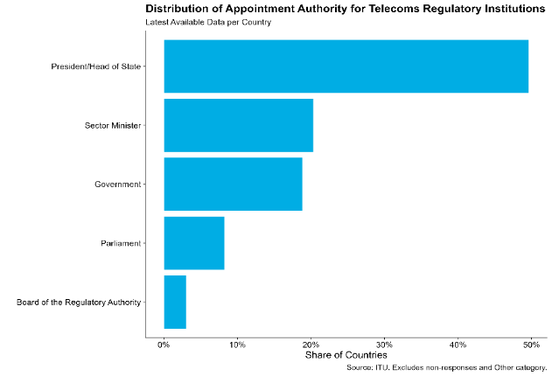 | 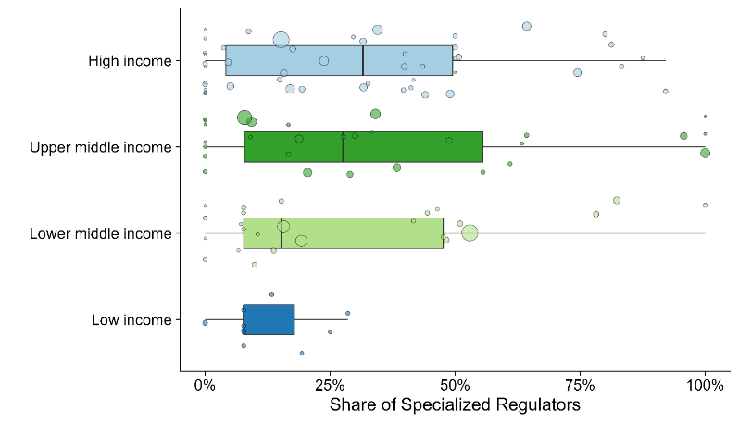
Source: International Telecoms Union.  Note: Most recent data available for country respondents. Self-reported answers from telecoms authorities that are part of the International Telecoms Union, a UN agency that specializes in digital technologies. The sample includes 133 countries. | Source: Authors’ elaboration based on data from the Bank Regulation and Supervision Survey (2021) and World Bank.  Note: The share is computed as the total number of professional bank supervisors specialized in bank functions (e.g., treasury) or risks (e.g., credit markets), divided by the total number of supervisors (excluding support functions and management). The size of each circle is proportional to the total workforce in the regulatory institution. Country income groups reflect the latest classification provided by the World Bank.
Regulatory institutions should be staffed by personnel with adequate sectoral expertise. Given that sectors are complex and regulations can have unintended consequences, personnel in regulatory institutions need expertise to design and enforce regulations that are appropriate for their sector (Stern 2000). In financial regulation, for example, regulators should have relevant skills and specialization in specific bank and risk functions. There is substantial cross-national variation in the share of specialized banking regulators, even when accounting for country income levels (figure 3.5). While countries in the high-income group tend to have more specialized staff, the median share is below 50 percent and the range is wide. Generally, regulatory institutions in low-income countries have less specialized staff.
Given the skills requirements and the risks of capture, compensation is a key consideration for ensuring the appropriate staffing of regulatory institutions. To attract and retain competent personnel, regulatory institutions typically pay salaries with a positive wage premium with respect to prevalent wages in the public sector. This was the strategy used by regulatory institutions in Brazil, which pay comparatively higher salaries than other public institutions in the federal government (Santos, Brandão, and Maia 2015).

Financial Resources
Regulatory institutions’ funding streams comprise budget earmarks, regulatory fees, or a mixture of both (World Bank 2019a). Each of these financing mechanisms has implications for regulatory institutions’ incentive structures. If regulatory institutions rely on fees, for example, they may overregulate in an attempt to increase their budget. By contrast, budget earmarks provide more stability across fiscal years and enable institutions to separate their funding needs from their policy mandates.
For OECD countries, these financing mechanisms vary across sectoral regulatory agencies and income levels. Figure 3.6 provides an illustration. Among telecoms regulatory agencies (panel A) in countries in the lower-income tercile, for instance, 60.0 percent rely exclusively on regulatory fees while countries in the upper tercile rely on a blend of fees (26.7 percent) and earmarked budget (53.3 percent). Rail regulatory agencies (panel B) generally rely less on fees and more on national budgets, with slightly higher shares in higher-income terciles (64.3 percent in the upper tercile). Air transport regulatory agencies (panel C) instead rely predominantly on mixed financing mechanisms, although budget funding remains common in middle-tercile economies. Energy regulators (panel D) consistently rely on regulatory fees across income groups, with fees accounting for 53.3 percent in the lower tercile and 40 percent in both the middle and upper terciles. Overall, telecom and energy regulators tend to draw a large share of resources from regulatory fees, whereas rail regulators rely mostly on national budgets and air transport regulators exhibit more variation.
Figure 3.6. Financing mechanisms vary across income levels and types of sector regulatory agencies
Panel A. Telecoms regulators | Panel B. Rail regulators
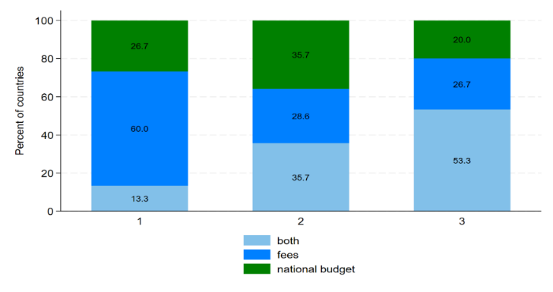 | 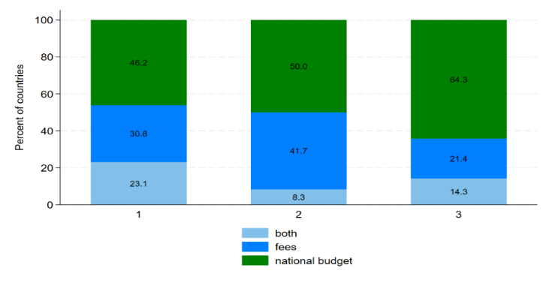
Panel C. Air transportation regulators | Panel D. Energy regulators
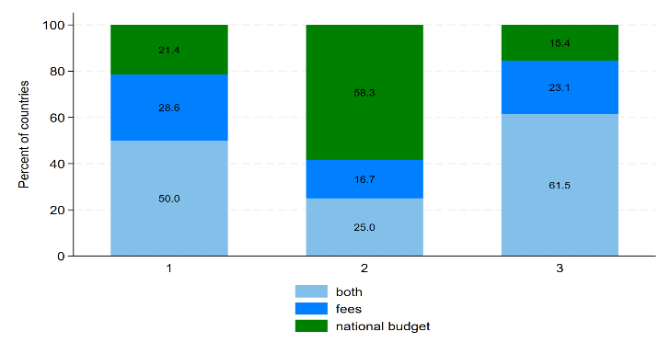 | 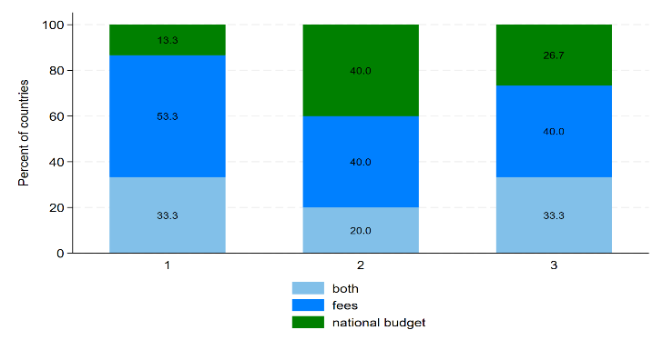
Source: Authors’ elaboration based on data from the OECD’s 2023 Indicators on the Governance of Sector Regulators.
Note: Numbers in the x-axis correspond to each tercile of national GNI per capita for respondents, which include OECD member countries and select non-member countries (e.g., Brazil). Sample includes 45 countries.
Beyond the type of financing mechanism, another key consideration is the adequacy of funding. Following the 2008 global financial crisis, heightened scrutiny of banking supervisors raised concerns about the adequacy of their institutional arrangements to regulate a financial services market that had grown in complexity and scale. Examples like these underscore that regulatory institutions need adequate funding, authority to spend it effectively, and the capacity to collect revenues. Levy and Spiller (1994), for instance, find that regulatory institutions with adequate public financial management are associated with credibility and long-term investments in the enforcement of regulatory frameworks.

Information systems
Regulatory institutions’ information systems include data on the market characteristics needed to inform the regulatory process as well as websites that make regulations and other documents publicly available. Regulatory institutions regulate a dynamic and evolving market. To ensure that their knowledge of the market is accurate and up-to-date, regulatory institutions require information in the form of data (OECD 2021). Data enables monitoring of market trends, technological developments, and compliance with existing regulations, including target metrics. Recent evidence suggests that automated data gathering on air pollution can enhance the quality and accuracy of information for environmental regulators: Greenstone and others (2022) find that the introduction of automated air pollution monitoring stations in China reduced misreporting in the air pollution reports produced by local government officials.
As markets are complex, regulatory institutions need to leverage multiple data sources. This, in turn, requires interoperable data sources so that regulatory institutions can integrate multiple sources and build a comprehensive picture of market conditions. Business Ready gathers data on the interoperability of information systems across multiple topics, including business entry and financial services (figure 3.7). Countries such as New Zealand, Rwanda, and Croatia tend to have more interoperable information systems, but still show variation across sectors and services (e.g., business entry). In Rwanda, information systems on business entry (e.g., company information and identifiers) are set up for automated data exchanges across agencies more often than in the financial sector (e.g., centralized registry of bank collaterals). In some countries, such as Mexico, the difference across regulatory institutions in the same country is almost as large as the average difference across countries, providing further evidence that government institutions are far from homogeneous.
Figure 3.7. The interoperability of information systems vary within the same countries and across sectors and services
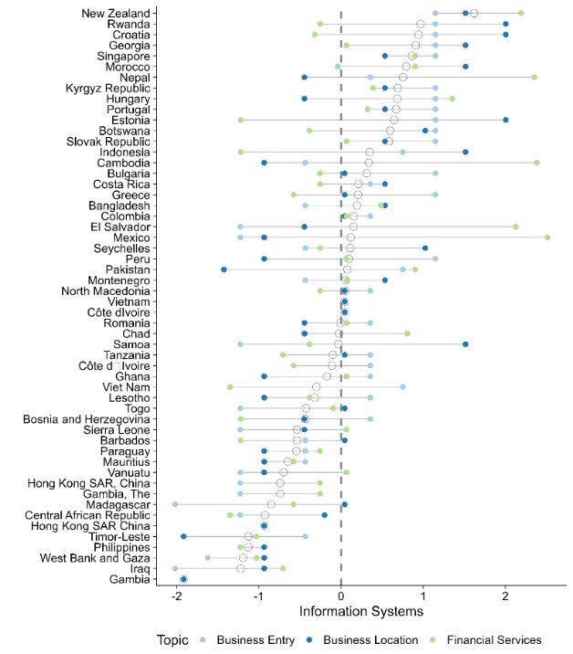
Source: Author’s elaboration based on data from Business Ready.
Note: Each circle represents a different sector or topic in the Business Ready data. Indicators are scored based on the presence of good practices in the interoperability of information systems, such as a centralized and integrated data registry. Indicators for each topic are z-scores, computed by subtracting the topic-specific mean and dividing by the standard deviation, to account for differences in the scoring of indicators.

Management practices
Regulatory institutions benefit from effective management practices, particularly in strategy setting and monitoring and evaluation. Setting a strategy and committing to it for the medium- to long-term is an important foundation for regulatory institutions. Strategic management requires clear objectives and plans to guide institutions’ internal functioning and establish different roles and responsibilities, complemented by mechanisms for coordination with relevant public institutions (OECD 2014). These management practices are mutually reinforcing: role clarity enables other institutions to identify where coordination is relevant, while coordination can reduce role duplication and clarify a regulatory institution’s scope. Notably, regulatory overlap and duplication are commonplace. A study of tourism in Cusco, Peru, for example, found significant overlap in the mandates of government agencies regulating tourism, increasing the cost and complexity for travel agencies to acquire their business licenses (World Bank 2019c). Strategy setting is generally the responsibility of a regulatory institution’s head, who ensures institutional alignment with a forward-looking vision. Evidence suggests that strategy setting as a management practice varies across countries and types of sectoral regulatory agencies (figure 3.8).
Figure 3.8. Sector regulatory agencies in OECD countries publish and report their strategic objectives consistently
Within-country and across-sector variation in the setting and disclosure of strategic objectives
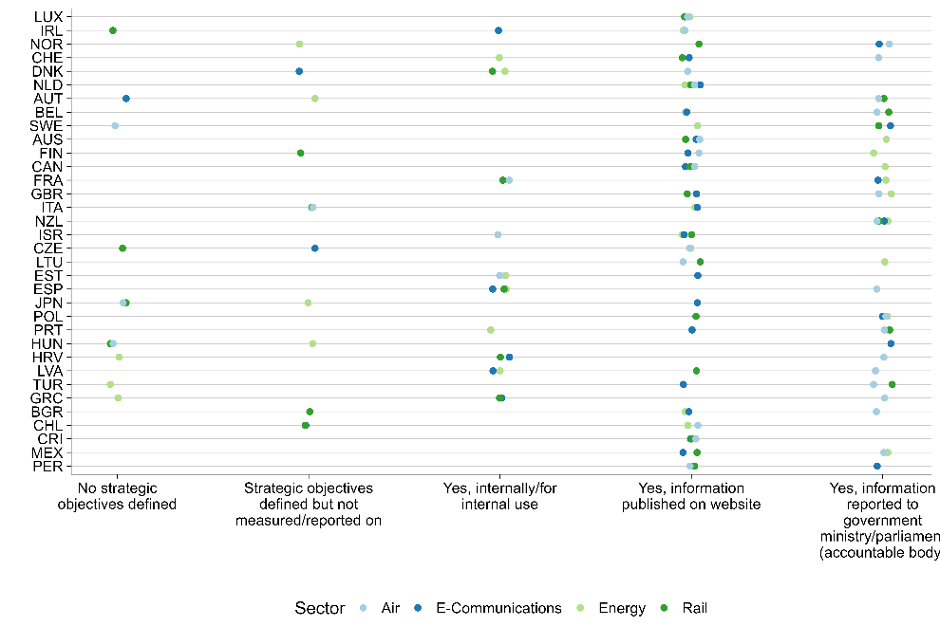
Source: Authors’ elaboration based on data from the OECD’s 2023 Indicators on the Governance of Sector Regulators. Each circle represents an individual sector regulatory institution and their type of management practice. Circles are displaced to reduce overlap. Economies are ordered by GDP per capita (constant international dollars, 2017), latest data available. The sample includes 45 countries.
Monitoring and evaluation are useful management tools for regulatory institutions. Regulatory impact assessments (RIAs) are a common tool for reviewing, evaluating, and adjusting the regulatory process according to its actual or expected impact on regulated entities (Ladegaard 2005; Ladegaard, Lundkvist, and, Kamkhaji 2018; OECD 2020). Through RIAs, regulatory institutions can make better informed decisions of what and how to regulate, minimizing unwanted consequences for firms and consumers. As such, these assessments offer an opportunity for regulatory institutions to adjust their strategy, learn from the consequences of regulations, and predict what might occur in the future. Together, robust strategy setting and monitoring and evaluation facilitate coordination between regulatory institutions and other relevant public institutions.

Governance dimensions

Accountability
Accountability enables regulatory institutions to be responsive to external stakeholders, including politicians and the private sector. The variety of stakeholders with competing interests – including politicians, firms, and citizens – makes accountability a challenge for regulatory institutions, requiring a broad set of accountability mechanisms linked to each stakeholder type. For accountability to politicians as well as to other public institutions, annual reviews and regulatory oversight committees can be established (OECD 2014). For accountability to the private sector and citizens, dispute resolution, grievance mechanisms, and opportunities to provide public comments on proposed regulations enable firms and the public to voice their concerns and influence regulations. Evidence suggests that these accountability mechanisms, including consultations, increase foreign direct investment and regulatory compliance by firms (Hebous, Kher, and Tran 2020; Malesky and Taussig 2019).
The accountability of sector regulators varies across institutions within the same country. Drawing on data from the Governance of Sector Regulators collected by the OECD, figure 3.9 visualizes this variation in the accountability of sector-specific regulatory institutions for OECD countries. The accountability indicators used in the dataset combine multiple types of accountability: to the executive and legislative branches, to regulated entities, and to citizens. The data shows significant variation in the degree of accountability across sector regulators, although the type of accountability is consistent within sectors (e.g., to the parliament or to the public). For example, energy and e-communications regulatory agencies score high on accountability to both the legislature and the public, while water regulatory agencies score low on both
Figure 3.9. Accountability to the legislature and to the public varies across sectors: energy and e-communications sector regulatory agencies are more accountable
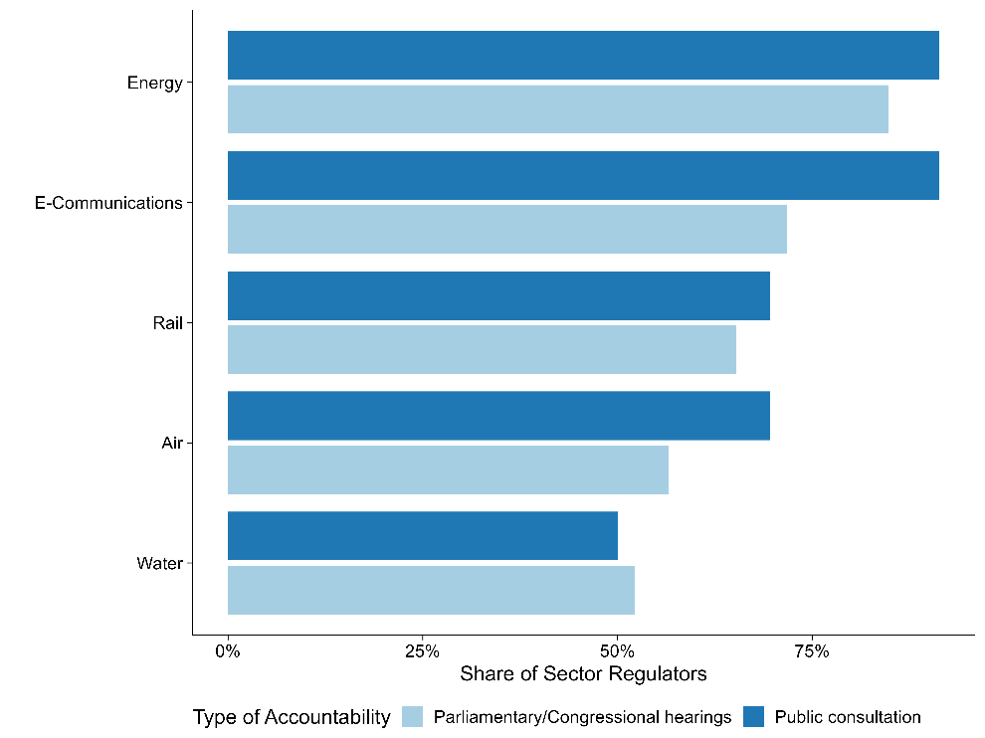
Source: Authors’ elaboration based on data from the Governance of Sector Regulators. Shares of sector regulators are computed by sector. Each bar color corresponds to a different type of accountability (i.e., to the legislature or to the public). Data is self-reported and reviewed by the OECD. Not all sector regulatory agencies have responded to the questionnaire for each country. Specific questions include who the regulatory agency is accountable to (e.g., parliament or congress) and whether the government collects feedback through public consultation. Sample size is 230 sector regulators in 46 countries.

Transparency
A range of rules and processes can strengthen regulatory institutions’ transparency. Transparency is the degree to which regulatory institutions disclose regulations, their implementation, and the regulatory process itself to the public. For example, regulatory frameworks on infrastructure projects and services can be made publicly accessible to the public and key stakeholders (World Bank 2020). Transparency also depends on the accuracy and timeliness of information, including the provision of real-time, high-quality market data for public scrutiny.
In the energy sector, evidence points to substantial variation in transparency practices for regulatory institutions. The Electricity Regulatory Index for Africa, for instance, shows that energy regulators in Uganda, Kenya, and Tanzania exhibit relatively high levels of transparency, while Zambia and Nigeria lag behind (figure 3.10). Similarly, a study of the energy sector in Latin America and the Caribbean (LAC) found that improved governance of energy regulatory agencies, particularly greater transparency, is associated with increased reliability and connectivity of electricity grids (Andres, Guasch, and Azumendi 2009). Transparency reduces the risk of regulatory capture by making public how regulatory decisions are made, creating opportunities for greater scrutiny and accountability of regulatory institutions’ operations. As such, transparency enhances the functioning of accountability rules and processes.
Figure 3.10. Transparency of regulatory institutions in the energy sector varies across countries in Africa
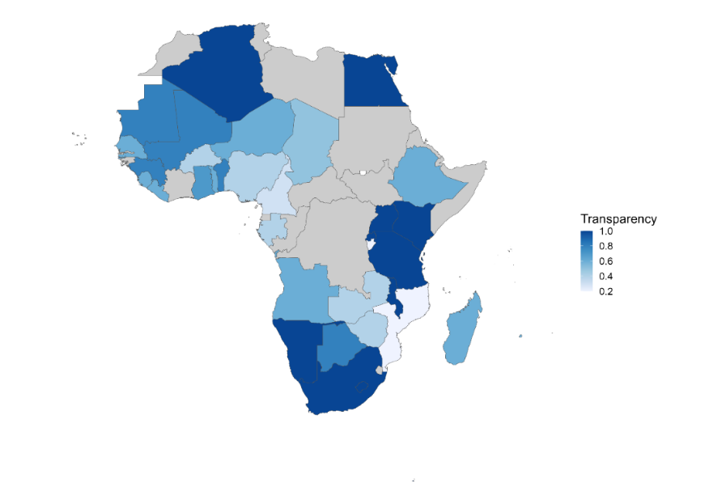
Source: Authors’ elaboration based on data from the Electricity Regulatory Index for Africa, 2022 from the African Development Bank.
Note: Data is collected through a questionnaire sent to electricity regulators. The indicator assesses the extent to which regulatory agencies adopt international practices regarding transparency (with higher scores indicating a greater degree of adoption). This includes publication of information on regulatory procedures, regulatory decisions, and the rationale underlying these decisions.

Independence
Independence protects regulatory institutions from undue influence from politicians and the private sector. Independence refers to the rules and processes to prevent regulatory capture (Carpenter and Moss 2013). Undue influence is a key distinction between independence and accountability mechanisms, the latter of which involves stakeholders exercising legitimate influence. An example of undue influence is revolving door appointments, which enable private sector firms to capture regulatory institutions by appointing their own staff and rewarding regulators with jobs when they leave regulatory institutions (Dal Bó 2006). Independence rules and procedures can protect regulatory institutions from capture by politicians and are particularly important for the framework’s organizational dimensions, such as personnel and financial resources. One of the benefits of independence is that it can ensure continuity in the regulatory framework. For example, regulatory institutions can commit to implementing regulations with a long-term horizon, which reduces the risk of sudden regulatory changes and lowers risk for regulated entities (World Bank 1997, 2017). Within recruitment, it is important to consider how regulatory staff are hired and whether competitive selection processes take place.
Systematic evidence on the independence of sector regulatory institutions is limited primarily to developed countries. The majority of systematically collected data on the independence of sector regulators is done by the OECD. Drawing on those data, it is possible to map out variation across and within countries (figure 3.11, panel A). One example of a developing country that is doing relatively well in its overall regulatory independence is Brazil. This does not mean that its regulatory independence is not politically contested: as in many other countries, legislative and executive proposals to curtail the independence of its regulatory agencies are frequent. Figure 3.11, panel B focuses specifically on the independence of financial resources (e.g., assessing whether the regulatory institutions proposes and discusses their own budget or whether this is done by another governmental institution/ministry). Notably, the country ranking for overall independence is different from the ranking for independence of financial resources.
Figure 3.11. Independence of sector regulatory agencies vary across and within countries
Panel A. Overall independence | Panel B. Independence of financial resources
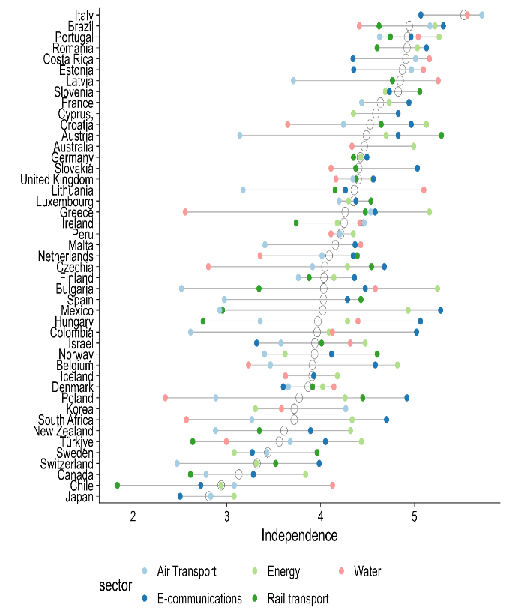 | 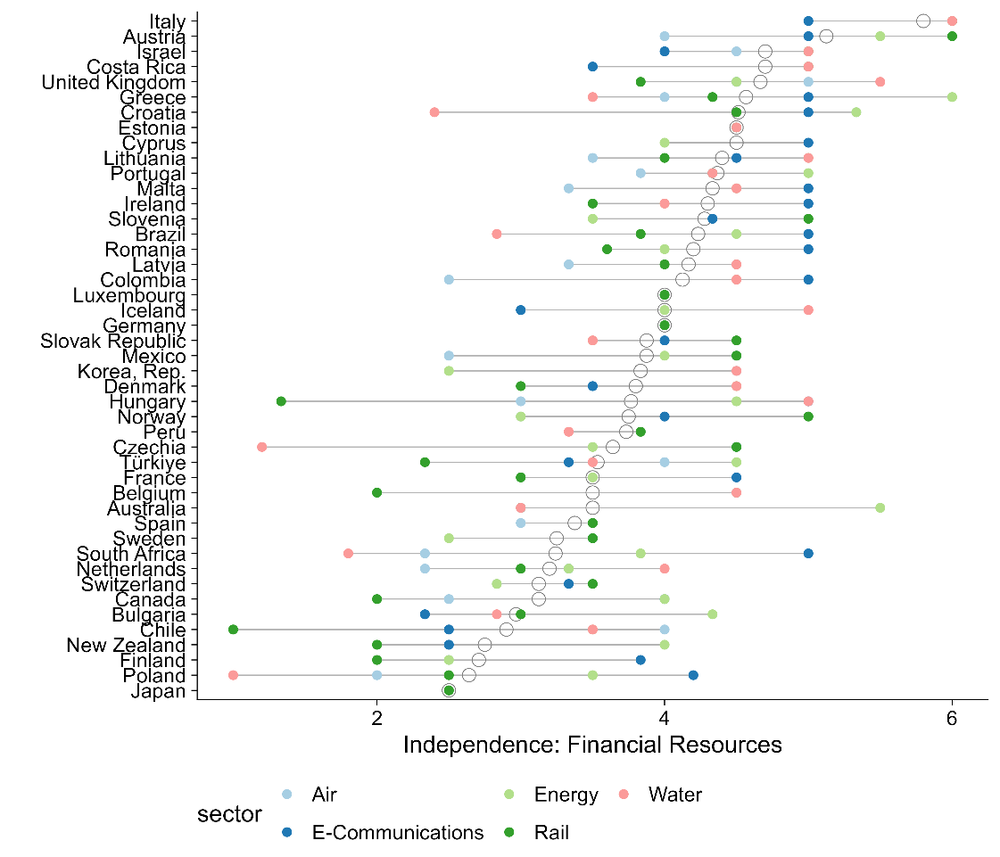
Source: Authors’ elaboration based on data from the Governance of Sector Regulators. Scores vary from 0 (lowest independence) to 6 (highest independence). Each color corresponds to a different sector regulator. Data is self-reported and reviewed by the OECD. Not all sector regulatory agencies have responded to the questionnaire for each country. Sample includes 45 countries. Panel A: Questions on independence cover multiple areas, including relationship with the executive, staff, and budget. Specific questions include the legal status of the regulatory agency (e.g., independent body), how the majority of staff is appointed (e.g., positions are advertised publicly and candidates selected by selection panel), and the length of budget appropriations (e.g., at least three years). Panel B: Questions on independence that specifically cover the budget (i.e., financial resources). For example, who is responsible for proposing and discussing the regulator’s budget? Scoring based on OECD schemata for the Governance of Sector Regulators indicators, 2023 methodology.

Regulatory institutional challenges span multiple dimensions
As with procurement institutions in Chapter 2, regulatory institutional challenges are multidimensional. Table 3.1 outlines a set of problems commonly faced by regulatory institutions, with key examples from the literature and practical experience. It highlights that institutional challenges span multiple dimensions and reveals connections between different parts of the framework. As with procurement institutions, the definition of a problem is closely linked to the regulatory institution’s mandate. For example, low-quality goods and services may reflect outdated information systems as well as limited expertise among regulatory personnel, making it difficult to identify and enforce quality issues. Organizing outcomes in this way helps diagnose where interventions can improve regulatory outcomes while also supporting broader private sector development.
Table 3.1 Regulatory outcomes are linked to the organization and governance dimensions
Regulatory problem | Organizational and governance dimensions | Regulatory outcome
Regulators lack sufficient knowledge of markets, as well as sufficient data and information systems to address market failures without undermining private sector development and competition levels. | - Information systems: Outdated tracking systems limit the data available for regulators to enforce quality standards (OECD 2021).  - Personnel: Regulatory staff may lack the required level of expertise to identify and diagnose quality issues (Stern 2000).  - Accountability: Not providing firms the opportunity to participate in and provide comments on regulations reduces the likelihood that firms will comply with existing chemical safety standards (Malesky and Taussig 2019). | Improve the quality of goods and services
Politicians appoint regulators who tilt the rules in favor of certain firms and private interests to the detriment of consumer interests.  Politicians or other decision-makers can cause disruptive changes in leadership of regulatory agencies, making it difficult to approve new regulations to address technological or market changes. | - Independence: Revolving door appointments by firms may pressure regulatory institutions to either increase barriers to entry or refrain from enacting competition-enhancing regulations (Dal Bó 2006).  - Management practices: Infrequent review and adjustment of competition regulations. Regulations may not be updated regularly to reflect market changes.  - Financial resources: Underfunding of market studies and regulatory audits. Lack of funding can limit the ability to conduct thorough analyses and audits, hindering market regulation. | Promote competition
Regulatory institutions do not have sufficient incentives or resources to provide information to the public. | - Transparency: Limited transparency in real-time data for public scrutiny, which prevents identification of excluded users.  - Financial resources: Inadequate financial incentives to attract private sector investment in underserved areas. There may not be enough benefits to encourage private companies to invest. | Ensure access
Source: Author’s elaboration

Applying the framework: Case study on telecoms regulatory institutions in Peru
Telecommunications play a significant role in economic development, although the digital divide in the LAC region remains noticeable. Telecommunications can provide network externalities and support economic activity by improving information flows for firms and consumers (Röller and Waverman 2001). However, coverage and access to mobile services are not uniform across LAC (World Bank 2016b). The region has seen slower growth in broadband connectivity, as indicated by the Global System for Mobile Association’s (GSMA’s) Telecom Connectivity Index. This stagnation is primarily attributed to regulatory frameworks that constrain the expansion of the telecommunications sector (World Bank 2017b).
This case study analyzes the design and implementation of telecoms regulation by the Ministry of Transport and Communications (MTC) and the Organismo Supervisor de Inversión Privada en Telecomunicaciones (OSIPTEL) in Peru. MTC and OSIPTEL are the country’s main regulatory institutions for mobile services. OSIPTEL is a specialized regulatory institution attached to the Presidential Council of Ministers with de jure technical, administrative, and financial autonomy. OSIPTEL’s broad mission is to improve the quality of services and customer protection in telecoms, all within a framework of equitable and open competition. It focuses particularly on regulations for mobile internet and services, including spectrum broadband allocation and mobile network infrastructure (e.g., cellular radio towers), among others. The MTC is mandated with broader infrastructure regulation, including telecoms infrastructure. In particular, it is responsible for building and offering concessions for the national optic fiber network (Red Dorsal Nacional de Fibra Óptica, RDNFO) in rural areas, in an attempt to bridge the urban-rural digital divide (OECD 2023b).
As table 3.2 illustrates, implementation challenges in the telecoms sector can have their roots in multiple organizational and governance dimensions. For example, low participation in spectrum auctions is driven by inadequate systems for monitoring market dynamics (an information systems issue) and lack of information shared with market participants (a transparency issue).
Table 3.2. Using the framework to diagnose potential sources of policy implementation problems in telecoms regulatory agencies in Peru
Implementation problem | Potential sources of problems |  | Possible solutions
 | Information Systems | Management Practices
Lack of oversight and clear metrics in spectrum auctions result in low participation and compromise the integrity of the auction process. | Unclear market performance metrics lead to low participation by bidders.  Inadequate systems for monitoring market dynamics and spectrum use.  Accountability: Lack of comprehensive and up-to-date information hinders audits.  Transparency: Insufficient clarity in market performance metrics provided to market participants. |  | Establish real-time data collection and analysis systems.  Establish clear, standardized market performance metrics and regular evaluations/audits that are publicized to market participants.
Regulatory delays in the drafting and enactment of regulatory frameworks cause regulatory uncertainty in telecoms operators. |  | Frequent leadership turnover disrupts regulatory decisions.  Delays in inter-institutional coordination due to differing agendas and priorities among involved entities.  Independence: Politically motivated appointments of heads of regulatory agencies compromises independence. | Ensure that heads of regulatory agencies serve for a fixed term and are subject to review by either the legislature or regulatory board.  Strengthen decision frameworks so that there is clarity of mandate between multiple regulatory institutions.

Competitive spectrum auctions
In Peru, more robust information systems could enhance monitoring progress and ensure compliance in spectrum use, increasing the number of potential bidders in spectrum auctions. Currently, the regulators’ outdated tracking systems and insufficient regulatory compliance tools impede effective oversight. For example, after auctions to allocate radio spectrum to mobile services providers, OSIPTEL was unable to sufficiently track compliance, which resulted in operators either misusing or underusing their allocated spectrums. Improving real-time data collection and analytical capabilities would enhance compliance, enabling accurate monitoring with respect to the use of broadband spectrums. Clearer market performance metrics could lead to more competitive bidding behavior, affecting the overall competitiveness of the spectrum auction.
Transparency and accountability issues, such as inconsistent regulatory updates and communication delays to mobile operators, have limited stakeholder engagement and trust in the country’s broadband sector. Two key mobile service regulations – the National Broadband Plan and the Broadband Law – are designed to expand broadband access, but transparency limitations, such as a lack of clear metrics on how radio spectrums will be allocated, have undermined their success. To address this, regulators’ norms emphasize timely and clear communication to ensure that stakeholders are well-informed, facilitating smoother policy implementation. Transparency issues also make it challenging to enforce accountability. For example, if the regulatory agency does not publish responses to comments by regulated entities, it is difficult to hold the agency accountable for regulatory decisions they have made. Inadequate auditing processes have further weakened regulatory accountability. Spectrum caps and competitive spectrum auctions require robust accountability mechanisms, such as audits to prevent market monopolization and ensure fair competition. Irregular implementation of such audits leads to uneven compliance with allocated spectrum bands.

Regulatory delays
Strengthening the independence of Peru’s regulatory agencies could provide more managerial stability and consequently regulatory certainty. Frequent changes in political leadership and shifting regulatory priorities have created an unstable environment for long-term telecom infrastructure projects. The average tenure of ministers and vice ministers of communications is short, with many serving less than a year. Figure 3.12 shows the tenure of the nineteen ministers who oversaw telecoms regulation in Peru from 2009 to 2023 as well as the timing of key regulatory decisions. As the MTC is responsible for regulating the telecoms sectors, these frequent leadership changes have contributed to inconsistent policy directives, fragmented efforts, and delays in executing critical regulatory milestones. For example, the implementation of the National Broadband Plan and Spectrum Caps experienced delays due to shifting priorities caused by frequent managerial turnover. This case exemplifies how lack of independence can have an impact on management practices.
Figure 3.12 Frequent leadership change is a challenge for achieving key regulatory milestones
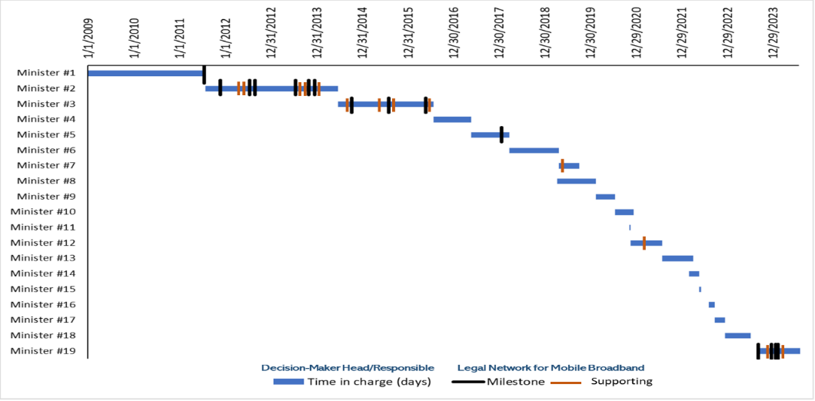
Source: Author’s elaboration.
Note: Each black line represents key legislative or regulatory acts (Milestones) that have significantly impacted the mobile internet service sector in Peru. Each orange line represents other legislative or regulatory acts (Supporting) that complemented Milestones. For instance, key regulatory milestones, like the 4G spectrum auction and Mobile Virtual Network Operator (MVNO) regulations, were also delayed due to leadership changes. Transitions in leadership often shift priorities, resulting in inconsistent implementation and lack of follow-through on existing plans.
Independence is crucial for unbiased decision-making, but Peru’s regulatory agencies have faced challenges in maintaining it. According to the Framework Law on Regulatory Agencies, f the country’s regulatory institutions should operate autonomously, reporting to the Presidency of the Council of Ministers and enjoying administrative, functional, technical, economic, and financial independence. In practice, however, this independence is subject to contestation by the legislative and executive branches. For example, the 2021-2022 Congress proposed a bill to alter the composition of regulatory councils and the criteria for membership. In May 2024, the Executive requested legislative powers to modify the Framework Law on Regulatory Bodies to increase executive oversight of regulatory institutions. This proposal suggested unifying their regulatory functions to achieve cost savings and operational efficiencies. In practice, this centralization risked diluting regulatory independence: by unifying functions without considering different sectors’ distinct regulatory needs, it created opportunities for the politicization of technical issues and reduced legal certainty for private investments. The proposal was ultimately rejected by the Congress.
A key challenge for telecoms regulation in Peru is the lack of inter-institutional coordination. Telecoms is a complex system, requiring regulatory institutions to focus on regulating specific services and infrastructure while also coordinating their efforts. As mentioned earlier, OSIPTEL is responsible for improving the quality of services, protecting consumers, and ensuring competition. The MTC, by contrast, focuses on telecoms infrastructure. In theory, these two institutions should coordinate their regulatory efforts: a high-quality mobile service requires the maintenance or roll-out of mobile service infrastructure to support it. In practice, these institutions have often failed to coordinate their regulatory efforts, working either in isolation or competing with one another. This lack of inter-institutional coordination and collaboration has led to both regulatory delays and the uneven implementation of regulations that sought to improve the quality of mobile services.

Annex 1. Methodology for Assessing Procurement Systems (MAPS) indicators
Figures 2.2 and 2.5 are constructed based on specific criteria coded in the Methodology for the Assessment of Procurement Systems (MAPS) framework. For each country, the MAPS assessment rates each criterion as present, partially present, or not present. These ratings are then coded as 2, 1, and 0, respectively. The two figures plot the percentage of possible points that countries could have received for their personnel-related criteria.

Table A1.1 Criteria in the MAPS framework relevant for the “personnel” dimension:
MAPS Pillar | Criteria
Pillar 1: Legal, Regulatory, and Policy Framework | None.
Pillar 2: Institutional Framework and Management Capacity | - One or several agencies is clearly responsible for providing tools and documents, including integrity training programs, to support training and capacity development of the staff responsible for implementing procurement.  - One or several agencies is clearly responsible for supporting the professionalization of the procurement function (e.g., development of role descriptions, competency profiles, and accreditation and certification schemes for the profession).  - The institution’s internal organization, authority, and staffing are sufficient and consistent with its responsibilities.  - The centralized procurement body’s internal organization and staffing are sufficient and consistent with its responsibilities.  - Responsibility for the management and operation of the system is clearly defined.  - Government officials have the capacity to plan, develop, and manage e-procurement systems.  - Procurement staff are adequately skilled to reliably and efficiently use e-procurement systems.  - Substantive permanent training programs of suitable quality and content for the needs of the system.  - Routine evaluation and periodic adjustment of training programs based on feedback and need.  - Advisory service or help desk function to resolve questions by procuring entities, suppliers, and the public.  - A strategy well-integrated with other measures for developing the capacity of key actors involved in public procurement.  - Procurement is recognized as a specific function, with procurement positions defined at different professional levels, and job descriptions and the requisite qualifications and competencies specified.  - Appointments and promotion are competitive and based on qualifications and professional certification.  - Staff performance is evaluated on a regular and consistent basis, and staff development and adequate training are provided.  - The country has established and consistently applied a performance measurement system that focuses on both quantitative and qualitative aspects.
Pillar 3: Public Procurement Operations and Market Practices | None.
Pillar 4: Accountability, Integrity, and Transparency of the Public Procurement System | - There is an established program to train internal and external auditors to ensure that they are qualified to conduct high-quality procurement audits, including performance audits.  - The selection of auditors requires that they have adequate knowledge of the subject as a condition for carrying out procurement audits; if auditors lack procurement knowledge, they are routinely supported by procurement specialists or consultants.  - Auditors are selected in a fair and transparent way and are fully independent.  - The appeals body is adequately resourced and staffed to fulfill its functions.  - Regular training programs are offered to ensure sustained awareness and implementation of measures.

Table A1.2 Criteria in the MAPS framework relevant for the “transparency” dimension:
MAPS Pillar | Criteria
Pillar 1: Legal, Regulatory, and Policy Framework | - The legal framework requires that procurement opportunities are publicly advertised, unless the restriction of procurement opportunities is explicitly justified.  - Publication of opportunities provides sufficient time, consistent with the method, nature, and complexity of procurement, for potential bidders to obtain documents and respond to the advertisement. The minimum time frames for submission of bids/proposals are defined for each procurement method, and these time frames are extended when international competition is solicited.  - Publication of open tenders is mandated in at least one newspaper of wide national circulation or on a unique Internet official site where all public procurement opportunities are posted. This should be easily accessible at no cost and should not involve other barriers (e.g., technological barriers).  - Opening of tenders in a defined and regulated proceeding, immediately following the closing date for bid submission.  - Records of proceedings for bid openings are retained and available for review.
Pillar 2: Institutional Framework and Management Capacity | - One or several agencies are clearly assigned the function of providing procurement information without creating gaps or overlaps in responsibility.  - In support of the concept of open contracting, more comprehensive information is published on the online portal in each phase of the procurement process, including the full set of bidding documents, evaluation reports, full contract documents including technical specification, and implementation details.  - Information is published in an open, structured, and machine-readable format, using identifiers and classifications.
Pillar 3: Public Procurement Operations and Market Practices | - The selection and award processes are carried out effectively, efficiently, and in a transparent way.  - Procurement statistics are available and a system is in place to measure and improve procurement practices.  - The records are complete and accurate, and easily accessible in a single file.
Pillar 4: Accountability, Integrity, and Transparency of the Public Procurement System | - Requirements in combination with actual practices ensure that all stakeholders have adequate and timely access to information as a precondition for effective participation.  - As part of the anti-corruption framework, statistics on corruption-related legal proceedings and convictions are compiled and reports are published annually.  - There are legal provisions to protect whistle-blowers, and these are considered effective.

References
Abad, Jose, Vincente Bermejo, Vicente Cunat, and Rafael Zambrana. 2023. “Government Arrears and Corporate Decisions: Lessons from a Natural Experiment.” Working paper, Bank for International Settlements (bis), Basel, Switzerland.
Adam, Isabelle, and Mihály Fazekas. 2021. “Are Emerging Technologies Helping Win the Fight Against Corruption? A Review of the State of Evidence.” Information Economics and Policy 57.
Addison, Douglas M. 2013. "The quality of budget execution and its correlates." Working Paper No. 6657, World Bank Policy Research, Washington, DC.
Akerlof, George A. 1978. "The market for lemons: Quality uncertainty and the market mechanism." In Uncertainty in economics, 235-251. Academic Press.
Andres, L., J.L. Guasch, and S.L. Azumendi. 2009. Regulatory governance and sector performance: methodology and evaluation for electricity distribution in Latin America. In Regulation, Deregulation, Reregulation. Edward Elgar Publishing.
Andrews, Matt, Lant Pritchett, and Michael Woolcock. 2017. Building state capability: Evidence, analysis, action. Oxford University Press.
Andrews, Matthew, Marco Cangiano, Neil Cole, Paolo De Renzio, Philipp Krause, and Renaud Seligmann. 2014. "This is PFM." CID Working Paper Series No. 285, Harvard University, Cambridge, MA.
Avis, Eric, Claudio Ferraz, and Frederico Finan. 2018. “Do Government Audits Reduce Corruption? Estimating the Impacts of Exposing Corrupt Politicians.” Journal of Political Economy 126 (5): 1912–64.
Azulai, Michel, Imran Rasul, Daniel Rogger, and Martin J. Williams. 2020. "Can training improve organizational culture? Experimental evidence from Ghana’s civil service." Working Paper, Economic Development and Institutions.
Bajpai, Rajni, Bernard C. Myers, 2020. Enhancing Government Effectiveness and Transparency: The Fight Against Corruption (English). Washington, DC. World Bank Group.
Baltrunaite, Audinga, Cristina Giorgiantonio, Sauro Mocetti, and Tommaso Orlando. 2021. “Discretion and Supplier Selection in Public Procurement.” Journal of Law, Economics, and Organization 37 (1): 134–66.
Bandiera, Oriana, Andrea Prat, and Tommaso Valletti. 2009. "Active and passive waste in government spending: evidence from a policy experiment." American Economic Review 99 (4): 1278-1308.
Bandiera, Oriana, Michael Carlos Best, Adnan Qadir Khan, and Andrea Prat. 2021. "The allocation of authority in organizations: A field experiment with bureaucrats." The Quarterly Journal of Economics 136 (4): 2195-2242.
Banerjee, Abhijit, Esther Duflo, and Nancy Qian. 2020. “On the Road: Access to Transportation Infrastructure and Economic Growth in China.” Journal of Development Economics 145: 102442.
Bauhr, Monika, Ágnes Czibik, Jenny de Fine Licht, and Mihály Fazekas. 2019. “Lights on the Shadows of Public Procurement: Transparency as an Antidote to Corruption.” Governance 33 (3): 495–523.
Bellodi, Luca, Massimo Morelli, and Matia Vannoni. 2024. “A Costly Commitment: Populism, Economic Performance, and the Quality of Bureaucracy.” American Journal of Political Science 68 (1): 193–209.
Bersch, Katherine, Sérgio Praça, and Matthew M. Taylor. 2016. "State capacity, bureaucratic politicization, and corruption in the Brazilian state." Governance 30 (1): 105-124.
Bertelli, Anthony M., Mai Hassan, Dan Honig, Daniel Rogger, and Martin J. Williams. 2020. "An agenda for the study of public administration in developing countries." Governance 33 (4): 735-748.
Bertrand, Marianne, Robin Burgess, Arunish Chawla, and Guo Xu. 2020. "The glittering prizes: Career incentives and bureaucrat performance." The Review of Economic Studies 87 (2): 626-655.
Berwick, Elissa, and Fotini Christia. 2018. "State capacity redux: Integrating classical and experimental contributions to an enduring debate." Annual Review of Political Science 21(1): 71-91.
Besley, T., and Coate, S. 2003. “Elected versus appointed regulators: Theory and evidence.” Journal of the European Economic Association, 1(5), 1176-1206.
Best, Michael Carlos, Jonas Hjort, and David Szakonyi. 2023. "Individuals and organizations as sources of state effectiveness." American Economic Review 113 (8): 2121-2167.
Bloom, Nicholas, Renata Lemos, Raffaella Sadun, and John Van Reenen. 2015. "Does management matter in schools?" The Economic Journal 125 (584): 647-674.
Blum, Jurgen, Arkopal Datta, Mihaly Fazekas, Sushmita Samaddar, and Ishtiak Siddique. 2023. “Introducing E-Procurement in Bangladesh: The Promise of Efficiency and Openness.” Working Paper No. 10390, World Bank Policy Research, Washington, DC.
Boas, Taylor, F. Daniel Hidalgo, and Neal Richardson. 2014. “The Spoils of Victory: Campaign Donations and Government Contracts in Brazil.” Journal of Politics 76 (2): 415–29.
Bolton, Alexander, Rachel Augustine Potter, and Sharece Thrower. 2016 "Organizational capacity, regulatory review, and the limits of political control." The Journal of Law, Economics, and Organization 32 (2): 242-271.
Brierley, Sarah. 2020. “Unprincipled Principals: Co-Opted Bureaucrats and Corruption in Ghana.” American Journal of Political Science 64 (2): 209–22.
Brogaard, Jonathan, Matthew Denes, and Ran Duchin. 2021. “Political Influence and the Renegotiation of Government Contracts.” Review of Financial Studies 34 (6): 3095–3137.
Brown, Ashley C., Jon Stern, Bernard William Tenenbaum, and Defne Gencer. 2006. Handbook for evaluating infrastructure regulatory systems, World Bank, Washington DC: World Bank Publications.
Buntaine, Mark T., Bing Zhang, and Patrick Hunnicutt. 2021. “Citizen monitoring of waterways decreases pollution in China by supporting government action and oversight.” Proceedings of the National Academy of Sciences Vol. 118 | No. 29
Caires, Filipe, Susana Peralta, and Diogo Mendes. 2023. “Contract Splitting in Public Procurement.” Working Paper, European University Institute, Fiesole FI, Italy.
Callen, Michael and Gulzar, Saad and Hasanain, Syed Ali and Khan, Muhammad and Rezaee, Arman. 2015. “Personalities and Public Sector Performance: Evidence from a Health Experiment in Pakistan." HKS Working Paper No. RWP15-023.
Camaj, Lindita. 2013. "The media’s role in fighting corruption: Media effects on governmental accountability." The International Journal of Press/Politics 18 (1): 21-42.
Campos, Nicolás, Eduardo Engel, Ronald Fischer, and Alexander Galetovic. 2021. “The Ways of Corruption in Infrastructure: Lessons from the Odebrecht Case.” Journal of Economic Perspectives 35 (2): 171–90.
Canen, Nathan, Rafael Ch, and Leonard Wantchekon. 2023. “Political uncertainty and the forms of state capture.” Journal of Development Economics, Volume 160, January 2023, 102972.
Carpenter, Daniel P. 2002. "Groups, the media, agency waiting costs, and FDA drug approval." American Journal of Political Science 46 (3): 490-505.
Carpenter, Daniel P. and David A. Moss. 2013, Preventing regulatory capture: special interest influence and how to limit it, Cambridge, MA: Cambridge University Press.
Centeno, M. A., Kohli, A., and Yashar, D. J. 2017. Unpacking states in the developing world: Capacity, performance, and politics. States in the developing world, 1-32, Cambridge University Press.
Chassang, Sylvain, and Juan Ortner. 2019. “Collusion in Auctions with Constrained Bids: Theory and Evidence from Public Procurement.” Journal of Political Economy 127 (5): 2269–2300.
Chaurey, Ritam, and Duong Trung Le. 2022. “Infrastructure Maintenance and Rural Economic Activity: Evidence from India.” Journal of Public Economics 214: 104725.
Christoph, Mary J., Nicole Larson, Melissa N. Laska, and Dianne Neumark-Sztainer. 2018. "Nutrition facts panels: who uses them, what do they use, and how does use relate to dietary intake?." Journal of the Academy of Nutrition and Dietetics 118 (2): 217-228.
Colonnelli, Emanuele, and Mounu Prem. 2022. “Corruption and Firms.” The Review of Economic Studies 89 (2): 695–732.
Colonnelli, Emanuele, Francesco Loiacono, Edwin Muhumza, and Edouard Teso. 2024. “Do Information Frictions and Corruption Perceptions Kill Competition? A Field Experiment on Public Procurement in Uganda.” NBER Working Paper, No. W32170, Cambridge, MA.
Conti, Maurizio, Leandro Elia, Antonella Rita Ferrara, and Massimiliano Ferraresi. 2021. “Governments’ Late Payments and Firms’ Survival: Evidence from the European Union.” Journal of Law and Economics 64 (3): 603–27.
Coviello, Decio, and Mario Mariniello. 2014. “Publicity Requirements in Public Procurement: Evidence from a Regression Discontinuity Design.” Journal of Public Economics 109:76–100.
Coviello, Decio, Andrea Guglielmo, and Giancarlo Spagnolo. 2018. “The Effect of Discretion on Procurement Performance.” Management Science 64 (2): 715–38.
Coviello, D., Deserranno, E., Persico, N., and Sapienza, P. 2024.” Effect of mood and worker incentives on workplace productivity.” The Journal of Law, Economics, and Organization, 40(2), 362-393.
Deserranno, E., Philipp Kastrau, and León-Ciliotta, G. 2022. “Promotions and productivity: the role of meritocracy and pay progression in the public sector." STEG Working Paper, No. WP037, London.UK.
Dahis, Ricardo, Bernardo Ricca, and Thiago Scot 2024. "Speed of Payment in Procurement Contracts: The Role of Political Connections." Available at SSRN 3934021.
Dahlstrom, C., and Lapuente, V. 2022. “Comparative bureaucratic politics.” Annual Review of Political Science, 25(1), 43-63.
Dal Bó, Ernesto, Frederico Finan, and Martín A. Rossi. 2013. "Strengthening state capabilities: The role of financial incentives in the call to public service." The Quarterly Journal of Economics 128 (3): 1169-1218.
Dal Bó, Ernesto. 2006. "Regulatory capture: A Review.” Oxford review of economic policy 22 (2): 203-225.
Dasgupta, A., and Kapur, D. 2020. “The Political Economy of Bureaucratic Overload: Evidence from Rural Development Officials in India.” American Political Science Review.;114(4):1316-1334.
Decarolis, Francesco, Leonardo Giuffrida, Elisabetta Iossa, Vincenzo Mollisi, and Giancarlo Spagnolo. 2020. “Bureaucratic Competence and Procurement Outcomes.” Journal of Law, Economics, and Organization 36 (3): 537–97.
Decarolis, Francesco, Raymond Fisman, Paolo Pinotti, and Silvia Vannutelli. 2020. “Rules, Discretion, and Corruption in Procurement: Evidence from Italian Government Contracting." National Bureau of Economic Research. No. 28209, Cambridge, MA.
Decarolis, Francesco. 2018. “Comparing Public Procurement Auctions.” International Economic Review 59 (2): 391–419.
Duguay, Raphael, Thomas Rauter, and Delphine Samuels. 2023. “The Impact of Open Data on Public Procurement.” Journal of Accounting Research 61 (4): 1159–1224.
Estache, Antonio, and Liam Wren‐Lewis.2010. "On the theory and evidence on regulation of network industries in developing countries." In The Oxford Handbook of Regulation edited by Robert Baldwin, Martin Cave, and Martin Lodge, 371-406, Oxford Academic, UK
Eutsler, Jared, M. Kathleen Harris, L. Tyler Williams, and Omar E.Cornejo. 2023. "Accounting for partisanship and politicization: Employing Benford's Law to examine misreporting of COVID-19 infection cases and deaths in the United States." Accounting, Organizations and Society 108, 101455.
Evans, Peter and Rauch, James E. 2000. "Bureaucratic structure and bureaucratic performance in less developed countries." Journal of Public Economics 75 (1): 49-71.
Evans, Peter, and James E. Rauch. 1999 "Bureaucracy and growth: a cross-national analysis of the effects of “Weberian” state structures on economic growth." American Sociological Review 64 (5): 748-765.
Finan, F., Olken, B. A., and Pande, R. 2017. “The personnel economics of the developing state.” Handbook of economic field experiments, 2, 467-514.
Foarta, Dana, and Michael Ting. 2023. "Organizational capacity and project dynamics." Stanford University Graduate School of Business Research Paper. 4321890. SSRN.
Fukuyama, Francis. 2013. "What is governance?" Governance 26 (3):347-368.
Gailmard, Sean. 2010. "Politics, principal–agent problems, and public service motivation." International Public Management Journal 13 (1): 35-45.
Garcia-Santana, Manuel, and Marta Santamaria. 2024. “Governments’ Home Bias and Efficiency Losses: Evidence from National and Subnational Governments.” FRB of New York Staff, Working paper.
Gerardino, Maria Paula, Stephan Litschig, and Dina Pomeranz. 2022. “Distortion by Audit: Evidence from Public Procurement.” NBER Working Paper, No. 23978, Cambridge, MA.
Gingerich, Daniel W. 2013 "Governance indicators and the level of analysis problem: empirical findings from South America." British Journal of Political Science 43 (3): 505-540.
Giuffrida, Leonardo, and Emilio Raiteri. 2023. “Bureaucratic Frictions and Innovation Procurement.” CESifo Working Paper 10775, Available at SSRN.
Greenstone, Michael, Guojun He, Ruixue Jia, and Tong Liu. 2022. "Can technology solve the principal-agent problem? Evidence from China’s war on air pollution." American Economic Review: Insights 4, (1): 54-70.
Grindle, Merilee S. 1997. "Divergent cultures? When public organizations perform well in developing countries." World Development 25 (4): 481-495.
Grindle, Merilee S. 2007. "Good enough governance revisited." Development Policy Review 25 (5): 533-574.
Grindle, Merilee S., 2012. Jobs for the boys: Patronage and the state in comparative perspective. Harvard University Press.
Hanson, Jonathan K., and Rachel Sigman. 2021. "Leviathan’s latent dimensions: Measuring state capacity for comparative political research." The Journal of Politics 83 (4): 1495-1510.
Hasnain, Zahid, Daniel Oliver Rogger, Daniel John Walker, Kerenssa Mayo Kay and Rong Shi. 2019. “Innovating Bureaucracy for a More Capable Government." World Bank Working Paper 134585, Washington, DC.
Hebous, Sarah, Priyanka Kher, and Trang Thu Tran. 2020. "Regulatory risk and FDI." In Global Investment Competitiveness Report: Rebuilding Investor Confidence in Times of Uncertainty. Washington, DC: The World Bank.
Honig, D., 2024. Mission driven bureaucrats: Empowering people to help government do better. Oxford University Press.
Honig, D. 2022. "Managing for motivation as public performance improvement strategy in education and far beyond." Research on Improving Systems of Education, CID Faculty Working Paper Series.
Honig, D. 2021. “Supportive management practice and intrinsic motivation go together in the public service.” Proceedings of the National Academy of Sciences, 118(13), e2015124118.
IFC. 2021. Creating Markets in Pakistan: Country Private Sector Diagnostic, the International Finance Corporation, Washington, DC.
IFC. 2023a. Creating Markets in Moldova: Country Private Sector Diagnostic, the International Finance Corporation, Washington, DC.
Iyer, Lakshmi and Anandi Mani. 2012. “Traveling Agents: Political Change and Bureaucratic Turnover in India." Review of Economics and Statistics 94:723-39.
Jacobs, Scott and Peter Ladegaard. 2010, Regulatory Governance in Developing Countries, International Finance Corporation, Multilateral Investment Guarantee Agency and Washington, DC: The World Bank.
Joskow, Paul L.2007. "Regulation of natural monopoly." Handbook of Law and Economics 2: 1227-1348.
Kelly, Tim, and Carlo Maria Rossotto, eds. 2012. Broadband strategies handbook. World Bank Publications, Reports No. 67620, Washington DC.
Kelman, Steven. 1990. “Procurement and Public Management: The Fear of Discretion and the Quality of Government Performance." American Enterprise Institute, Washington, DC.
Kenny, Charles, and Ben Crisman. 2016. “Results Through Transparency: Does Publicity Lead to Better Procurement?” Working Paper 437, Center for Global Development, Washington, DC.
Khemani, Stuti; Dal Bó, Ernesto; Ferraz, Claudio; Finan, Frederico Shimizu; Stephenson Johnson, Corinne Louise; Odugbemi, Adesinaola Michael; Thapa, Dikshya; Abrahams, Scott David. Making politics work for development: harnessing transparency and citizen engagement (English). Policy Research Reports Washington, DC: World Bank Group.
Khemani, S. 2019. “What is state capacity?” Working Paper, No, 8734, World Bank Policy Research, Washington, DC.
Kim, Galileu, Tanu Kumar, Rita Ramalho, and Stuart Russell. 2026. “Institutional Capacity for Policy Implementation: An Analytical Framework”, Working Paper, No, 11279, World Bank Policy Research, Washington, DC.
Klein, Michael and Bita Hadjimichael. 2003. The Private Sector in Development: Entrepreneurship, Regulation, and Competitive Disciplines, The World Bank Publications, Washington DC
Kotsanopoulos, Konstantinos V., and Ioannis S. Arvanitoyannis. 2017. "The role of auditing, food safety, and food quality standards in the food industry: A review." Comprehensive Reviews in Food Science and Food Safety 16 (5):760-775.
Kosack, Stephen, and Archon Fung. 2014. "Does Transparency Improve Governance?" Annual Review of Political Science 17 (1): 65-87.
La Cascia, Hunt, Adrian Fozzard, Diana Carolina Annandsingh Rattia, and Yolanda Saito. 2023. “Green Public Procurement: An Overview of Green Reforms in Country Procurement Systems (English)." Climate Governance Papers, Washington, DC.
Ladegaard, Peter Farup, Petter Lundkvist, and Jonathan Camillo Kamkhaji. 2018. "Giving Sisyphus a helping hand: pathways for sustainable RIA systems in developing countries." Working Paper, No, 8367, World Bank Policy Research, Washington, DC.
Ladegaard, Peter. 2005. "Improving business environments through Regulatory Impact Analysis-Opportunities and challenges for developing countries." In International Conference on Reforming the Business Environment, Cairo, Egypt,29:1089-1127.
Laffont, Jean-Jacques, and Jean Tirole. 1993. A theory of Incentives in Procurement and Regulation. Cambridge, MA: MIT press.
Laffont, Jean-Jacques. 2005. Regulation and development. Cambridge, UK: Cambridge University Press.
Levitin, Adam J. 2012. "The consumer financial protection bureau: An introduction." Rev. Banking & Fin. L. 32, 321.
Levitsky, Steven, and María Victoria Murillo. 2009. "Variation in institutional strength." Annual Review of Political Science 12 (1):115-133.
Levy, Brian and Spiller, P. T. 1994. “The Institutional Foundations of Regulatory Commitment: A Comparative Analysis of Telecommunications Regulation.” Journal of Law, Economics, and Organization, 10(2), 201–246.
Lewis, G., and Bajari, P. 2014. “Moral hazard, incentive contracts, and risk: evidence from procurement.” Review of Economic Studies, 81(3), 1201-1228.
Lewis, Gregory, and Patrick Bajari. 2011. “Procurement Contracting with Time Incentives: Theory and Evidence.” Quarterly Journal of Economics 126 (3): 1173–1211.
Lewis-Faupel, Sean, Yusuf Neggers, Benjamin A. Olken, and Rohini Pande. 2016. "Can electronic procurement improve infrastructure provision? Evidence from public works in India and Indonesia." American Economic Journal: Economic Policy 8 (3): 258-283.
Liebman, Jeffrey, and Neale Mahoney. 2017. “Do Expiring Budgets Lead to Wasteful Year-End Spending? Evidence from Federal Procurement.” American Economic Review 107 (11): 3510–49.
Liscow, Zachary, Will Nober, and Cailin Slattery. 2023. “Procurement and Infrastructure Costs.” NBER Working Paper, No. 31705, Cambridge, MA.
Liu, Guoer. 2023. "Where Are the Missing Dead? How Metrics Management Mitigates Official Data Misreporting in China." Journal of Political Institutions and Political Economy 4 (2): 231-258.
Licetti, Martinez, Goodwin, Martha, Tanja K. Sanchez Navarro, Dennis Carreras, Schabauer, Noelia. 2021. “Fixing Markets, Not Prices: Policy Options to Tackle Economic Cartels in Latin America and the Caribbean.” World Bank. Washington, DC.

Locke, E. A., & Latham, G. P. 2002. “Building a practically useful theory of goal setting and task motivation: A 35-year odyssey.” American Psychologist, 57(9), 705–717.
Lofaro, Ryan J., Emily A. Boykin, Clifford P. McCue, and Eric Prier. 2023. “Year-End Spending Spikes and Single Bid Procedures: An Analysis of Public Procurement in the European Economic Area.” Public Finance and Management 21 (2): 135–66.
Lourenço, Joana S., Renos Vakis, and Laura Zoratto.2022. "The behavioral professional: Improving decision-making and performance in the public sector." Working Paper No. 168343, Washington, DC.
Malesky, Edmund, and Markus Taussig. 2019. "Participation, government legitimacy, and regulatory compliance in emerging economies: a firm-level field experiment in Vietnam." American Political Science Review 113 (2): 530-551.
Mann, Michael. 1984. "The autonomous power of the state: its origins, mechanisms and results." European Journal of Sociology/Archives européennes de sociologie 25 (2): 185-213.
Martimort, D. 1999. “The life cycle of regulatory agencies: Dynamic capture and transaction costs.” The Review of Economic Studies, 66(4), 929-947.
McDonnell, Erin Metz. 2017. "Patchwork leviathan: How pockets of bureaucratic governance flourish within institutionally diverse developing states." American Sociological Review 82 (3): 476-510.
Mironov, Maxim, and Ekaterina Zhuravskaya. 2016. “Corruption in Procurement and the Political Cycle in Tunneling: Evidence from Financial Transactions Data.” American Economic Journal: Economic Policy 8 (2): 287–321.
Müller, K. 2023. “Electoral cycles in macroprudential regulation. American Economic Journal: Economic Policy," 15 (4): 295-322.
Nogues Comas, Antoni Albert, and Nuno Felipe Mendes dos Santos. 2021. “Measuring Public Procurement Rules and Practices: Benchmarking a Recurrent Infrastructure Contract.” Policy Research Working Paper 9651. Washington, DC.
North, D.C. 1990. Institutions, Institutional Change and Economic Performance. 1st edition. New York: Cambridge University Press.
OECD. 2014. “The Governance of Regulators, OECD Best Practice Principles for Regulatory Policy.” Paris: OECD Publishing.
OECD. 2016. “Preventing Corruption in Public Procurement. Organization for Economic Cooperation and Development.” Paris: OECD Publishing.
OECD. 2017. “Creating a Culture of Independence: Practical Guidance against Undue Influence, The Governance of Regulators.” OECD Publishing, Paris.
OECD. 2020. “Regulatory Impact Assessment, OECD Best Practice Principles for Regulatory Policy.” Paris: OECD Publishing.
OECD. 2021. “Data-Driven, Information-Enabled Regulatory Delivery,” in Data-Driven, Information-Enabled Regulatory Delivery, Paris: OECD Publishing.
OECD. 2023a. “Professionalization in Public Procurement: A review of current initiatives and challenges," OECD Public Governance Policy Papers, Paris: OECD Publishing.
OECD. 2023b. “Progress Review of Peru's Telecommunications Regulator: Driving Performance, The Governance of Regulators.” Paris: OECD Publishing.

OECD. 2025. “The 2023 Indicators on the Governance of Sector Regulators.”

Olken, Benjamin A. 2007. "Monitoring corruption: evidence from a field experiment in Indonesia." Journal of Political Economy 115 (2): 200-249.
Ordóñez, L. D., Schweitzer, M. E., Galinsky, A. D., and Bazerman, M. H. 2009. “Goals gone wild: The systematic side effects of overprescribing goal setting.” Academy of Management Perspectives, 23(1), 6-16.
Pepinsky, Thomas B., Jan H. Pierskalla, and Audrey Sacks. 2017. "Bureaucracy and service delivery." Annual Review of Political Science 20 (1): 249-268.
Rasul, Imran, and Daniel Rogger. 2018. "Management of bureaucrats and public service delivery: Evidence from the Nigeria civil service." The Economic Journal 128 (608): 413-446.
Rasul, Imran, Daniel Rogger, and Martin J. Williams. 2021. "Management, organizational performance, and task clarity: Evidence from Ghana civil service." Journal of Public Administration Research and Theory 31 (2): 259-277.
Reinikka, Ritva, and Jakob Svensson. 2011. "The power of information in public services: Evidence from education in Uganda." Journal of Public Economics 95, no. 7-8: 956-966.
Rijkers, Bob, Caroline Freund, and Antonio Nucifora. 2017. “All in the family: State capture in Tunisia” Journal of Development Economics, Volume 124, January 2017, Pages 41-59.
Ritz, Adrian, Gene A. Brewer, and Oliver Neumann. 2016. "Public service motivation: A systematic literature review and outlook." Public Administration Review 76 (3): 414-426.
Röller, Lars-Hendrik, and Leonard Waverman. 2001. "Telecommunications infrastructure and economic development: A simultaneous approach." American economic review 91 (4): 909-923.
Rogger, Daniel, and Christian Schuster, eds. 2023. The Government Analytics Handbook: Leveraging Data to Strengthen Public Administration. World Bank Publications, Washington, DC.
Ryan, Nicholas. 2020. “Contract Enforcement and Productive Efficiency: Evidence from the Bidding and Renegotiation of Power Contracts in India.” Econometrica 88 (2): 383–424.
Sandefur, Justin, and Amanda Glassman. 2015. "The political economy of bad data: Evidence from African survey and administrative statistics." The Journal of Development Studies 51 (2): 116-132.
Saussier, Stephane, and Jean Tirole. 2015. “Strengthening the Efficiency of Public Procurement.” Notes Du Conseil d’analyse Economique 22 (3): 1–12.
Schillemans, Thomas and Madalina Busuioc. 2015. “Predicting Public Sector Accountability: From Agency Drift to Forum Drift.” Journal of Public Administration Research and Theory, Volume 25, Issue 1, Pages 191–215.
Schuster, Christian, Kim Sass Mikkelsen, Daniel Rogger, Francis Fukuyama, Zahid Hasnain, Dinsha Mistree, Jan Meyer‐Sahling, Katherine Bersch, and Kerenssa Kay. 2023. "The Global Survey of Public Servants: Evidence from 1,300,000 Public Servants in 1,300 Government Institutions in 23 Countries." Public Administration Review 83 (4): 982-993.
Scur, Daniela, Raffaella Sadun, John Van Reenen, Renata Lemos, and Nicholas Bloom.2021. "The World Management Survey at 18: lessons and the way forward." Oxford Review of Economic Policy 37 (2): 231-258.
Shamdasani, Yogita. 2021. “Rural Road Infrastructure and Agricultural Production: Evidence from India.” Journal of Development Economics 152: 102686.
Sigman, Rachel. 2023. Parties, Political Finance, and Governance in Africa: Extracting Financial resources and Shaping States in Benin and Ghana. Cambridge University Press.
Soifer, Hillel. 2008. "State infrastructural power: Approaches to conceptualization and measurement." Studies in comparative international development 43: 231-251.
Smart, S. R. 1994. “The consequences of appointment methods and party control for telecommunications pricing.” Journal of Economics and Management Strategy, 3(2), 301-323.
Stasavage, David. 2003. "Transparency, democratic accountability, and the economic consequences of monetary institutions." American Journal of Political Science 47 (3): 389-402.
Stern, Jon. 2000. "Electricity and telecommunications regulatory institutions in small and developing countries." Utilities Policy 9 (3): 131-157
Szucs, Ferenc. 2024. “Discretion and Favoritism in Public Procurement.” Journal of the European Economic Association 22 (1): 117–60.
Tendler, Judith. 1998. “Good Government in the Tropics.” Baltimore: Johns Hopkins Univ. Press.
Toral, G. 2023. “How Patronage Delivers: Political Appointments, Bureaucratic Accountability, and Service Delivery in Brazil.” American Journal of Political Science, 68: 797-815.
Trinh, Minh. 2019. "Statistical Misreporting from Below, as Seen from (Very High) Above." MIT Political Science Department Research Paper No. 2019-22
Vogler, Jan P. 2020. "The political economy of the European Union: An exploration of EU institutions and governance from the perspective of polycentrism." In Exploring the Political Economy and Social Philosophy of Vincent and Elinor Ostrom, 145-181., edited by Peter J. Boettke, Bobbi Herzberg, and Brian Kogelmann. Rowman & Littlefield International.
Williams, Martin J. 2021. “Beyond state capacity: bureaucratic performance, policy implementation and reform. Journal of Institutional Economics." 17(2):339-357.
Williams, Martin J. 2017. "The political economy of unfinished development projects: Corruption, clientelism, or collective choice." American Political Science Review 111 (4): 705-723.
World Bank. 1997. “World Development Report 1997; The state in a changing world” Washington DC.
World Bank. 2001. “The Regulation and Supervision of Banks around the World: A New Database.” Policy Research Working Paper; No. 2588. Washington DC.
World Bank. 2002. World development report 2002: building institutions for markets, World Development Report, World Development Indicators, Washington, DC.
World Bank. 2004. World Development Report 2004: Making services work for poor people - Overview (English). World Development Report, World Development Indicators, Washington, DC.
World Bank. 2006. “Handbook for evaluating infrastructure regulatory systems.” The World Bank Publications, Washington DC.
World Bank. 2011. Telecommunications Regulation Handbook: Tenth Anniversary Edition, World Bank and the International Telecommunication Union, Washington DC.
World Bank. 2016a. Doing Business 2016 Measuring Regulatory Quality and Efficiency. 13th Edition, Washington DC.
World Bank. 2016b. World development Report 2016: Digital Dividends. Washington DC.
World Bank. 2017a. World development report 2017: Governance and the law, Washington DC.
World Bank. 2017b. “Innovative Business Models for Expanding Fiber-Optic Networks and Closing the Access Gaps." Digital Development Partnership, Washington DC.
World Bank. 2018. “Promoting Open and Competitive Markets in Road Freight and Logistics Services: World Bank, Markets and Competition Policy Assessment Tool Applied in Peru, The Philippines and Vietnam." Washington DC.
World Bank. 2019a. “Governing Infrastructure Regulators in Fragile Environments: Principles and Implementation Manual. International Development in Practice." Washington DC.
World Bank. 2019b. “Innovating Bureaucracy for a More Capable Government." Washington DC.
World Bank. 2019c. “Business Licensing Reforms: Insights from Selected Country Experiences.” Washington DC.
World Bank. 2020. “Infrastructure Governance, Assessment Framework." Washington DC.
World Bank. 2021. Aiming high: Navigating the next stage of Malaysia’s development. Country Economic Memorandum. Washington DC.
World Bank. 2022a. "Water Supply and Sanitation Policies, Institutions, and Regulation: Adapting to a Changing World-Policy Brief." Washington DC.
World Bank. 2022b “A Global Procurement Partnership for Sustainable Development: An International Stocktaking of Developments in Public Procurement." Washington DC.
World Bank. 2022c. “Evaluation Du Système de Passation Des Marches Publics Du Burkina Faso.” Methodology for Assessing Procurement Systems (MAPS).” Washington DC.
World Bank. 2023a. “The Business of the State.” Washington DC.
World Bank. 2023b. Chad - Country economic memorandum: Boosting growth and reducing vulnerability. Washington DC.
World Bank. 2023c. Bulgaria Public Finance Review. Washington, DC.
World Bank. 2024a. Business Ready 2024. Washington, DC.
World Bank. 2024b. Making Procurement Work Better: An Evaluation of the World Bank’s Procurement System. Washington, DC.
World Bank. 2026. Public Workforce Performance and Prosperity. Washington, DC.

The Global Survey of Public Servants is an international research initiative led by the Bureaucracy Lab at the World Bank, in collaboration with academic institutions including the University College of London, Stanford University, and the University of Nottingham. The survey respondents are public servants, providing individual- and organizational-level insights into human resource management in governments. While the specific topics covered in the survey vary by country, they generally include public officials’ attitudes and behaviors, management practices, and similar topics. Additional details can be found on the Global Survey of Public Servants’ website.
See Levitsky and Murillo (2009); Williams (2021); World Bank (2017a); Pepinsky, Pierskalla, and Sacks (2017); Bertelli and others (2020); Tendler (1998); and Grindle (2007).
Foarta and Ting (2023).
The expansive literature on state capacity includes Mann (1984); Soifer (2008); Fukuyama (2013); Hanson and Sigman (2021); Berwick and Christia (2018); and Khemani (2019).
For arguments highlighting the need to refine the concept of institutional capacity, see Centeno, Kohli and Yashar 2017, Williams 2023. For empirical work on variation of institutional capacity within the same state, see Gingerich (2013); Azulai and others (2020); Bersch, Praça, and Taylor (2016); and McDonnell (2017).
See Andrews, Pritchett, and Woolcock (2017) for a discussion of how isomorphic mimicry can undermine state capacity.
Dal Bó, Finan, and Rossi (2013); World Bank (2021).
The BOOST data contains highly disaggregated budget and expenditure data for a range of countries. These microdata are derived from the chart of accounts. The countries were selected based on availability of harmonized data.
For more on organizational culture, see Honig (2022); Gailmard (2010); Grindle (1997); Khemani (2019); Lourenço, Vakis, and Zoratto (2022) ; Ritz, Genem, and Neumann (2016).
Note that the framework does not refer to “electoral accountability” here (i.e., the linkage between public institutions and citizens that occurs through elections and the ballot box). The framework considers these to be aspects of the policy arena, which is not within the scope of the framework.
Independence and accountability are compatible with structured consultations with private sector firms, which are often important stakeholders for public institutions. The framework’s accountability dimension highlights how public institutions should consult firms during the implementation process. Independence requires that these accountability mechanisms follow due process, ideally with strong mechanisms for transparency and oversight. By contrast, informal attempts of influence, such as patronage appointments, are not compatible with independence or accountability.
It also complements the work of the World Bank Business Ready (B-Ready) report, which has a wider scope and focuses on good practices in regulatory frameworks, public services, and operational efficiency for enabling the private sector.
This definition is adapted from the OECD and Jacobs and Ladegaard (2010). Such external-facing regulations are distinct from internal-facing rules and laws that govern how public institutions operate. The latter are considered a branch of administrative law.
The issue of regulatory enforcement varies by country. In some countries, the responsible entities are justice institutions. In others, the regulatory institutions themselves have the mandate for enforcement. For example, regulatory institutions overseeing the water sector may be responsible for inspecting water resources; in such cases, the use of risk ratings can support the management of water resources. In South Africa, for example, such ratings have been used to monitor water supply and demand, informing both policy dialogue and mitigation measures. (World Bank, 2022a)
More information can be found here: www.mapsinitiative.org. See annex 1 for a more detailed discussion of how the indicators are constructed from the MAPS assessments.
In recent years, Brazil has passed several laws and decrees that seek to address the issue of delayed payments. Whether these laws are effectively implemented and enforced still remains to be seen.
This definition is adapted from the OECD and Jacobs and Ladegaard (2010). External-facing regulations are distinct from internal-facing rules and laws that govern how public institutions operate. The latter are considered a branch of administrative law.
The four topic areas were chosen because they represent sectors (e.g., utilities) and services that are often subject to regulations by specialized regulatory agencies (e.g., banking supervisor, competition authority, and utilities regulator).
The appointment of regulatory agency heads links the organizational dimension of personnel to the governance dimension of independence, illustrating the cross-cutting nature of these dimensions highlighted in Chapter 1.
The definition of accountability in the Governance of Sector Regulators is similar to the one presented in this report: the mechanisms to hold the regulatory agency to account on its performance and decision making. This concerns the regulator’s accountability vis-à-vis the executive, legislature, regulated entities, users, and society (OECD 2025).
The transparency indicator is composed of three sub-indicators: information on regulatory procedures, information on regulatory decisions, and publication of regulatory documents and decisions.
While some countries have rules safeguarding regulatory institutions from revolving doors (e.g., cool-off periods), implementation of such safeguards is uneven.
The definition of independence employed in the Governance of Sector Regulators is: “this dimension looks at the degree to which regulatory agencies can operate independently, free from undue influence from government and regulated entities. The independence dimension covers three sub-dimensions: relationship with the executive, staff and budget” (OECD 2025).
A recent example of a legislative proposal in Brazil is to curtail the independence of the Central Bank of Brazil, the key regulator of banking services. The proposal ultimately failed. See: https://www.camara.leg.br/noticias/938424-PROJETO-REVOGA-AUTONOMIA-DO-BANCO-CENTRAL-E-ESTABELECE-QUARENTENA-PARA-DIRETORES.
Henceforth referred to as Connectivity Index. The Connectivity Index comprises about 31 indicators. This index provides a broad overview of mobile and broadband services. To gain deeper insights into the institutional ecosystem of the telecom service sector, the indicators are split into two categories: (i) Sector-responsibility indicators: metrics that the telecommunications sector directly controls, reflecting internal capabilities and performance.; and (ii) coordination-dependent indicators: metrics requiring collaboration with other sectors, highlighting the need for cross-sectoral policies and public infrastructure support.
The case study is adapted from a background paper prepared for this report, selectively applying that paper’s proposed methodology, the Implementation of Regulatory Governance Assessment (IRGA), which assesses and provides recommendation to strengthen the institutional capacity of regulatory institutions.
For the remainder of this section, we refer to mobile internet and services as mobile services, for conciseness.
Issues around outdated tracking systems and appropriate regulatory tools for enforcement are mentioned in norms issued by regulatory agencies in Peru. These include Law 29904 and DS 004-2021-MTC.
Note that these ministers do not directly manage OSIPTEL, due to its de jure autonomy. However, the ministers heading the MTC often coordinate with OSIPTEL in designing and implementing regulations on telecoms.
For more information, see https://www.congreso.gob.pe/Docs/comisiones2023/PueblosAndinos/files/informes/so-024-informe-opinion-cpaaae-pl-7752-2023-cr-04-06-2024.pdf.
For resolutions addressing the issue of lack of inter-institutional coordination, see: Res 040-2005-CD-OSIPTEL and Res 012-2008-CD-OSIPTEL.

